Voices Forum
2023
Receiving Quality Care Through Goals, Preferences, and Priorities

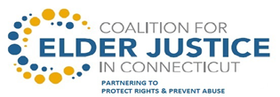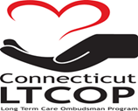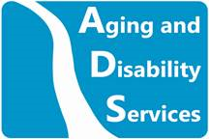

Photographs and/or video will be taken at today's event

By taking part in this event you grant the rights to use the images resulting from the photography/video filming for publicity or other purposes. This might include (but is not limited to), the right to use them in printed and online publicity and press releases.

If you do not wish to be photographed, please inform an event organizer.

VOICES FORUM: Quality in Care
October 6 ,2023
Agenda

Arrival and Registration

Pledge of Allegiance
John Banks
Council President from Sgt. John Levitow

Welcome
Mairead Painter
State Long Term Care Ombudsman

Opening Remarks
Amy Porter
Commissioner of the Department of Aging and Disability Services

Presentation – Quality Surveys
Julie Robison, Ph.D.
Professor of Medicine, UConn Center on Aging

Presentation – Why have a Family Council?
Liz Stern
Statewide Family Council Member

Award Presentations
Carol Rosenwald Spirit of Advocacy Award – The Late Quentin Williams
Brian Capshaw Rock Star Award - Toby Edelman

Legislative Update
Daniel Beem
Ombudsman Program

Center for Medicare Advocacy - Know your Medicare Rights
Judy Stein - Center for Medicare Advocacy; Executive Director/Attorney

The importance of Resident Council
John Balisciano
Statewide Coalition of Presidents of Resident Councils

Resident and Staff Raffle
Lunch
Open Mic & Panel Discussion
Closing Remarks
Carol Rosenwald Spirit of Advocacy Award

“You Must Hold onto Your Ideals and Always Have the Courage to Speak Your Mind” ~ Carol Rosenwald

History of the VOICES Forum

In September of 1996, nursing home resident and activist Carol Rosenwald, with assistance from the Ombudsman Program, began organizing residents across the state to advocate for improvements in the long-term care system. Carol envisioned a time when the “VOICES” of nursing home residents could be heard “beyond the walls” of their facilities. She became the founder of the Statewide Coalition of Resident Councils and the driving force behind the first “VOICES” Forum in 1997. As a large group of voting constituents, residents were able to speak directly with political leaders and public officials about important issues affecting their quality of life.

VOICES 2019 marks the 26th anniversary of Carol’s vision and of this historic event. Our heartfelt thanks to the many courageous residents who have attended VOICES over the years and to all of you attending today who inspire systems change in long term care. You have our deepest admiration and respect.

~The Long-Term Care Ombudsman Program

This year we are pleased to award the
Carol Rosenwald Spirit of Advocacy Award
to
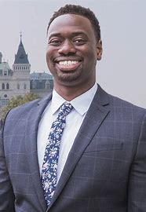
Quentin Williams – The late State Representative

The first-ever Black State Representative for the City of Middletown, CT and previous House chair of the Aging Committee, Quentin Williams worked tirelessly and inspired us to create a more equitable future. Quentin was instrumental in leading the debate and the ultimate passage of several significant bills related to long term care residents. This included strengthening the bill of rights for long-term care residents and authorizing the use of resident technology for virtual visitation and virtual monitoring during the COVID-19 Pandemic. Quentin had taken the Oath of Office for his third consecutive term just before his passing. At age 39 he touched many more lives with his optimism, passion, and joy than most people twice his age. His electric smile was a source of encouragement for all those who knew and loved him. He died unexpectedly on Thursday, January 5, 2023

Brian Capshaw Rock Star Award

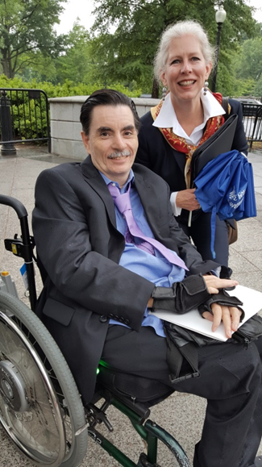

The Coalition of Presidents of Resident Councils and the Long-Term Care Ombudsman Program are pleased to announce the Brian Capshaw annually award recipient. Brian is remembered for his incredible advocacy both in Connecticut and at the national level. In 2012, Brian participated in the Consumer Voice Conference in Washington, DC. He represented Connecticut nursing home residents with a strong voice and with the incredible advocacy that only one who has “walked the walk” can bring to the conversation. He was the resident representative on the Long-Term Care Advisory Council, he testified at countless hearings and he went door to door at the capitol talking with legislators about all the issues so important to quality care and services for nursing home residents: improved staffing levels, video monitoring, personal needs allowance, to name just a few. Brian also worked on national advocacy: he was appointed to be the Chair of the Leadership Council of the Consumer Voice, he was interviewed numerous times by the national media and participated in a wide variety of state and national workgroups. Brian was invited to the White House to participate in the 2015 White House Conference on Aging.
Brian loved sports, his family and friends, getting into his van to meet friends for concerts and various activities. He thoroughly enjoyed his rock music! Brian, in every fashion, was an inspiration and a joy to all who knew and admired him. We miss him dearly.

This year we are pleased to award the
4th annual Brian Capshaw Rock Star Award
to
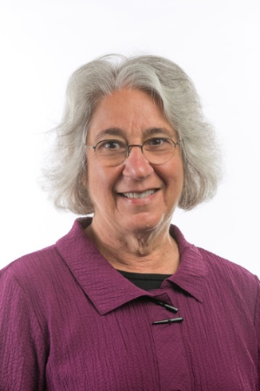
Toby Edelman
Senior Policy Attorney
Center for Medicare Advocacy

Toby S. Edelman has been representing older people in long-term care facilities since 1977. As a Senior Policy Attorney with the Center for Medicare Advocacy since January 2000, Ms. Edelman provides training, research, policy analysis, consultation, and litigation support relating to nursing homes and other long-term care facilities. Under two grants from the Commonwealth Fund, she evaluated the federal nursing home survey and enforcement system and its impact on state activities and provided technical assistance to states on effective enforcement practices. In cooperation with the Centers for Medicare & Medicaid Services, she recently completed a Commonwealth Fund project to evaluate seven states' deficiency citations for misuse of antipsychotic drugs. Since September 1999, she has written a monthly newsletter on nursing home enforcement issues.

Ms. Edelman was the lead attorney for a statewide class of nursing facility residents who successfully challenged the state of California's refusal to implement the federal Nursing Home Reform Law (Valdivia v. California Department of Health Services, Civ. No. S-90-1226 EJG (E.D. Calif. 1993). As a beneficiary representative, Ms. Edelman has testified before Congress and served on federal task forces, technical expert panels, and working groups on nursing home issues.

Ms. Edelman received a B.A., Magna cum Laude, from Barnard College (1968), an Ed.M. from the Harvard Graduate School of Education (1969), and a J.D. from the Georgetown University Law Center (1974). Ms. Edelman is a member of the Washington, DC Bar.

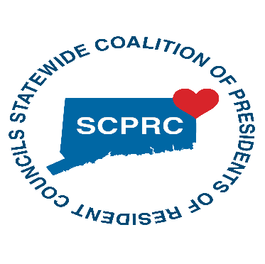
Executive Board Members

E-board Member Name Facility & Contact Information
John Balisciano Jr.  President | Hewitt Health and Rehab  203-924-6118  john.balisciano196593@aol.com
Susan Bilansky | Hebrew Home  860-906-4292  SBilansky45@gmail.com
Martha Leland | Touchpoints of Manchester  860-432-7279  meleland5@gmail.com
Thomas Dorman | Amberwoods of Farmington  860-294-6494  trdorman0783@gmail.com
Jeanette Sullivan-Martinez | Pendleton Healthcare  860-333-3411  Jennie.Martinez518@gmail.com

The E-Board members are open to other resident councils reaching out to them for information or to join the greater coalition of resident council presidents.

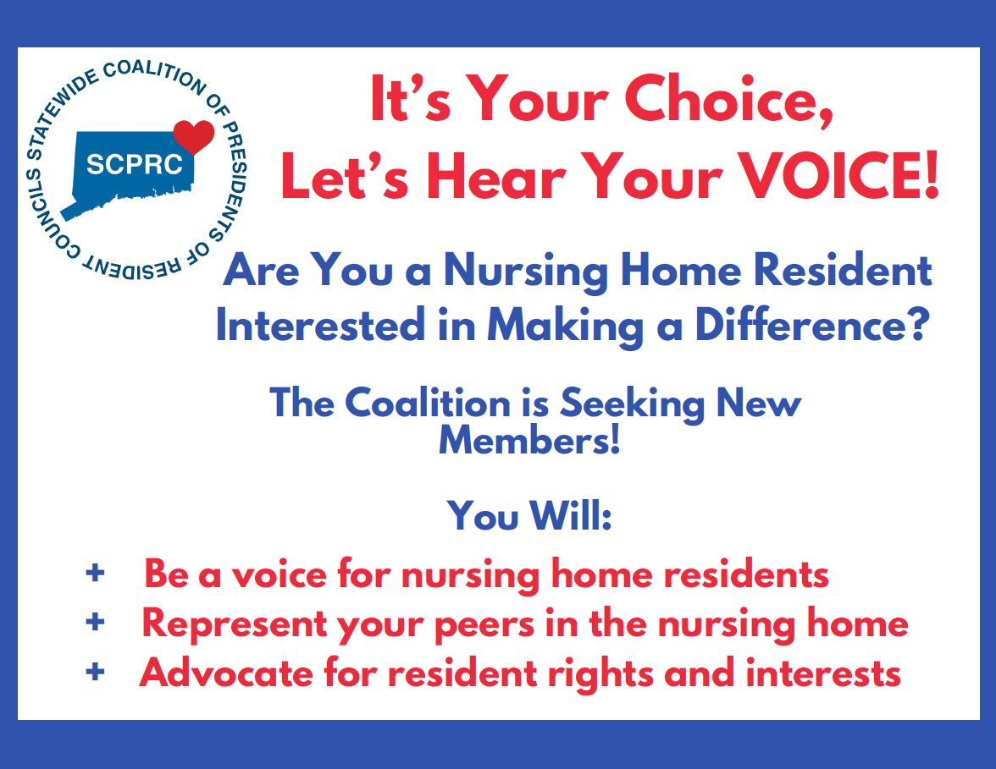

To our Resident Advocates who selflessly volunteer their time advocating on behalf of nursing home residents.
Thank You!
Volunteer | Facility
Ann Marie Fumo | Middlesex Healthcare Center
Barbara Clerkin | Apple Rehab Old Saybrook
Brenda Fife | Geer Nursing and Rehabilitation Center
Colleen Mcdermott | Touchpoints of Farmington
Deb Ciofi | Bayview Health Care Center
Doreen Near | Mystic Healthcare
Jennifer Glick | Chelsea Place
Joyce Werden | Norwich Sub-Acute (Norwichtown)
Karen Haabestad | Apple Rehab Mystic
Kevin Place | Candlewood Valley Nursing Home
Linda Rosen | Governor’s House
Richard Steele | Beechwood
Susan Williams | Touchpoints at Chestnut
Vy Pham | Civita of Newington

Voices Forum 2023 Post Event Survey

Anyone can respond, Anonymous

Scan the QR code to Vote or go to: https://forms.office.com/g/qaaZNRAWn1




For more information or to contact the
Long-Term Care Ombudsman Program
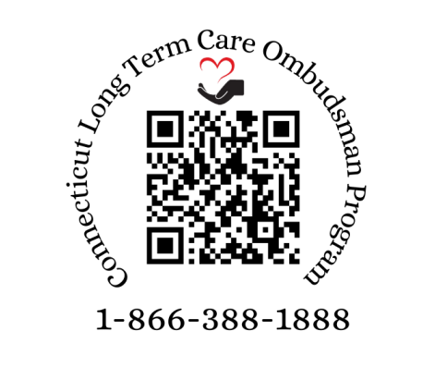

You can also e-mail us: ltcop@ct.gov

Follow us on Facebook: www.facebook.com/CTLTCOP

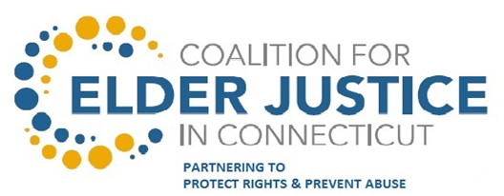

Mission
Coalesce and leverage a multi-disciplinary, statewide group of private and public
stakeholders to prevent elder abuse and protect the rights, independence, security, and
well-being of vulnerable elders.

Our Coalition
The Coalition of Elder Justice in CT ~ A multi-disciplinary, statewide group of private and public stakeholders working together to prevent elder abuse and protect the rights, independence, security, and well-being of vulnerable elders.”

Our History
The Coalition for Elder Justice in CT was formed by the State Department on Aging in 2013 to lead and convene public and private stakeholders addressing elder justice issues in Connecticut. Governor Dannel Malloy recognized the Coalition and authorized the active participation by various state departments to collaborate and protect elders from multiple forms of elder abuse as illustrated in Executive Order 42. Since that time, the Coalition has hosted annual Seminars and Coordinating Council sessions and our partners have increased two-fold. A number of Action Teams have also been working on such issues as Financial Exploitation, Bank and Faith-Based training, and partnering with AARP Fraud Watch. With the recent award of an Administration of Community Living grant, support will be provided for Conservator Web-based Training, Law Enforcement training, and Elder Abuse Awareness.

Steering Committee
While the day to day coordination and operations are executed by Co-Chairs, presently State Unit on Aging lead staff, the Steering Committee is comprised of five key, member organizations with distinct expertise in elder abuse. Together they provide support, guidance and oversight of progress on behalf of the Coalition.

Coalition Members
The Coalition is a multidisciplinary, statewide network of agencies and organizations that are partnering to achieve the vision and goals of the Coalition. Membership is open to all interested stakeholders at no cost. Members receive information and updates and have opportunities to attend seminars and the annual meetings and participate in Action Teams.

Interested in joining the Coalition

Please Visit
http://elderjusticect.org/
Click on Join the Coalition tab and fill out the membership form.

Coalition For Elder Justice In Connecticut
Co-Chairs
Lara Stauning, Staff Attorney, Aging and Disability Services, State Unit on Aging
Mairead Painter, State Long-Term Care Ombudsman

