
Middletown State Veterans Cemetery
Niche Cover
Phone (860) 616-3688 or Fax (860) 616-3561
oaa-cms.dva@ct.gov
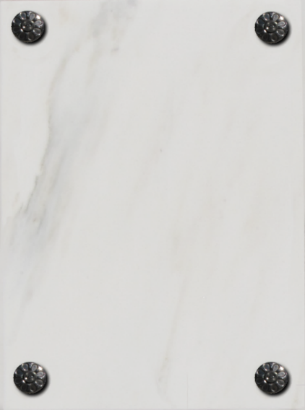
Marble Niche Cover Inscription Instructions. You may use this form to write-out the inscription you would like on the headstone. Please provide the information to the cemetery prior to the date of the burial. You can email, or fax the application using the information listed above.
EXAMPLE

CARRAGHER
JOHN S
CSM USA
IRAQ
DSM LM BSM
1964 20xx
LUCY ANN
1969 20xx
AMERICAN
SOLDIER

There are 10 lines of text available on a niche cover. The first line is always for the last name and will accommodate up to 11 characters, including spaces. The 10th line (last line on the niche cover) allows up to 9 characters, including spaces. All other lines allow up to 13 characters, including spaces. Please complete inscription lines as indicated below. *Items in bold are mandatory on VA markers. All other items are optional.
When the mandatory portions of the inscription are complete, you may use the remaining lines to include a personalized additional inscription of your choice, provided it is consistent with our mission to honor Veterans and their families.
** If you choose NOT to use Lines 4 – 6 (War Periods or Military Awards) for optional inscription
you may use an equal number of lines for Additional Inscription of your choice in their place.
Emblem of Belief (Optional) |  |  |  | Emblems of Belief (EOB) currently offered for inscription at the top of the niche cover are depicted on the back of this form. If you wish to add an EOB, please enter the number associated with the EOB.
1. | * Last Name:
2. | * First name w/Middle Initial:  (or Middle Name in place of First Name)
3. | Veteran’s Highest Rank  & *Branch of Service (*Abbreviated)
4. | War periods or Military Awards:
5. | War periods or Military Awards:
6. | War periods or Military Awards:
7. | Veteran’s * Year of Birth  and * Year of Death:
8. | Dependent’s First Name / MI:  (or Middle Name in place of First Name)
9. | Dependent’s * Year of Birth  and * Year of Death:
10. | Additional Inscription:
** | Additional Inscription:  (Only if equal number of optional lines  4 – 6 are not used)
** | Additional Inscription:  (Only if equal number of optional lines  4 – 6 are not used)
** | Additional Inscription:  (Only if equal number of optional lines  4 – 6 are not used)
Next of Kin Signature: |  |  |  |  |  |  |  |  |  |  | Date:
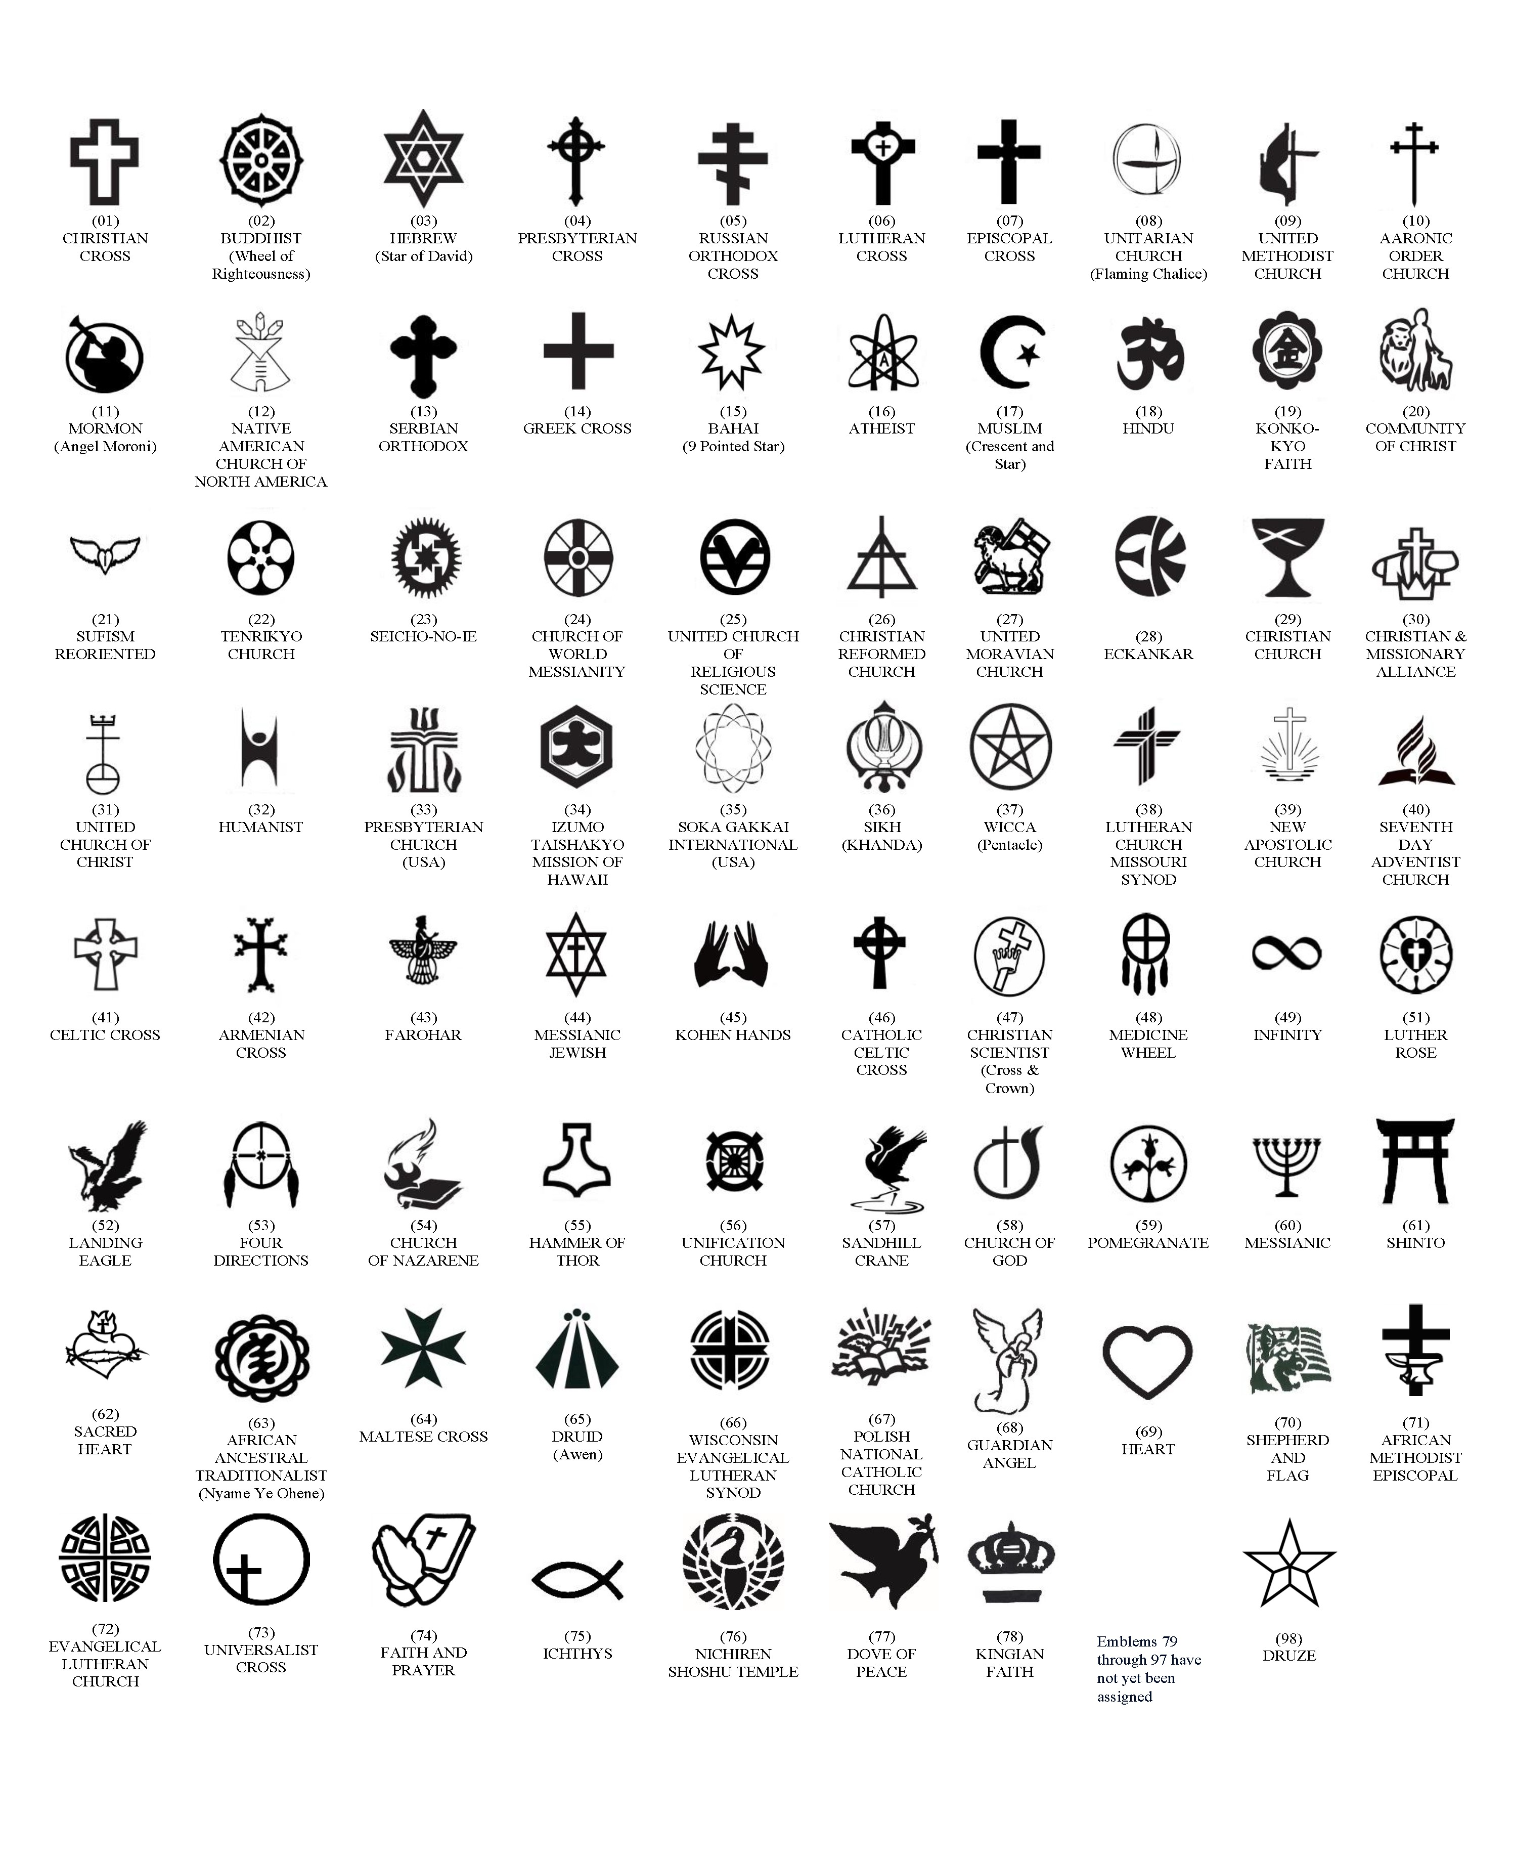
AVAILABLE EMBLEMS OF BELIEF FOR PLACEMENT ON GOVERNMENT HEADSTONES AND MARKERS (As of August, 2022)

