SAMPLE BIDDING AND CONTRACT DOCUMENTS
FOR FIELD SUBSURFACE INVESTIGATIONS
BY BORING CONTRACTORS

Prepared by the Connecticut Department of Transportation
Bureau of Engineering and Construction
Office of Geotechnical Engineering

(Revised October 2019)

Contract Components

Page

I. Invitation to Bid |  | I-1
II. Bid Forms |  | II-1
III. Contract |  | III-1
Table of Contents |  | III-1
 | Exhibit A – Technical Requirements | III-19
 | Exhibit B – Bid Sheet  Exhibit C – Work Zone Safety Guidelines revised 2013 | III-37
 |  | III-38
IV. List of Attachments: |  | IV-1
 | Sample CDOT Boring Log | IV-2
 | List of Boring Contractors Interested in Submitting Bids | IV-3

Note: These Contract documents, including specifications, were prepared for informational purposes and is furnished solely as a guide. The State assumes no liability for use of the contents herein.

INVITATION TO BID

Sealed proposals for the performance of subsurface explorations, including the makings of borings in soil and rock; securing samples and other work incidental thereto in the Town(s) of
_______________(Town)_______________________________, Connecticut, will be received by ____________________(Consultant)______________________________, Consulting Engineer,
until 12:00 noon, Eastern (Daylight) (Standard) Time, __________(date)______________, 20__.

Plans, specifications, boring schedule, proposal form and form of contract are attached hereto.

If available, preliminary soils information obtained by subsurface explorations already completed at the site are attached. It shall be understood by all bidders that the preliminary data presented is no intended as a warranty of the subsurface conditions to be encountered, but is furnished for information only.

Proposals must be made upon the form provided. The blank places in the form must be filled in as noted, and no change shall be made in the phraseology of the proposal or in the items mentioned herein. Proposals that contain any omissions, alternations, additions, or items not called for in the itemized proposal, or that contain irregularities of any kind, may be rejected as non-responsive.

A certified check for the sum of ten percent (10%) of the amount of the bid, made payable to ______________(Consultant)______________________________ must accompany the bid, as a guarantee that the contract will be entered into, if awarded.

In lieu of a certified check, a proposal guaranty in the form of a bond furnished by a surety company in the amount of 10% of the amount of the bid will be accepted. The surety must be a corporate surety licensed to sign surety bonds in the State of Connecticut.

A performance contract bond and payment bond, each in the sum of one hundred percent (100%) of the contract price, will be required on execution of the contract.

___________(Consultant)________________ reserves the right to reject any or all bids.

BID FORMS FOR SUBSURFACE EXPLORATIONS

________________(description of project – use as many lines as needed)________________

TO: (Contractor)

In submitting this bid, the undersigned declares that he/she is the only person or persons interested in the said bid; that it is made without any connection to any person making another bid for the same contract; and that the bid is, in all respects, fair and without collusion, fraud, or mental reservation.

The undersigned also declares that he has carefully examined the plans, specifications and form of contract and that he has personally inspected the actual location of the work, together with the local sources of supply; has satisfied himself as to all the quantities and conditions; and understands that in signing this proposal, he waives all right to plead any misunderstanding regarding same.

The undersigned further understands and agrees that he is to furnish and provide for the respective unit bid price, all the necessary material, machinery, implements, tools, labor, services, etc., and to do and perform all the necessary work under the aforesaid conditions, to complete the work in accordance with the plans and specifications, which plans and specifications it is agreed are a part of this proposal. The list of bid items, together with the estimated quantities thereof, is set forth in the Bid Sheet, which accompanies and forms a part of this proposal. The undersigned further agrees that his total bid prices, which shall be evaluated in comparison with the total bid prices of other bidders, shall be completed as the summation of the products of the approximate quantities shown on the Bid Sheet multiplied by the gross sum bid. In case of discrepancy between the words and the numerals giving the unit bid prices, the words shall govern.

Furthermore, the undersigned fully understands that the quantities of the items set forth in the Bid Sheet are only approximate and agrees to accept the unit price as full compensation for the actual quantities of such items required to complete the work to the satisfaction of the Engineer, be the quantities more or less than those set forth in the Bid Sheet.

The undersigned agrees to submit a schedule of progress or time chart for the work concerned if so requested by the Engineer after the opening of the bids, and to do so within three (3) days of such request. The schedule or chart will be used in consideration of the bids and after award of the contract by the Engineer in the field as a check on the actual progress.

On acceptance of this proposal for said work, the undersigned does hereby bind himself to enter into written contract with _________________(Consultant)_____________________ within three (3) days of the date of notice of award and to comply in all respects with the terms of said contract. The undersigned agrees that this proposal shall be valid for thirty (30) calendar days from the date of this proposal.

Accompanying this proposal is a guarantee, payable to the order of ___(Consultant)___, in the sum of 10% of the amount of the Gross Sum Bid, which deposit is to be forfeited as liquidated damages in case this proposal is accepted and the undersigned shall fail to execute a contract under the conditions of this proposal within three (3) days after date of official notice of the award of the contract. Otherwise, said deposit is to be returned to the undersigned.

All proposal guarantees will be returned within three (3) calendar days following the award of the contract. When the award is deferred for a period of time longer than ten (10) calendar days after the opening of the proposals, all guarantees, except those of the three lowest bidders, will be returned. Should no award be made within 30 calendar days after the opening of proposals, all proposals will be rejected and the proposal guarantee returned, except that with the approval of the Bidder and the Surety, the Engineer may retain the proposal and proposal guaranty of the low bidder for as long as may be agreed upon by the Engineer, Bidder and Surety.

The Bid Sheet submitted with these bid documents will become part of the Contract documents in Exhibit B of the Contract.

Dated ___________________________________, 20___

_________________________________________
(Legal name of person, firm, or corporation)

By______________________________________
(Name of person submitting form)

The P. O. Address of the bidder is:

__________________________________________________________________________
(Street)

__________________________________________________________________________
(City and State)

If a Corporation:

Name Address

__________________________________ ______________________________
(President) ______________________________

__________________________________ ______________________________
(Secretary) ______________________________

__________________________________ ______________________________
(Treasurer) ______________________________

If a Firm:

Names of Members Address

__________________________________ ______________________________
(Member name) ______________________________

_________________________________ ______________________________
(Member name) ______________________________

_________________________________ ______________________________
(Member name) ______________________________

BID SHEET
Item  No. | Description of Commodity | Unit | Approximate Quantities | Unit Price  Dollars/Cents | Total Amount of Bid  Dollars/Cents
1.01 | Soil Boring – Type A (0-75 feet) | L.F.
1.02 | Soil Boring – Type A (Over 75 feet) | L.F.
1.03 | Soil Boring – Type B | L.F.
1.04 | Cement Grout Backfill | L.F.
2.01 | Auger Boring. 4” Diameter | L.F.
3.01 | Split Tube Sample | Each
4.01 | Stationary Piston Samples | Each
5.01 | Rock Coring – NX | L.F.
5.02 | Structural Coring – NX | L.F.
6.01 | Pavement Core – 4 inch | Each
7.01 | Test Pits | Each
8.01 | Bar Soundings | L.F.
9.01 | Drill Rod Probe | L.F.
10.01 | Observation Wells | L.F.
11.01 | Piezometers | L.F.
12.01 | Inclinometers | L.F.
13.01 | Trafficperson – Uniformed | Hour
13.02 | Trafficperson – Police Officer (Municipal) | Hour
13.03 | Trafficperson – Police Officer (State Police) | Hour
14.01 | Mobilization and Dismantling - Land | Ea. Rig
14.02 | Mobilization and Dismantling - Railroad | Ea. Rig
15.01 | Mobilization and Dismantling - Water | Ea. Rig
16.01 | Mobilization and Dismantling – Tracked Rig or Skid Rig on Land | Ea. Rig
17.01 | Standby Time | Hour
18.01 | Truck Mounted Impact Attenuator Vehicles (TMAs) | Day
19.01 | Light Plant | Day
Total Bid

Contract Table of Contents

- Contract Agreement
- Extra Work
- Payment
- Contract Not To Be Assigned
- Modification of Contract
- Default of Contract
- Commencement of Work
- Performance Contract Bond Payment Bond
- Insurance
- Waiver of Responsibility
- Non-Liability of State and Engineer’s Representatives
- Contractor’s Warranties
- General Conditions
- Contract Requirements
Exhibit A Technical Requirements
Exhibit B Bid Sheet
Exhibit C Work Zone Safety Guidelines revised 2013

Article 1 - Contract Agreement

This Contract (the “Contract”) is made and entered into on ________(date)____________, by and between, ____________(Consultant)_________________, hereinafter referred to as the Engineer and ____________(Contractor)_______________, hereinafter referred to as the Contractor.

The Contractor shall furnish all labor, materials, equipment, supplies and other facilities, and shall perform all work necessary or proper for or incidental to the making of subsurface explorations at the locations on the plans at the site of ____________________________________________ at ______________________, Connecticut, in strict accordance with the Specifications found herewith and the accompanying Contract Plans, and to the satisfaction and approval of the Engineer; and shall perform all other obligations and assume all liability imposed upon him by the Contract and Specifications.

In full consideration thereof, the Engineer will pay the Contractor, at the times and in the manner hereinafter provided, an amount determined by the prices named on the Bid Sheet in Exhibit B, hereof entitled "Contract Unit Prices," and, except as otherwise provided herein, such amounts only. The prices for items named therein include full compensation to the Contractor for all labor, materials, and other things incidental to the completion of the entire work. Such payment shall be computed upon the basis of the actual quantities in the completed work, whether such quantities be more or less than those shown in the Bid Sheet.

Article 2 – Extra Work

Unforeseen work made necessary by changes in plans or work necessary to complete the subsurface investigations, for which no price is provided in the contract, shall be classified as extra work and done in accordance with the requirements of the specifications and as directed by the Engineer.

The Engineer shall notify the Contractor of the necessity for extra work, stipulating its character and extent. Upon receipt of such notification, the Contractor shall notify the Engineer, in writing, of the compensation, either unit price or lump sum as requested, for which he proposes to perform the extra work required. The Engineer may accept or reject the compensation proposed by the Contractor. If the extra work is rejected by the Engineer no extra work will be done or paid for. If the Engineer considers the prices submitted to be excessive, he may order the work done on a "Cost Plus" basis as specified hereinafter. In any case, the character and extent of extra work, together with the accepted basis of compensation shall be communicated to the Contractor in writing.

If the Engineer orders extra work performed on a "Cost Plus" basis, the Contractor shall perform the same and shall receive in payment there for an amount equal to the actual net cost in money to him of the materials, wages of applied labor, other direct expense and insurance required for labor, plus 20 percent of the above items and plus such rental for plant and other equipment (other than small tool) as the Engineer deems reasonable, and that amount only.

No work shall be considered Extra Work unless it has been ordered in writing as such by the Engineer before the said work started, or unless the Contractor shall file a written claim for Extra work with the Engineer within two (2) days from the date of instructions from the Engineer or his representative to proceed with such work.

Article 3 – Payment

Partial Payment(s): On or about the first day of each calendar month, the Engineer will request the Contractor to furnish information necessary to estimate the value of the work satisfactorily done up to that time. Within three (3) days after receipt of this information, the
Engineer will request the State to pay him 90% of the value of the work thus estimated, less any previous payments made; and the Engineer, within three (3) days after receipt of such payment from the State, will pay to the Contractor the amount thus received.

Final Payment: Upon the satisfactory completion of all work whatsoever required, the Contractor shall furnish to the Engineer satisfactory evidence that all just liens, claims and demands for rental of equipment, labor and material, arising out of such work, are fully satisfied, and that all of the work is fully released from liens, claims and demands, whether just or otherwise. Within three (3) days after receipt of such evidence, the Engineer will request the State to pay him the total value of all work satisfactorily done, less any payments previously made, and within three (3) days of receipt of this Final Payment from the State, the Engineer will pay to the Contractor all amounts still outstanding and due him. All prior estimates and payments shall be subject to correction in this payment, which is throughout this Contract called the Final Payment.

The acceptance by the Contractor of the Final Payment shall be and shall operate as a release to the Engineer of all claims and all liability to the Contractor for all things done or unfinished for or relating to the work, and for every act of the Engineer, his representatives, agents and employees, or other relating to or arising out of the work.

Article 4 – Contract Not To Be Assigned

The Contractor shall give his personal attention constantly to the faithful prosecution of the work. He shall not assign or otherwise dispose of the Contract, or his right, title or interest in or to the same or any part thereof.

Article 5 - Modification of Contract

No modification of or change in this Contract shall be valid or enforceable against either of the parties unless it is in writing and signed by the parties or their duly authorized representatives.

Article 6 - Default of Contract

When, in the opinion of the Engineer, the project or any part thereof has been abandoned, or the Contractor is willfully violating any of the covenants of this Contract, then the Engineer may declare the Contractor in default of the Contract and notify him to discontinue the project. The Engineer may then call on the Surety to complete the project.

Article 7 - Commencement of Work

The Contractor agrees to mobilize and actually start work on the Contract within nine (9) consecutive calendar days from the date of the written notice to proceed.

Article 8 - Performance Contract Bond and Payment Bond

The successful Bidder, at the time of the execution of the contract, may deposit with the Engineer, a surety company bond for the satisfactory completion of the work and a surety company bond for the payment of all debts pertaining to materials, rental of equipment, and labor used or employed in the execution of the Contract. These bonds shall each be in an amount equal to the amount of the contract award and in a form acceptable to the Engineer.

The Surety must be a corporate surety licensed to sign surety bonds in the State of Connecticut.

Article 9 - Insurance

The Bidder, to whom the Contract has been awarded, shall furnish to the Engineer, prior to the commencement of any work, satisfactory proof that all provisions, herewith specified, relating to the Contractor's insurance have been fully complied with.

Article 10 – Waiver of Responsibility

It shall be understood that preliminary data obtained by subsurface explorations prior to this Contract and presented for examination by prospective bidders is not intended as a warranty of actual subsurface conditions to be encountered. The Engineer will bear no responsibility for the accuracy or suitability of subsurface information made available for examination and the conditions indicated by such information shall not be used by the Contractor as possible cause for subsequent revisions or waivers in the Contract.

Article 11 – Non-Liability of the State and Engineer’s Representatives

No agents or employees of the Engineer (Consulting Engineer), the State of Connecticut, all officers, agents and servants of the State of Connecticut, Commissioner of Transportation and his successors, shall be charged personally by the Contractor with any liability or held liable to him, under any terms or provisions of this Contract or because of its execution or attempted execution, or because of any breach thereof.

Article 12 – Contractor’s Warranties

The Contractor represents and warrants:

That he is financially solvent; that he is experienced in and competent to perform the type of work contemplated by this Contract.

That he has carefully examined the specifications, plans, and the site of the work, the general and local conditions, and other matters which may in any way affect the work or its performance.

IN WITNESS WHEREOF, the parties have caused these presents to be signed and sealed the day and year first above written.

Witness

_______________________________________ __________________________________
(Signature) (Date)

_______________________________________ __________________________________
(Name) (Contractor Company Name)

Witness

_______________________________________ __________________________________
(Signature) (Date)

_______________________________________ __________________________________
(Name) (Engineer Company Name)

SPECIFICATIONS FOR SUBSURFACE EXPLORATIONS

Article 13 – General Conditions

Definitions:

"Engineer" shall mean the firm of ________________(Consultant)_____________________, or their authorized representative, or the Commissioner of Transportation or his authorized representative.

"Commissioner of Transportation" shall mean the Commissioner of Transportation for the State of Connecticut, acting directly or through his duly authorized representative.

"Contractor" shall mean the person, persons, or corporation, which has executed the Contract with the Engineer for the proposed work.

"Inspector" shall mean the authorized representative of the Engineer assigned to the inspection of work and materials.

"State" shall mean the State of Connecticut.

Authority and Duties of the Engineer:

All work shall be performed to the satisfaction of the Engineer and at such times and places, by such methods and in such manner and sequence as he may require, and shall at all stages be subject to his inspection.

Upon request of the Contractor, the Engineer will confirm in writing any oral order, direction or requirement.

Injury to Persons or Property:

The Contractor shall be responsible for all injury to persons or damage to property, either directly or indirectly, that may result from his operations.

Insurance:

With respect to the operations performed by the contractor under the terms of this contract and also those performed for the contractor by its subcontractors, the contractor will be required to obtain at its own cost and for the duration of this contract, and any supplements thereto, for and in the name of the State of Connecticut in conjunction with paragraph (A) below, and with the State being named as an additional insured party for paragraphs (B), (C), (E), (F), (G), and (H) is specified, the following minimum liability insurance coverage at no direct cost to the State.

Changes to the types and dollar amounts of coverage, if required, will be specified in the individual bid package.

Insurance Provisions

The State of Connecticut, its officers, officials, employees, agents, Boards and Commissions shall be named as additional insured. The coverage shall contain no special limitations on the scope of protection afforded to the State.

Contractor shall assume any and all deductibles in the described insurance policies.

The contractor’s insurers shall have no right of recovery or subrogation against the State and the described insurance shall be primary coverage.

Any failure to comply with the claim reporting provisions of the policy shall not affect coverage provided to the State.

Each required insurance policy shall not be suspended, voided, cancelled or reduced except after 30 days prior written notice by certified mail has been given to the State.

“Claims Made” coverage is unacceptable, with the exception of Professional Liability.

Contractor agrees that he/she will not use the defense of Governmental immunity in the adjustment of claims or in the defense of any suit, unless requested by the State.

- Owner’s And Contractors Protective Liability:

The contractor shall purchase Owner’s and Contractor’s Protective Liability Insurance for and in the name of the State of Connecticut. This insurance will provide a total limit of one million dollars ($1,000,000.00) per occurrence for all damages arising out of injury to or death of all person and out of injury to or destruction of property in any one accident or occurrence and, subject to that limit per occurrence, a total (or aggregate) limit of two million dollars ($2,000,000.00) for all damages arising out of bodily injury to or death of all persons in all accidents or occurrences and out of injury to or destruction of property during the policy period.

(B) Commercial General Liability:

The Contractor shall carry Commercial General Liability Insurance, including Contractual Liability Insurance, providing for a Combined Single Limit of one million dollars ($1,000,000.00) for all damages arising out of bodily injury to or death of all persons in any one

accident or occurrence, and for all damages arising out of injury to or destruction of property in any one accident or occurrence, and, subject to that limit per occurrence, a total (or aggregate) limit of two million dollars ($2,000,000.00) for all damages arising out of bodily injury to or death of all persons and out of injury to or destruction of property during the policy period.
Total/aggregate coverage shall be per project, purchase order or contract aggregate. Coverage shall include Premises and Operations, Independent Contractors, Products and Completed Operations, Contractual Liability and Broad Form Property Damage. The policy shall have coverage for and exclusions removed for “Explosion, Collapse and Underground” (“XCU”).

(C) Automobile Liability:
The operation of all motor vehicles, including those hired or borrowed, used in connection with the contract shall be covered by Automobile Liability Insurance providing for a total limit of one million dollars ($1,000,000.00) Combined Single Limit per occurrence for all damages arising out of bodily injury to or death of all persons in any one accident or occurrence, and for all damages arising out of injury to or destruction of property in any one accident or occurrence. In cases where an insurance policy shows an aggregate limit as part of the automobile liability coverage, the aggregate limit must be at least two million dollars ($2,000,000.00). Coverage extends to owned, hired and non-owned automobiles. If the vendor/contractor does not own an automobile, but one is used in the execution of the contract, then only hired and non-owned coverage is required. When it is clearly established that no vehicle is used in the execution of the contract, then automobile coverage is not required. Contractor operations on airports that use vehicles on the air side require five million dollars ($5,000,000.00) automotive coverage unless specifically modified by the State, and may require additional special vehicle coverage depending on the types of vehicles employed.

(D) Worker's Compensation:

With respect to all operations the contractor performs and all those performed for the contractor by subcontractor(s), the contractor and subcontractor(s) if used, shall carry Workers’ Compensation Insurance at statutory coverage limits and, as applicable, insurance required in accordance with the U.S. Longshoremen and Harbor Workers’ Compensation Act, in accordance with the requirements of the laws of the State of Connecticut, and of the laws of the United States respectively.

Additional Coverage

Other types of coverage may be offered by the vendor or required by the terms of a particular bid.

- Railroad Requirements:

When the Contract requires work on, over or under the right of way of any railroad company, the Contractor shall provide, with respect to the operations that it or its subcontractors perform under the contract the following additional insurance requirements apply:

The Contractor is warned that entrance to the railroad property will not be allowed by the Railroad Company if there are outstanding charges remaining against the Contractor for Railroad Services rendered on prior projects. No request for an extension of time will be considered as a result of any delay to the Contractor's operations caused by the Contractor's indebtedness to the railroad. It is agreed that providing of any conductors, flagmen, or other employees shall not relieve the Contractor from liability or payment for any damages previously caused by its operations.

If any of the railroad insurances specified in this section is provided on a claims-made basis, then in addition to coverage requirements, such policy shall provide that:
- The policy retroactive date must coincide with or precede the Contractor's start of work (including subsequent policies purchased as renewals or replacements),
- The Contractor shall maintain insurance for at least two years following Project completion,
- If insurance is terminated for any reason, the Contractor agrees to purchase an extended reporting provision of at least two years to report claims arising from Work performed in connection with this Contract, and,
- The policy must allow for reporting of circumstances or incidents that might give rise to future claims.

1 - Worker's Compensation Insurance:
Workers compensation insurance must provide a minimum coverage of $100,000 per accident and $100,000 per employee for any projects on, over or under the railroad.

"Employer’s Liability insurance shall be provided in amounts not less than $2,000,000 which limit may be met by a combination of primary and excess insurance meeting the statutory limits of the laws of the state in which the work is performed, whichever is greater."

2 – Commercial General Liability Insurance:
For projects involving work on, over or under the railroad the "Contractual Liability, Products and Completed Operations, Broad Form Property Damage and Independent Contractors coverages,” shall have all railroad exclusions deleted. The “named as an additional insured” shall be as noted on the Request for Quotation." Any Umbrella/Excess Policy used to meet the minimum contract requirements must follow form of the underlying policy and be extended to “drop down” to become primary in the event the primary policy is exhausted.”

For projects involving work on, over or under the railroad use the following “Limits of Coverage” chart for Commercial General Liability Insurance:

Contract Amount ($) | Minimum Single  Occurrence Limit ($) | Minimum Annual  Aggregate Limit ($)
0-10,000,000 | 3,000,000 | 3,000,000
>10,000,000 | 4,000,000 | 8,000,000

3 - Owner’s and Contractor’s Protective Liability Insurance for and in the Name of The State:

For projects involving work on, over or under the railroad use the following “Limits of Coverage” chart for Owners, Contractor’s Protective Liability Insurance:

Contract Amount ($) | Minimum Single  Occurrence Limit ($) | Minimum Annual  Aggregate Limit ($)
0-50,000,000 | 3,000,000 | 3,000,000
>50,000,000 | 4,000,000 | 4,000,000

Each policy shall waive right of recovery (waiver of subrogation) against the State of Connecticut or the Railroad and the described insurance shall be primary coverage.

For projects on Metro-North rights-of-way the Contractor is required to file certificates of insurance with Metro-North Commuter Railroad at least 30 days prior to commencing any work within the Railroad right-of-way. Certificates are to be sent to:

Ms. Sharon Sebro, Risk Analyst
Metro-North Railroad Risk and Insurance Management Department
2 Broadway, 21st floor, New York, NY, 10004
Phone: 646-252-1429 Email: ssebro@mtahq.org

Ms. Priscilla Yen may also be contacted for questions at 646-252-1437 or Pyen@mtahq.org.

Note: For projects with limits of construction that cross the Connecticut/New York State Line into New York, “American Premier Underwriters” shall also be shown as an additional insured.

For coverage provided under the Article “Railroad Protective Liability Insurance”, the names of the “Additional Insured” shall be as indicated on the Request for Quotation.

(F) Protection and Indemnity Insurance for Marine Operations in Navigable Waters

If a vessel of any nature or kind is involved, the Contractor shall obtain the following insurance coverage:

If a vessel of any nature or kind is involved, the Contractor shall obtain the following insurance coverage:

- Protection and Indemnity Coverage of $300,000 per vessel or a limit equal to the value of hull and machinery, whichever is greater.

- If there is any limitation or exclusion with regard to crew or employees under the protection and indemnity form, there must be a worker’s compensation policy in effect, including coverage for operations under admiralty jurisdiction with a limit of liability of $300,000 per accident or to a limit equal to the hull and machinery, whichever is greater, or as otherwise required by statute.

- Umbrella Liability:

In the event the contractor secures excess/umbrella liability insurance to meet the minimum requirements specified as items B, C, E, F, G, and H (if required), the State of Connecticut must be named as Additional Insured. The State of Connecticut must be the Named Insured if a separate umbrella policy is obtained to supplement the coverage specified for item A.

- Other Insurance:

Certain contracts require higher levels of coverage and/or specialized types of coverage that are unique to that contract. When required, the additional type(s) of insurance and specific coverage dollar levels will be specified in the terms and conditions of the individual bid. If additional specialized coverage is required by the bid, the State must be named as additional insured for each policy unless otherwise specified.

Certificate of Insurance

The contractor agrees to furnish to the Engineer a Certificate of Insurance in conjunction with Items A, B, C, D, E, F, G, and H above, fully executed by an insurance company or companies satisfactory to the State, for the insurance policy or policies herein above, which policy or policies shall be in accordance with the terms of said Accord form. For the Workers’ Compensation Insurance and, if applicable, the U.S. Longshoremen and Harbor Workers’ Compensation Act coverage, the policy number (s) and term of the policy(ies) shall be indicated on the Certificate of Insurance. Each insurance policy shall state that the insurance company agrees to investigate and defend the insured against all claims for damage, even if groundless.

Laws To Be Enforced:

The Contractor, at all times, shall observe and comply with all federal and state laws and local bylaws, ordinances, and regulations n any manner affecting the conduct of the work or applying to employees on the project, as well as all orders or decrees which have been promulgated or enacted, by any legal bodies or tribunals having authority or jurisdiction over the work, materials, employees for contract.

Article 14 - Contract Requirements

General:
The work will consist of, but not be limited to, various types of soil borings, installation of instrumentation, and testing of soil and rock. Contractors shall also provide traffic control when stated in the contract documents.

Basis of Payment:
The Engineer will pay the Contractor at the contract unit prices stated in Article 2 of the contract agreement for work completed to the satisfaction of the Engineer. Payment includes full compensation for all materials, equipment, tools, labor, obtaining, recording and submitting data as well as the procuring of any required permits or licenses and any incidental work necessary to complete the services.

Equipment Regulations:
Contractors shall have the equipment or vehicles properly equipped as necessary to perform the services. Equipment is to be maintained in compliance with all applicable Federal, State of Connecticut Department of Motor Vehicle (DMV) and local regulations in effect at all times during the contract. All Contractor operators of specialized equipment shall be properly trained, insured and licensed.

Contractors must comply with all applicable provisions and regulations of Title 14, Motor Vehicles, Use of the Highway by Vehicles, of the Connecticut General Statutes.

Under Connecticut law, a commercial vehicle used by Contractors and vendors in conjunction with the Contract may be subject to Connecticut registration requirement. Section 14-12a of the Connecticut General Statutes required such registration for any vehicle with is most frequently garaged in this State, or most frequently leaves from, and returns to one or more points within this State in the normal course of operations. In addition, a vehicle must obtain a Connecticut registration if it continuously receives and discharges cargo in the State.

For work on water, the barge, boat, or other float shall be securely anchored and at all times be free of the casing. Drill rigs for rock coring on water shall be mounted on the casing, where required.

Equipment Inspection:
Equipment supplied by the Contractor must be in safe operating condition at all times. The Engineer reserves the right to inspect the Contractor's equipment at any time and to confirm that equipment is in good operating condition. Contractors having equipment unavailable for inspection or for the performance of the Services will be considered in breach.

Work Day:
No work shall be performed by the Contractor without prior approval of the Engineer. Normal on site working hours are ____(Time)___ to ____(Time)___, Monday through Friday. Normal on site work hours may vary slightly by season. On Site work hours may vary, or be restricted for work on Interstates, Expressways, Railroads and Airports; on site work deviating from normal work hours will be as directed by the Engineer. No additional premium or Standby Time will be paid.

Contractors will not be permitted to work on the following Legal Holidays; New Year's Day, Washington's Birthday, Good Friday, Memorial Day, Independence Day, Labor Day, Thanksgiving Day, Christmas Day, Martin Luther King Day, Lincoln's Birthday, Columbus Day, and Veteran's Day.

Contractors will not be permitted to work on the day before and the day after any of the above Legal Holidays on Interstate Highways or Expressways. This applies also to the Friday immediately preceding any of the above Legal Holidays celebrated on a Monday and the Monday immediately following any of the above Legal Holidays celebrated on a Friday.

Traffic Control:
When traffic control is required for the project, the Contractor or its authorized subcontractor for traffic control shall supply and be responsible for all equipment, signs, supports, cones, and any other materials and equipment necessary. When traffic control personnel are required, they will be paid at the contract unit prices stated in Article 2 of the contract agreement. Traffic control personnel must be uniformed, trained and equipped for the proper performance of their duty. Traffic control personnel must comply with the Manual of Uniform Traffic Control Devices (MUTCD), revised 2009 edition, and the "Work Zone Safety Guidelines for Maintenance Operations 2013" booklet including the general notes. The booklet is attached to this document and is incorporated herein. Contractor shall provide the installation and removal of all signs, sign supports, barricades, traffic cones, traffic delineators, and any other equipment and material necessary as set forth in the provisions of the Work Zone Safety Guidelines for Maintenance Operations 2013.

Quality Control:
Quality control of the Services will be the responsibility of the Contractor. Services will be performed in conformance with the attached technical provisions, general procedures and specifications for items, traffic control patterns and any related specifications.

Use of Site:
The Contractor shall confine operations, equipment and materials to the designated work area. The work area and site access must be maintained free and clear of any obstructions or hazards by the Contractor. The Contractor shall take particular care in the Performance of work in order to prevent injury or defacement to property. Any damage caused by the Contractor in the Performance of work must be remedied at the Contractor's own expense.

The Engineer will have access to the work area whenever it is in preparation or progress and the Contractor shall provide proper accommodations for access and inspection.

Health and Safety Plan:
The Contractor shall have a General Health and Safety Plan (HASP) for the work to be performed and assumes full responsibility for site safety of the Contractor’s personnel. The Engineer may request a copy of the HASP. The purpose of this requirement is to assure proper and safe conduct of drilling operations. Items to be covered in the General Health and Safety Plan include, but are not limited to general safety practices of drill rig movement and operation:

- Protective clothing and gear
- Buried and overhead utilities
- Traffic Safety
- First Aid
- Location of and directions to the nearest urgent care center or hospital
- Emergency contact information

Extenuating circumstances which affect work performed and payments:
No payment will be made to the Contractor where the Contractor has been given reasonable notification of any temporary shutdown of work for work that could not be performed due to extenuating circumstances or adverse weather conditions declared by the State.

Should the Engineer direct the Contractor to standby at a project site, the standby time rate at the contract unit prices stated in Article 2 of the contract agreement, will be used to assess charges per rig/crew required to standby.

Supervision:
The Services will be performed under the supervision and direction of the Engineer. The Engineer will check the drillers logs of the explorations to determine that the information designated herein is being obtained and see that all samples are properly preserved, protected against damage, boxed and stored in a suitable place or immediately turned over to the Engineer.

Call before you dig (CBYD) – existing conditions:
Before any subsurface exploration is Performed, the Contractor shall contact CBYD at 811 or 1-800-922-4455 or by e-mail to obtain and maintain a request number and the names of the utility companies that are being notified. The Contractor, shall supply the Engineer with the request number(s) and shall update them as needed. Upon request the Contractor shall supply to the Engineer a complete list of utilities that CBYD will contact for each request. Any relocation of borings or other subsurface explorations will be cleared with CBYD at least two (2) days prior to drilling. The relocation of borings, including those due to utility conflict, must be approved by the Engineer. The Contractor shall locate all known utilities prior to work and repair/replace all damage done to known utilities at no cost to the State. Contractor may be held responsible for any damage done to unknown utilities if Contractor suspected that a utility may have existed due to drilling resistance or other evidence encountered during the Performance of the Services and did not immediately take steps to ensure that no damage was done to the unknown utility.

Boring Stakeout:
Work locations are to be laid out in the field by the Engineer prior to authorizing the Contractor to begin work.

Contractor’s Equipment:
All equipment and methods to be used by the Contractor will be subject to approval by the Engineer at any time during the performance of the Services. Contractor shall maintain all equipment in good and safe operating condition. Engineer approval of the use of any equipment will not be construed as including the approval of the equipment’s performance. Additional equipment and methods will be provided where ordered by the Engineer if required to perform the work satisfactorily according to the specifications.

The Contractor may be required to provide more than one (1) rig at a time on a project. The Contractor shall have access to sufficient personnel, equipment and materials to provide two (2) manned drill rigs throughout the Contract term. The Contractor must have one (1) drill that has been rated by its manufacturer to have at least 6500 ft-lbs of torque. All other drill rigs listed must be rated by their manufacturer to have at least 3500 ft-lbs of torque.

Cooperation by Contractor:
The Contractor will at all times provide a competent lead driller, thoroughly experienced in the type of Services being performed, who will receive instructions from the Engineer. The lead driller will have full authority to execute the orders or directions of the Engineer, without delay and to supply promptly such materials, equipment, tools, labor and incidentals as may be required. The Contractor shall employ only workers that are careful and competent. The Engineer may demand the dismissal of any person or persons employed by the Contractor who misconduct themselves or are incompetent or negligent in the performance of their duties or neglects or refuses to comply with directions given by the Engineer. Should the Contractor continue to employ or again employ such person or persons, the Engineer may withhold all payments, which are due or become due, or the Engineer may suspend the work until such orders are complied with.

Qualification of Personnel:
An experienced lead driller will have a minimum of five (5) years’ experience in performing geotechnical borings, or a minimum of two (2) years’ experience as a lead driller for a geotechnical boring contractor.

Records:
The Contractor shall keep complete, neat, accurate and legible field records of each boring (based in part on the driller’s field logs as described herein) and other subsurface exploration and these records will show the Contractor’s interpretation of the results of the explorations as to the nature of the subsurface conditions. The records will be made at the site and will be furnished to the Engineer as the work progresses. With the exception of the following items; CT grid coordinates, station, offset and elevation the records will contain complete boring logs that include all information specified in the latest version of the Connecticut DOT Geotechnical Engineering Manual.

Submission of Reports and Samples:
One copy of the driller's field log will be given to the Engineer at the site at the end of each working day.

Complete data files and typed boring logs referenced to ground surface with stratum classified as described above, together with all notes, remarks and pertinent information required by the Contract will be e-mailed to the Engineer (____________________) by the Contractor no later than five (5) days after the completion of exploration program. The boring logs and data files shall be submitted in gINT (*.gpj) format.

All samples except as otherwise specified below will be stored at or near the site as directed by the Engineer. All soil and rock samples will be given to the Engineer on completion of the last hole or as directed by the Engineer. If samples are not turned over by the Contractor, the Engineer will consider that the hole or holes were not drilled and no payment will be made for those borings.

After sealing by the Contractor, all stationary piston tube samples will be immediately transferred to the custody of the Engineer at the site.

Rights-of-Way and Damage to Property:
The Contractor shall obtain all necessary permits and licenses at his how expense from the authorities having jurisdiction. He shall comply with all federal laws, state statutes and local ordinances of the city, town or village in which the work is being done.

The Contractor shall be responsible for carrying out the work in accordance with the provisions of all permits.

The Contractor may occupy during his operations only those portions of streets or public places at the boring locations for which the required permits have been obtained by him. If the Contractor desires to use additional areas outside of those required for the borings, he shall arrange for such areas at his own expense.

The Contractor shall take every precaution against injuring pavement, utilities, or private properties and shall promptly repair at his own expense any damage to such pavement, utilities, or private property, to the satisfaction of the Engineer. The requirement includes the filling of all drill holes and the resodding of any areas where the grass is damaged. Property, which is damaged as the result of the Contractor’s operations, shall be repaired at the Contractor's expense, to the satisfaction of the Engineer.

The location of all stationary and mobile equipment shall be subject to the approval of the Engineer and upon the completion of the Contractor's operations at each site, he shall remove equipment therefrom and shall clear the area of all debris and restore it to the condition existing before the start of his operations. All casings shall be withdrawn from the drill holes.

The Contractor shall carry on his operations without interference or delay to traffic. He shall furnish all labor, material, watchmen, barricades, signs, and lights necessary to maintain traffic, to protect his work and the public during the operations, and to comply with all orders of the Engineer, of the Corps of Engineers, U. S. Army, and of the U. S. Coast Guard pertaining to navigation, and of all other agencies having jurisdiction when applicable.

The Contractor is cautioned that there shall be no entry of his equipment or personnel upon private property until the Engineer first notifies him that such entry is permissible in accordance with state statutes and state policy and until he, the Contractor, then informs the property owner that entry is being made pursuant to said notification. He shall, at all times, carry out his operations so as to inconvenience no resident at or near the working area. The Contractor shall make clear to all his personnel, the importance of proper public relations. The Engineer will not condone any rude or inconsiderate treatment of any citizens of the State by personnel employed on this project. The Engineer reserves the right to require the removal from the work of any persons or persons employed by the Contractor who has violated this section of the specifications, and such person or
persons shall not be employed again thereon without the written consent of the Engineer.

Cleaning up:
After completing the work, the Contractor shall promptly remove all plant and other materials brought by him to the site and restore the site to its original condition.

Progress and Time of Completion:
The work under this Contract shall be commenced within ( ) consecutive calendar days from the date of written notice to proceed and shall be prosecuted continuously to completion within ( ) calendar days from the date of written notice to proceed.

If the quantities stated in the proposal are increased, as hereinafter provided, the number of calendar days allowed for completion will be similarly increased. This increase will be in the same
proportion as the increase in the total payments to the Contractor above the amount of the executed Contract.

Liquidated Damages:
In case the Contractor shall fail to complete the work hereunder in accordance with the Contract within the time limit specified, he shall pay to the Engineer the sum of ____________________________________________________ for each and every calendar day that the time consumed in said completion exceeds the above-mentioned time allowed for that purpose. This sum shall not be considered as a penalty, but as the liquidated damages that the State will suffer by reason of said delay. The Engineer shall deduct the amount of such liquidated damages from the moneys, which may be due or become due to the Contractor under this Contract.
Exhibit A - Technical Requirements

Note – All “Item” designations refer to the “Item” designation for payment of each item as herein described and as shown on the Bid Sheet included with the request for quotation.

Item 1.01 Soil Boring, Type A (0-75 feet)
Item 1.02 Soil Boring, Type A (over 75 feet)
Item 1.03 Soil Boring, Type B
Item 1.04 Cement Grout Backfill

General Boring Procedures: Sequence of borings and the type or types of samples to be taken at each hole will be as directed by the Engineer. In general, borings will be carried out as follows:

  - For determination of soil strata, borings will normally be 3 inch minimum diameter holes in which 2 inch outer diameter split tube samples will be taken. The 2 inch sampler will be used regardless of the size of casing being employed if, in the opinion of the Engineer, such sampler will recover a representative sample. Undisturbed samples may also be taken. For taking undisturbed samples, a 3 inch stationary piston sampler will be required.
  - For determination of depth to and soundness of bedrock, borings will be 3 inch minimum diameter holes through which NX type rock cores can be recovered.
  - If pilot borings are shown on the plans, such boring or borings at a site of a bridge or highway cut or fill will be completed not less than three (3) working days prior to commencing the other borings at that site.
  - Borings designated as soil borings, Type A (0-75 feet) or soil borings, Type A (over 75 feet) will be cased holes performed in accordance with the requirements of these specifications for such work.

For borings designated as soil borings - Type B the Contractor, at its option, may employ drilling methods involving uncased holes or use of hollow-stem augers or use of the methods required for soil borings - Type A or any combination of these methods, provided it can also perform split tube sampling, stationary piston sampling and rock coring as required in the bore hole.

In boring methods using a heavy drilling fluid, casing will be driven to such depths below ground surface as required to maintain the top of bore holes. Thereafter, heavy drilling fluid may be used to maintain the holes. At the completion of such holes, the heavy drilling fluid will be removed by flushing or bailing in order that the true water level may be accurately determined.

In soil borings using hollow-stem auger methods, holes will be advanced using hollow-stem auger flights capable of accommodating 2 inch outer diameter samplers at locations where 3 inch borings are specified. The inner rod-center plug assembly will be used to prevent disturbed soil from entering the stem.

Hollow-stem auger borings or uncased borings which fail to penetrate to the specified depth will be continued by other methods which may include use of the cased methods described herein. Payment for borings specified as "soil borings - Type B" will be made at the Contract unit price for this item regardless of the method or combination of methods necessary to achieve the required depth.
- No soil samples will be obtained by driving and removing casing.
- After completion of the boring the hole must be completely backfilled as directed by the Engineer. Usually cuttings from the borings will be used as backfill, however, the Engineer may require the hole to be backfilled with other materials such as sand, crushed stone or cement grout. All borings located in the roadway and any borings that include structural coring will be backfilled with cement grout. The bid documents will specify which borings, if any, will require cement grout backfill. Borings drilled in fine grained soil that is below the water table may require backfilling with sand or crushed stone. The Contractor should always have sand or crushed stone on-site in sufficient quantity to backfill borings in case it is necessary to use. Soil backfill will be placed in hole and be thoroughly compacted as the hole is filled. Spoils that remain after the hole is completely backfilled will be handled as directed by the Engineer. On some sites the spoils may be evenly dispersed on-site upon the ground surface, but on some sites, such as urban areas the spoils may need to be taken off-site. Disposal of spoils that are to be taken off-site will be the responsibility of the Contractor. All holes drilled through the pavement will be topped with a minimum of 3 inches of bituminous cold patch material.

Casing:
(a) Sinking: Casing will be driven vertically through earth or other materials to such depth below the surface of the ground as required to maintain the sides of bore holes or as directed by the Engineer. The blows per foot required for the penetration of the casing will be recorded and included in the Contractor's drill record. Simultaneous washing and driving of the casing will not be permitted except by order of the Engineer and where so permitted the elevations between which water was used in driving the casing must be recorded on the Contractor's logs.

It is the Contractor's responsibility when boulders or other obstacles are encountered to carry the drilling through or past such obstacles.

Blasting with small charges will not be permitted.

(b) Size: Casing will be of a size that will permit the specified soil sample, soil test, rock core, or monitoring device to be installed or to allow for the telescoping and spinning of casing.

(c) Weight of hammer for casing: The weight of hammer for driving the casing will be 300 pounds and the drop will be 24 inches.

(d) Removal: The casing will be removed on completion of the work and it will remain the property of the Contractor.
However, no casing will be removed until measurements of the water level have been made and the Engineer has approved such removal. In addition, water level measurements will be made at twenty-four (24) hours and forty-eight (48) hours after the casing has been removed, provided the hole has not collapsed. Bore holes will not be backfilled until the final water level measurement has been made unless ordered by the Engineer. Casing may be removed upon completion of soil borings at which the Engineer directs that observation wells be installed.

Should the casing or apparatus be removed from a bore hole or should the hole be abandoned, without the permission of the Engineer or should a boring re-started and for any reason not carried to the depth required by the Engineer or should the Contractor fail to keep complete records of materials encountered or furnish the Engineer the required samples and cores, the Contractor will make an additional soil boring at a location selected by the Engineer and no payment will be made for either the abandoned hole or any samples or cores obtained therein. However, the Contractor will make a record of abandoned bore holes and note thereon the reasons for the abandonment.

Method of Measurement: Soil borings when completed as such will be measured by the actual number of vertical linear feet bored for each accepted boring between the ground surface at the boring and the bottom of the accepted bore hole or the bottom of the last soil sample taken, whichever is deeper. This measurement will include the portion(s) of the boring in boulder(s), if any, as well as structural coring regardless of their thickness, but will not include the portion of the hole in bedrock, if any.

Soil boring, Type A (0-75 feet) will be the accepted linear feet of soil boring less than 75 feet deep, or the first 75 feet in soil borings that extend deeper than 75 feet. Soil boring, Type A (over 75 feet) will be the accepted linear feet of soil boring that extends deeper than 75 feet. Soil boring, Type B will be the accepted linear feet of soil boring. The cost for soil backfill material and disposal of spoils, if required, is considered incidental to this item and will not be measured for payment.

Cement grout backfill will be the accepted linear feet of cement grout backfill installed.

Item 2.01 Auger Boring – 4 Inch Diameter
Auger borings must be made with earth augers ranging in size from 4 inches to 8 inches in diameter, depending upon the type of soil encountered and the amount of soil required for a disturbed sample. Earth augers may be hand or power operated. Unless otherwise permitted in writing by the Engineer, a power auger, if used, will be a type which does not mix the soil in advancing the hole, such as a short flight section single flight auger which is withdrawn without rotation from the hole after each new advancement of the auger into undisturbed material. The augers will be turned under a downward pressure, but in no case will the augers be pushed or driven below the soil layers encountered by the twist of the auger in turning the auger into the soil. The auger will be removed when it is filled and a disturbed sample obtained of each soil type and for every 5 feet in depth of the auger hole if there is no change in soil type. Auger borings will be carried to such depths below the ground surface as are directed by the Engineer.

An accurate log will be made for each auger boring with the location of each boring noted, as well as elevations of the top and bottom of the hole and each change of material, as well as the water level when encountered. Materials will be carefully described and identified in the log of every hole. This item will include the procurement of split tube samples. Samples from auger holes will be preserved and submitted as specified for split tube samples unless otherwise directed.

Payment will not be made for any auger holes from which, in the opinion of the Engineer satisfactory soil samples are not obtained.

If gravel or cobbles or other obstacles are encountered, the Contractor will make all reasonable efforts to carry the auger boring past such obstacles. However, if such efforts fail and the hole must be abandoned before adequate information is obtained, another auger boring will be tried nearby where directed by the Engineer.

Method of Measurement: This work will be measured for payment by the actual number of vertical linear feet between the ground surface and the deepest point penetrated by the auger for each Engineer accepted auger boring. Abandoned auger holes will be accepted and measured for payment from the ground surface to the top of the obstacle which caused abandonment of the hole, provided the Contractor made all reasonable efforts to advance the hole before abandoning it.

Item 3.01 Split Tube Sample
While performing soil or auger borings, the Contractor will take split tube samples at approximately 1 foot below the ground surface and at the beginning of every change of stratum and at intervals not to exceed 5 feet, unless otherwise directed by the Engineer. At these points, advancement of the bore hole will be stopped and all material removed from inside the casing or bore hole. The sampler will be driven in accordance with equipment and procedures outlined in ASTM D-1586-84 or American Association of State Highway and Transportation Officials (“AASHTO”) T 206-87, Standard Penetration Test (“SPT”) which are both incorporated herein as they may be amended, updated or supplemented from time to time. A fully automatic hammer system will be used to conduct the SPT. The automatic hammer system will lift a 140 pound drive weight and completely release the weight for a 30 inch free fall. The drive weight will not have a cable or rope attached that may impede the fall. The Engineer has the option to waive the required use of the automatic hammer system and allow the use of rope and cable systems. The use of water for cleaning out between samples will generally be allowed and approved chopping bits, augers or sampling spoons may be used for cleaning the casing or bore hole preparatory to taking split tube samples. The reuse of wash water will not be permitted except in unusual cases and then only with the written approval of the Engineer. The pump used for wash water will have sufficient capacity to adequately clean the bore holes before sampling the material which has been loosened. The samples will be obtained by driving a split tube sampler 24 inches into the undisturbed material below the bottom of the casing or bore hole.

When sampling in granular materials, the casing will be kept full of water at all times, unless otherwise directed by the Engineer. The casing will be filled with water and covered at the end of the working day and the drop recorded when work is resumed.

Split tube samplers will be equipped at the top with a reliable check valve and will have a minimum inside sampling length of 24 inches. They will have minimum inside diameter of 1 1/2 inches. If difficulty is experienced in the first attempt to recover a sample, the split tube sampler for the second attempt will be equipped at the bottom with a basket shoe or other spring type sample retainer. Flap (trap) valves will be allowed only with the approval of the Engineer. If the earth is very compact and cannot be sampled using the split tube sampling methods required herein, the Contractor will resort to coring methods to obtain a sample.

To facilitate determination of the relative resistance of the various strata, the 2 inch split tube samplers will be driven by a hammer weighing 140 pounds and having a 30 inch drop. The number of blows for each 6 inches of penetration will be recorded.

Representative specimens of each sample will be preserved. The containers for preserving drive samples will be large-mouth, round, screw top, air tight, clear glass jars. Size of jars will be 8 ounce for all drive samples. The specimens will be placed in the jars and tightly capped with gasket sealed caps as soon as they are taken in order to preserve the original moisture in the material. Samples which retain their form upon removal from the sampling spoon will not be jammed or forced into the jar. The jars will be suitably boxed in cardboard boxes, twelve (12) to a box, marked and identified with legible labels. These labels will show the date, town, project name, route number, road name, project number, boring number, sample number, depth at which the sample was taken, number of blows for each 6 inches of penetration. The samples will be protected against freezing and the jars protected against breaking. When a split tube sample contains material from more than one (1) distinct soil stratum, a representative specimen from each stratum will be placed in separate jars. Additional identification will be as required by the Engineer.

Method of Measurement: Split tube samples will be paid at the contract unit price each. The quantity of split tube samples will be the actual number of completed samples actually taken and accepted. The use of an automatic hammer, where required by the Engineer, will be included in the cost of the split spoon samples and will not be measured for payment.

Item 4.01 Stationary Piston Sample
While performing soil borings, it may be necessary to obtain stationary piston samples. Stationary piston samples will be taken with a sampler containing a close fitting piston operated by a separate piston, rod and a sampler head with appropriate spring and piston rod check. The sampler will meet AASHTO T 207-87 which is incorporated herein as it may be amended, updated or supplemented from time to time. The sampler tube will have a No. 16 wall thickness, (as described in AASHTO T 207-87) will be 30 to 36 inches long and 3.0 inches outer diameter, will be provided with a sharp cutting edge and positive inside clearance and will be bright, clean and free from rust. The end of the tube will be drawn in so the inner diameter of the cutting edge will be 1/64 inch less than the inner diameter of the sampler tube.

Samples will be taken in a "piston clamped flush position," unless otherwise directed by the Engineer to produce samples 24 inches long.

Before each sample is taken, the casing or bore hole will be thoroughly cleaned with a cleanout jet auger.

The sampler will be jacked or forced into the ground without rotation in one continuous operation under steady pressure at a rate of from 1/2 to 1 foot per second.

The sampler tube with sample will be detached from the head of the mechanism in a manner so as to cause as little disturbance as possible to the sample.

Samples having less than 50 percent recovery of undisturbed soil will not be accepted for payment under this item.

All samples will be preserved. In preserving samples, a maximum of 1 inch of material will be removed from the bottom of the tube and used to make up a jar sample. All disturbed material will be removed from the top of the tube. A 1 inch wax seal will be placed at the top and bottom of the remaining undisturbed material and allowed to harden. Empty portions of the tube will then be filled with firmly pressed damp sand and the tube ends will be sealed with a metal or plastic cap, friction tape and wax.

Stationary piston samples will be marked upon removal from the ground to indicate the upper end of the sample and will be transported and stored in the same relative position as they existed in the ground.

The weights of all stationary piston samples will be determined and recorded immediately after they are sealed and ready for transfer to the custody of the Engineer. The utmost care will be used in protecting the stationary piston samples from freezing, jarring or disturbance of any kind.

Method of Measurement: Stationary piston samples will be paid at the Contract unit price each. The quantity of stationary piston samples will be the actual number of completed samples actually taken and Engineer accepted.

Item 5.01 Rock Coring – NX
Wherever bedrock is encountered, the Contractor will take continuous core samples to a depth directed by the Engineer. Each core run will be drilled by means of a rotary method and diamond bit of such size as will yield cores not less than 2 1/8 inch in diameter (NX).

The diamond core bit will be started in the hole and the bedrock will be drilled until the required depth is reached. When the core is broken off, it will be withdrawn, labeled and stored before the drilling is continued. The holes will be carried into the bedrock to a depth sufficient to permit the Engineer to determine to its satisfaction the character of the bedrock penetrated. In general, it is expected that the depth of the core holes in bedrock will be 5 feet, but it may be required in some cases to penetrate the bedrock as much as 45 feet or as directed by the Engineer. The maximum length of each coring run will be 5 feet. However, the Engineer reserves the right to reduce the length of core run as necessary to affect maximum recovery.

Rock cores will be carefully handled to insure their proper identification and placed in the order in which they are removed from the hole. Care will be taken to recover as large a percentage of core as possible. The Contractor will regulate the speed of the drill and remove the core as often as necessary to insure the maximum percentage of recovery. The drilling time for each successive foot of rock drilling will be recorded.

Should the recovered length of core be less than 50 percent of the depth cored for any run, the Contractor will adopt such measures as may be necessary to improve the percentage of recovery. These measures may include, but will not necessarily be limited to changes in type of diamond bit, feed rate, speed of rotation, volume of circulation, use of a triple tube core barrel, length of run per removal and change in machine operator. In those cases where, in the opinion of the Engineer, the competency, structure and condition of the bedrock are critical to the design, the Engineer reserves the right to direct that a triple tube core barrel be used.

All rock cores will be stored in wooden boxes, constructed rigidly enough to prevent flexing of the core when the box is picked up by its ends. The boxes will be provided with hinged covers and with longitudinal spacers that will separate the core into compartments. Small blocks which fit between the spacers will be provided to mark the beginning and end of each run or pull of core. The top of the first core run will start at the uppermost left corner of the box (hinge side). Any break in a core that occurs during handling should be marked with three parallel lines across the mechanical break.

An indelible marker will be used to note the project number, boring number, core run numbers, depth interval, and box number on the top, front, inside lid, and both ends of the core box. The inside lid will also include a listing of the recovery and Rock Quality Designation (RQD) as determined per ASTM D6032 for each core run. Each sample attempted, regardless of recovery, will be designated with a name and number and recorded on a drillers field log.

Method of Measurement: This work will be measured for payment by the actual number of vertical linear feet of Engineer accepted drilled hole in bedrock and in individual boulders 2 feet or more in thickness.

Item 5.02 Structural Coring – NX
Structural coring will be specified when it is necessary to core into or through an existing structure. Material encountered, may include concrete, steel reinforced concrete, stone masonry, etc. Each core run will be drilled by means of a rotary method and diamond bit of such size as will yield cores not less than 2 1/8 inch in diameter (‘NX”).

The diamond core bit will be started in the hole and the structure will be drilled until the required depth is reached. When the core is broken off, it will be withdrawn, labeled and stored before the drilling is continued. Structure cores will be carefully handled to insure their proper identification and placed in the order in which they are removed from the hole. Care will be taken to recover as large a percentage of core as possible. The Contractor will regulate the speed of the drill and remove the core as often as necessary to insure the maximum percentage of recovery. The drilling
time for each successive foot of rock drilling will be recorded.

Should the recovered length of core be less than 50 percent of the depth cored for any run, the Contractor will adopt such measures as may be necessary to improve the percentage of recovery.

All structure cores will be stored in wooden boxes or other durable material, constructed rigidly enough to prevent flexing of the core when the box is picked up by its ends. The boxes will be provided with hinged covers and with longitudinal spacers that will separate the core into compartments. Small blocks which fit between the spacers will be provided to mark the beginning and end of each run or pull of core. The top of the first core run will start at the uppermost left corner of the box (hinge side). Any break in a core that occurs during handling should be marked with three parallel lines across the mechanical break.

An indelible marker will be used to note the project number, boring number, core run numbers, depth interval, and box number on the top, front, inside lid, and both ends of the core box. The inside lid will also include a listing of the recovery for each core run. Each sample attempted, regardless of recovery, will be designated with a name and number and recorded on a field log.

Method of Measurement: Structural coring will be the actual number of linear feet of Engineer accepted drilled borehole through a structure.

Item 6.01 Pavement Core-4 inch Diameter
Item 6.02 Pavement Core-8 inch Diameter
At each location indicated on the plans, the Contractor will take continuous core samples of the pavement to a depth directed by the Engineer by means of a rotary method and a bit of such size as to yield a core not less than 4 inches in diameter for a pavement core-4 inch diameter and 7 3/4 inches in diameter for a pavement core-8 inch diameter.

The core bit will be started at the pavement surface and the pavement will be drilled until the required depth is reached. When the core is broken off, it will be withdrawn, labeled and stored before drilling is continued. The holes will be carried to the bottom of the pavement.

However, the Engineer reserves the right to reduce the length of core run as necessary to affect maximum recovery. Upon removal of core, the hole will be backfilled with a suitable patch.

Cores will be carefully handled to insure their proper identification and placed in the order in which they are removed from the hole. Care will be taken to recover as large a percentage of core as possible. The Contractor will regulate the speed of the drill and remove the core as often as necessary to insure the maximum percentage of recovery.

Should the recovered length of core be less than 80 percent of the depth cored for any run, the Contractor will adopt such measures as may be necessary to improve the percentage of recovery. These measures may include, but will not be limited to changes in type of bit, feed rate, speed of rotation, volume of circulation, length of run per removal and change in machine operator.

Each pavement core will be placed in suitable cardboard box. Pavement cores will be suitably labeled and arranged neatly in the boxes in the sequence in which the material was removed from the hole. The boxes will be properly labeled showing the date the core was taken, town, project name, road name, project number, station and offset, boring number, depth of core and driller's names.

Method of Measurement: Pavement cores, of the size specified, will be paid at the contract unit price each. The quantity of pavement cores will be the actual number completed and accepted.

Item 7.01 Test Pits
Test pits, 3 feet by 5 feet minimum horizontal dimensions at the bottom and as specified below or ordered by the Engineer, will be dug at locations as directed by the Engineer. Test pits will be dug to a maximum depth of 5 feet. Test pits will be properly sheathed to protect the workers and will be large enough to allow easy inspection of soil conditions and procurement of soil samples, if necessary. A detailed log of soil and water conditions will be made for each test pit, including the location of each pit and elevation of the top and bottom of each pit and the elevation at each change of material therein. This item will include the procurement of samples which will be preserved and submitted as directed.

When the test pit is approved and accepted by the Engineer and the necessary samples taken, it will be backfilled.

Method of Measurement: This work will be measured for payment by the actual number of completed and accepted test pits.

Item 8.01 Bar Soundings
Bar soundings will be taken where and to such depths as directed by the Engineer. The estimated maximum depth of bar soundings is 15 feet.

If boulders or other obstacles are encountered, the Contractor will make all reasonable efforts to drive the bar past such obstacles. However, if such efforts fail and the sounding must be abandoned before adequate information is obtained, another sounding will be made nearby where directed by the Engineer. An accurate log will be made for each bar sounding with the location of each sounding and elevations noted for the ground surface at the sounding location and for the bottom of the sounding.

Method of Measurement: This work will be measured for payment by the actual number of vertical linear feet sounded for each accepted bar sounding between the ground surface, bottom of test pit, bottom of auger boring or bottom of other boring at the sounding and the bottom of the bar sounding. Abandoned bar soundings will be accepted and measured for payment from the ground surface or other starting elevation, if lower, to the top of the obstacle which caused abandonment of the sounding, provided the Contractor made all reasonable effort to drive the bar and the bar met refusal before the sounding was abandoned.

Item 9.01 Drill Rod Probe
Drill rod probes will be made to determine the depth and lateral extent of organic material in swamps or marshes. A drill rod or appropriate equal will be used in such areas to obtain the extent of the organic material. These probing’s will extend to firm-bearing soil. An accurate log will be made for each probing, including the elevation at the ground surface and at the bottom of the probing.

Method of Measurement: This work will be measured for payment by the actual number of vertical linear feet probed for each accepted drill rod probe between the ground surface and the bottom of the probe.

Item 10.01 Observation Wells
Observation wells, consisting of schedule 40 Polyvinyl Chloride (PVC) monitoring well casing and slotted screen of 3/4 to 2 inch outside diameter, will be installed in borings designated by the Engineer. Soil Borings in which observation wells are to be installed will be determined as the work proceeds. Notice to install an observation well will be given prior to time of completion of the borings selected. The total length of casing required for any observation well will not exceed 60 feet.

If the casing is to be left above ground, a riser pipe consisting of 5 feet of 3 inch nominal inner diameter steel casing with a locking cap will be required at the ground surface for protection. If the well is to remain flush with the ground, it will be encased in a bolt down, locking, water tight curb box or manhole. The curb boxes will be supplied by the Contractor and clearly labeled as a monitoring well. Curb boxes will be 8 inches to 12 inches in diameter and meet or exceed AASHTO standard for “HL-93” truck loadings. The curb boxes will be encased in a concrete pad 12 inches X 12 inches X 12 inches to prevent the destruction of the unit. The Contractor will supply the Engineer with a key or wrench that is designed to open the curb box.

The PVC will be new, clean 3/4 inch to 2 inch outside diameter and made of Type I, Schedule 40, flush joint threaded PVC with an o-ring seal. The bottom 5 feet or greater as determined by the Engineer, will be factory slotted with 0.010 or 0.020 high capacity slots. A suitable PVC threaded point and o-ring seal will close the bottom of the well screen.

Filter material will consist of fine aggregate used for Portland cement concrete or Number 0 New Jersey sands.

The boring will be filled with filter material to the elevation directed by the Engineer at which the bottom of well will be located. Dependent upon the depth of boring, there will be at least 2 feet of filter material below the bottom of PVC. The assembled well will be lowered into the cased boring and additional filter material will be placed around the PVC as the casing is withdrawn from the hole. The well will be kept centered in the boring during the backfilling operation. The filter material will be placed up to an elevation approximately 5 feet below the ground surface and the remaining depth of boring will be backfilled with firmly-tamped suitable impervious material, unless otherwise directed by the Engineer. The 5 foot length of casing and the PVC will be set flush with or extended above the ground surface to such height as the Engineer may direct.

Method of Measurement: This work will be measured for payment by the actual number of linear feet from the observation well bottom to the top of the riser pipe, but not more than 2 feet above the ground surface or to the top of the curb box, for each accepted well installed in accordance with these specifications, or as directed by the Engineer.

Item 11.01 Piezometer
Piezometers may be required to be installed in soil borings, type A. The borings, which will require the installation of a piezometer, will be specified in the bid documents. The piezometer unit to be installed will be supplied by the Contractor.

The piezometer will be installed in accordance with the manufacturer’s specifications and AASHTO specification T252-96.

To protect the piezometer from damage, a riser pipe consisting of 5 feet of 3 inch nominal inner diameter steel casing with a locking cap, will be required at the ground surface.

Method of Measurement: This work will be measured for payment by the actual number of linear feet from the piezometer tip to the top of the riser pipe, but not more than 2 feet above the ground surface for each accepted piezometer installed in accordance with these specifications, or as directed by the Engineer.

Item 12.01 Inclinometer
The Contractor is to install grooved inclinometer casing and appurtenances. The casing will be comprised of 2.75 inch outer diameter x 2.32 inch inner diameter acrylonitrile butadiene styrene (ABS) plastic telescoping coupling. The casing will have two (2) vertical, perpendicular sets of grooves on the inside surface to guide the inclinometer monitoring unit. The casing will have recessed ends to allow the coupling to freely slide for a minimum of 3 inches per 10 foot casing section. The casing will have screws set at the 1/4 points and mid-point between groove centers.

The inclinometer will be installed in accordance with AASHTO specification T 254-80 and the manufacturer's specifications.

For protection, the inclinometer is to be cut flush with the ground and encased in a bolt down locking, water tight curb box or manhole. The curb boxes will be supplied by the Contractor and clearly labeled as monitoring wells. Curb boxes will be 8 inches to 12 inches in diameter and meet or exceed AASHTO standard for “HL-93” truck loadings. The curb boxes will remain flush to the ground and be encased in a concrete pad 12 inches X 12 inches X 12 inches to prevent the destruction of the unit.

Method of Measurement: This work will be measured for payment by the actual number of linear feet from the bottom of the inclinometer casing to the ground surface for each accepted inclinometer installed in accordance with these specifications, or as directed by the Engineer.

Item 13.01 Uniformed Trafficperson
The Contractor will provide the services of uniformed traffic-persons as the Engineer determines and approves for the control and direction of vehicular traffic and pedestrians.

The Contractor will inform the Engineer of their scheduled operations and the number and type of uniformed traffic-persons required. A uniformed traffic-person when scheduled, will be on site during installation and removal of all traffic control devices (signs, etc.).

If the Contractor changes or cancels any scheduled operations without prior notice of same as required by the agency providing the uniformed traffic-person and such services are no longer required, the Contractor will be responsible for payment at no cost to Conn DOT of any cost for any traffic-person-uniformed not used because of the change. Exceptions, as approved by the Engineer in writing, may be granted at Engineer’s discretion for adverse weather conditions and unforeseeable causes beyond the control and without the fault or negligence of the Contractor.

Uniformed traffic-persons assigned to a work site are to only take direction from the Engineer.

Uniformed traffic-persons will wear a high visibility safety garment that complies with OSHA, MUTCD and ASTM Standards

Method of Measurement: Only uniformed traffic-persons services approved by the Engineer will be measured for payment. Services of uniformed trafficpersons will be measured for payment by the actual number of hours for each person rendering services in accordance with these specifications. Services of uniformed trafficpersons utilized by the Contractor, for which the Engineer did not approve, will not be measured for payment. In cases where the uniformed trafficpersons is an employee on the Contractor’s payroll, payment for the uniformed trafficpersons will be made only for those hours when the Contractor’s employee is performing uniformed traffic-persons duties.

Safety garments and STOP/SLOW paddles will not be measured for payment.

Item 13.02 Trafficperson(s) – Police Officer (Municipal)
Municipal police officers used as trafficperson(s) will be sworn municipal police officers or uniformed constables who perform criminal law enforcement duties from the municipality in which the project is located. Their services will also include an official police vehicle. Municipal police officers used as trafficperson(s), when available in a municipality will be used on non-limited access highways and local roads. When municipal police officers used as trafficperson(s) are unavailable, other uniformed traffic persons may be used when authorized in writing by the Engineer.

Municipal police officers used as trafficperson(s) will be used at such locations and for such periods as the Engineer deems necessary to control traffic operations and promote increased safety to motorists through the work site.

Municipal police officers used as trafficperson(s) may conduct motor vehicle enforcement operations in and around work areas as directed and approved by the Engineer.

Municipal police officers used as trafficperson(s) will wear the high visibility safety garment provide by their law enforcement agency. If no high visibility safety garment is provided, the Contractor will provide the law enforcement personnel with a garment meeting the requirements of OSHA, MUTCD and ASTM Standards for the municipal police officers used as trafficperson(s). The Contractor will also provide STOP/SLOW paddles if needed.

Method of Measurement: Only municipal police officer traffic person services approved by the Engineer will be measured for payment. Services of trafficpersons will be measured for payment by the actual number of hours for each municipal police officer rendering services in accordance with these specifications. The Contractor will also provide STOP/SLOW paddles if needed.

The minimum hours of payment for each municipal police traffic-person supplied by a law enforcement agency in any one day will be four hours.

No travel time will be allowed or paid for municipal police officers.

Safety garments and STOP/SLOW paddles will not be measured for payment.

Item 13.03 Trafficperson(s) – Police Officers (State)
Municipal police officers used as trafficperson(s) will be sworn State of CT police officers or uniformed constables who perform criminal law enforcement duties from the municipality in which the project is located. Their services will also include an official police vehicle. Municipal police officers used as trafficperson(s), when available in a municipality will be used on non-limited access highways and local roads. When municipal police officers used as trafficperson(s) are unavailable, other uniformed traffic persons may be used when authorized in writing by the Engineer.

State police officers used as trafficperson(s) will be used at such locations and for such periods as the Engineer deems necessary to control traffic operations and promote increased safety to motorists through the work site.

State police officers used as trafficperson(s) may conduct motor vehicle enforcement operations in and around work areas as directed and approved by the Engineer.

State police officers used as trafficperson(s) will wear the high visibility safety garment provide by their law enforcement agency. If no high visibility safety garment is provided, the Contractor will provide the law enforcement personnel with a garment meeting the requirements of OSHA, MUTCD and ASTM Standards for the state police officers used as trafficperson(s). The Contractor will also provide STOP/SLOW paddles if needed.

Method of Measurement: Only state police officer trafficperson services approved by the Engineer will be measured for payment. Services of trafficpersons will be measured for payment by the actual number of hours for each person rendering services in accordance with these specifications. Services of trafficpersons utilized by the Contractor, for which the Engineer did not approve, will not be measured for payment.

The minimum hours of payment for each state police trafficperson supplied by a law enforcement agency in any one day will be four hours.

One hour of travel time will be paid for each state police officer per day. If an officer splits the work shift with another officer the travel time will be cut in half for each of the officers.

Safety garments and STOP/SLOW paddles will not be measured for payment.

Item 14.01 Mobilization and Dismantling-Land
This item will include the initial mobilization of the drill rig at the project site and the final dismantling after all borings are complete. The Contractor is required to furnish the drill rig and tools, in good condition and all other equipment necessary to carry on and complete the work properly. The Contractor may be required to mobilize and dismantle its equipment at existing highway structures, highway embankments, highway rights of way, off the traveled way, wooded areas and other difficult sites. Standard site preparation includes activities such as minor tree or brush removal, temporary dismantling and reassembling guide rail, minor earth leveling work performed with hand tools and other minor site preparation activities, as determined by the Engineer. The Contractor will have the necessary equipment and personnel to assemble its drilling equipment at the desired locations.

The mobilization and dismantling-land item will include full compensation for all traffic control devices, cones, signs, etc. When the Contractors operations obtrude onto any part of the roadway, the Contractor is to adhere to ConnDOT’s publication "Work Zone Safety Guidelines for Maintenance Operations" revised 2013. Traffic control will not include crash trucks, arrow boards or message signs.

All material and equipment furnished under this item will remain the property of the Contractor and will be maintained and disposed of by it. This item will carry all charges incidental to such plant setup and removal, in order that the charges need not be distributed among the more variable items of the Contract.

Method of Measurement: This item will be measured for payment by the actual number of boring rigs and/or crews specified in the bid documents or as directed by the Engineer. This item will be due for payment at the time of final payment after removal of all materials and equipment from the project.

Item 14.02 Mobilization and Dismantling-Railroad
This item will include the initial mobilization of the drill rig at the project site and the final dismantling after all borings are complete. The Contractor is required to furnish the drill rig and tools in good condition and all other equipment necessary to carry on and complete the work properly.

The Contractor may be required to mobilize and dismantle his equipment at existing railroad structures, railroad embankments, railroad rights-of-way, and other areas under railroad ownership. The Contractor shall have the necessary equipment and personnel to assemble his drilling equipment at the desired locations. The Contractor may be required to provide the drill rig on a high rail vehicle.

The backfilling and casing, hand excavation in the top few feet of ballast, or any other requirements made by a railroad or public transportation authority for entering on their property shall be complied with by the Contractor and any costs shall be considered as part on the unit price of Mobilization and Dismantling-Railroad and no additional compensation will be allowed. The cost of the entry permit required by the railroad or public transportation authority will be reimbursed to the Contractor as a direct cost. No additional compensation will be made to the Contractor for preparation of the entry permit. Should Railroad flagmen and/or Groundmen be required, the Department will establish a force account with the railroad for their payment. If there are limitations of operations imposed by the railroad that reduce the work day to less than 8 hours then standby time will apply and will be measured and paid for under Item 18.01 Standby Time.

The Mobilization and Dismantling item shall include full compensation for all traffic control devices, cones, signs, etc. When the Contractors operations obtrude onto any part of the roadway, the Contractor is to adhere to the Department's publication "Work Zone Safety Guidelines" revised 2013.

All material and equipment furnished under this item will remain the property of the Contractor and will be maintained and disposed of by it. This item will carry all charges incidental to such plant setup and removal, in order that the charges need not be distributed among the more variable items of the Contract.

Method of Measurement: This item will be measured for payment by the actual number of boring rigs and/or crews specified in the Request for Quotation or as directed by the Engineer. This item will be due for payment at the time of final payment after removal of all materials and equipment from the project. There will be no separate payment for Contractor’s employees to receive training required by the railroad to work on rail property because that training is considered incidental to this item.

Item 15.01 Mobilization and Dismantling-Water
This item will include the initial mobilization of the drill rig at the project site, the launching, positioning and moving of rafts and other equipment necessary for making borings over water and the final dismantling after all borings are complete. The Contractor is required to furnish the drill rig and tools, in good condition and all other equipment necessary to carry on and complete the work properly. The Contractor will have the necessary equipment and personnel to assemble its drilling equipment at the desired locations.

For work on water, the Contractor shall provide and set a water level gauge as directed by the Engineer, the use of a boat or float, and boatmen, laborers and material to constitute a part of the usual equipment and crew, as may be required in supervising the work.

The mobilization and dismantling-water item will include full compensation for all traffic control devices, cones, signs, etc. When the Contractors operations obtrude onto any part of the roadway, the Contractor is to adhere to ConnDOT's publication "Work Zone Safety Guidelines" revised 2013. Traffic control will not include crash trucks, arrow boards or message signs.

All material and equipment furnished under this item will remain the property of the Contractor and will be maintained and disposed of by it. This item will carry all charges incidental to such plant setup and removal, in order that the charges need not be distributed among the more variable items of the Contract.

Method of Measurement: This item will be measured for payment by the actual number of boring rigs and/or crews specified in the bid documents or as directed by the Engineer. This item will be due for payment at the time of final payment after removal of all materials and equipment from the project. The cost for a water level gauge is considered incidental to this item and will not be measured for payment.

Item 16.01 Mobilization and Dismantling-Tracked Rig or Skid Rig on Land
This item will include the set up and breakdown of a tracked rig or skid rig on borings that require such a setup, as determined by the Engineer. If after examination of the site the Contractor feels a boring location warrants use of a tracked rig or skid rig, the Contractor will confirm approval for use of a tracked rig or skid rig under this item with the Engineer. The Contractor is required to furnish the tracked or skid rid rig, and tools, in good condition and all other equipment necessary to carry on and complete the work properly. The Contractor may be required to mobilize and dismantle its equipment at existing highway embankments, highway rights of way, off the traveled way, wooded areas and other difficult sites. Standard site preparation includes activities such as minor tree or brush removal, temporary dismantling and reassembling of guide rail, minor earth leveling work performed with hand tools and other minor site preparation activities, as determined by the Engineer. The Contractor will have the necessary equipment and personnel to assemble its drilling equipment at the desired locations.

Method of Measurement: This item will be measured for payment by the actual number of boring rigs and/or crews specified in the bid documents or as directed by the Engineer. This item will be due for payment at the time of final payment after removal of all materials and equipment from the project.

Item 17.01 Standby Time
Certain projects may require the Contractor to curtail operations from the workday specified in the contact documents due to working hour restrictions imposed by Connecticut DOT or for other reasons such as traffic control including highway, air and rail traffic, tides or other conditions. Construction projects may require that the Contractor stop the test boring operations.

When standby time occurs for any purpose it will be determined by the Engineer.

No standby time will be paid when work cannot be performed due to adverse weather conditions as determined by the Engineer, State police or municipal police, breakdowns, etc. Should the State deem any Contractor equipment or workers to be unsafe no standby time will be paid for the Contractor to furnish replacement workers or equipment.

Standby time will not be paid for time after all productive work as determined by the Engineer has been completed at a site.

Standby time will not be paid to assemble or remove a traffic control pattern.

If more than one (1) drill rig is being used on a project this item will be paid per hour per drill rig when applicable, as determined by the Engineer.

Method of Measurement: The item standby time will be measured for payment by the actual number of hours each drill rig is required by the Engineer to standby. Standby time will be measured to the nearest 15 minute interval.

Item 18.01 Truck Mounted Impact Attenuator Vehicles (TMAs) Operations on limited access, high volume roadways which require the use of a TMA (commonly referred to as a crash truck) will be provided in accordance with this item. The TMA will be placed prior to the first work area in the traffic control pattern. If there are multiple drill rigs working within the same pattern then each drill rig will have a TMA positioned at a sufficient distance (25 to 100 feet), as directed by the Engineer, to protect the workers and traveling public.
Any TMA/crash system manufactured before 12/31/2019 can be used throughout its service life must conform either to NCHRP 350 (TL-3) or AASHTO MASH (TL-3). Any TMA/crash system that is manufactured on or after 12/31/19 must meet AASHTO MASH (TL-3) requirements. Prior to using a TMA the Contractor shall submit to the Engineer a materials certificate for each attenuator supplies along with a copy of the federal aid eligibility letter issued to the manufacturer documenting that the device complies with the requirements stated here.

The truck will have a minimum weight (mass) of 15,000 pounds (6,800 kilograms) and a maximum weight (mass) in accordance with the manufacturer’s recommendations. Any ballast used to obtain the minimum weight requirement, or any other object that is placed on the vehicle will be anchored so that it will be retained on the vehicle during an impact.

The truck will be equipped with an internally illuminated flashing arrow visible from the rear. The bottom of the illuminated arrow sign will be installed a minimum of 7 feet above the ground. The illuminated arrow will conform to the requirements of Part VI MUTCD, Advance Warning Flashing Sequencing Arrow panels, Type C.

The truck will be equipped with a minimum of two (2) amber strobe type flashers mounted above the internally illuminated flashing arrow.

The TMA unit will have a chevron pattern that covers the rear face of the unit. The standard chevron pattern will consist of stripes, alternating non-reflective black and Type III retro-reflective yellow sheeting, slanted at 45 degrees in an inverted "V" pattern, centered on the rear of the unit. The width of the stripes will be between 4 and 8 inches.

The disposal of crushed or damaged systems is the responsibility of the Contractor. The disposal method employed will be approved by the Engineer.

Method of Measurement: This item will be measured for payment by the actual number of TMA(s) that are used on a daily basis when determined necessary by the Engineer. This item will be due for payment at the time of the final payment.

Item 19.01 Light Plant
Operations which will be performed during hours of darkness will require either equipment mounted or standalone illumination. Illumination will include a minimum of two (2) flood/wide lights and two (2) narrow/spot lights. The lighting will be UL listed as suitable for wet locations and be either 250 watt metal halide lamps with integral ballast or 1000 watt quartz PAR64, or approved lighting fixtures of equivalent light output characteristics.

All mounts will provide a secure connection that allows for adjustable positioning and aiming of the light fixture. Lighting must be capable of maximizing the illumination on each task, while minimizing glare to the passing traffic.

Lighting will be provided continuously during the entire operation and a sufficient number of spare lamps will be available on site in the event of failures.

Method of Measurement: Lighting will be measured for payment by the actual number of days that each drill rig requires illumination during the hours of darkness.

EXHIBIT B - BID SHEET
Item  No. | Description of Commodity | Unit | Approximate Quantities | Unit Price  Dollars/Cents | Total Amount of Bid  Dollars/Cents
1.01 | Soil Boring – Type A (0-75 feet) | L.F.
1.02 | Soil Boring – Type A (Over 75 feet) | L.F.
1.03 | Soil Boring – Type B | L.F.
1.04 | Cement Grout Backfill | L.F.
2.01 | Auger Boring. 4” Diameter | L.F.
3.01 | Split Tube Sample | Each
4.01 | Stationary Piston Samples | Each
5.01 | Rock Coring – NX | L.F.
5.02 | Structural Coring – NX | L.F.
6.01 | Pavement Core – 4 inch | Each
7.01 | Test Pits | Each
8.01 | Bar Soundings | L.F.
9.01 | Drill Rod Probe | L.F.
10.01 | Observation Wells | L.F.
11.01 | Piezometers | L.F.
12.01 | Inclinometers | L.F.
13.01 | Trafficperson – Uniformed | Hour
13.02 | Trafficperson – Police Officer (Municipal) | Hour
13.03 | Trafficperson – Police Officer (State Police) | Hour
14.01 | Mobilization and Dismantling - Land | Ea. Rig
14.02 | Mobilization and Dismantling - Railroad | Ea. Rig
15.01 | Mobilization and Dismantling - Water | Ea. Rig
16.01 | Mobilization and Dismantling – Tracked Rig or Skid Rig on Land | Ea. Rig
17.01 | Standby Time | Hour
18.01 | Truck Mounted Impact Attenuator Vehicles (TMAs) | Day
19.01 | Light Plant | Day
Total Bid


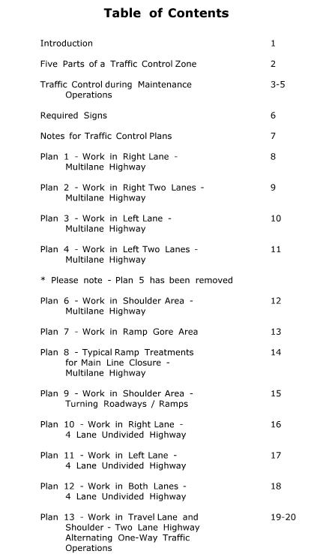
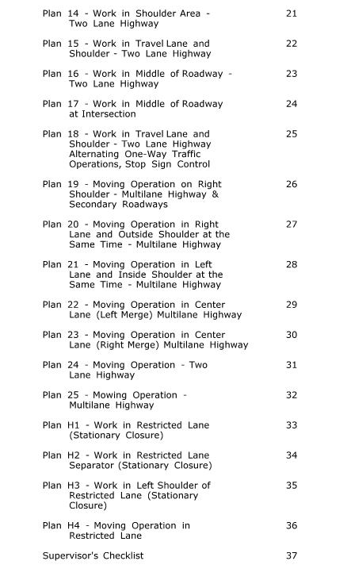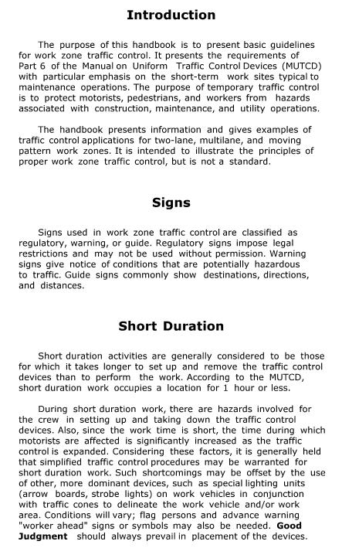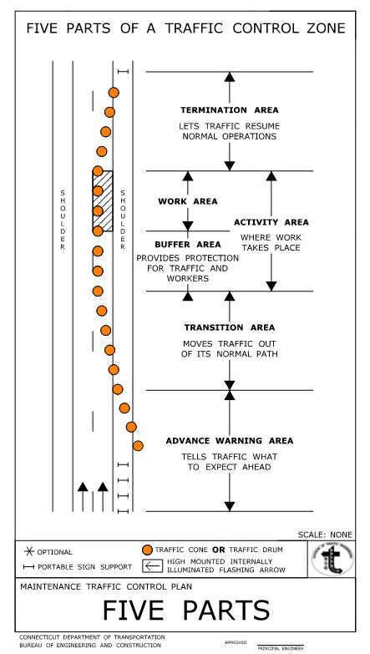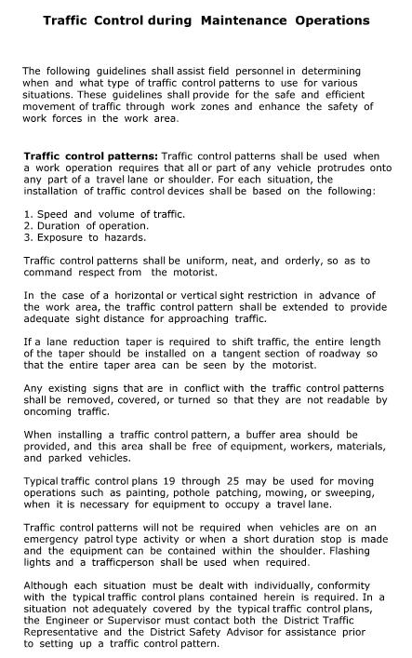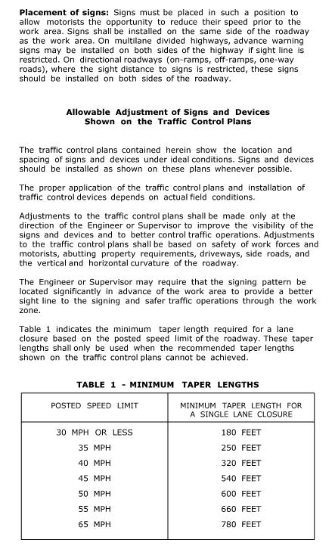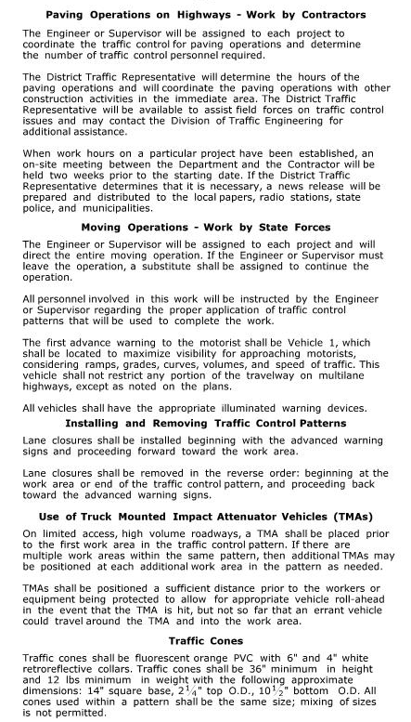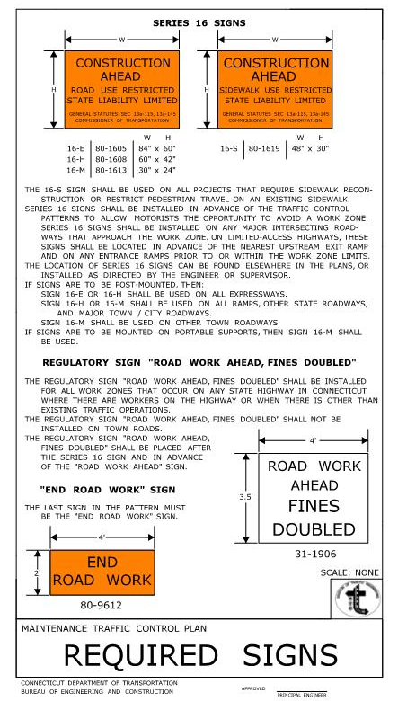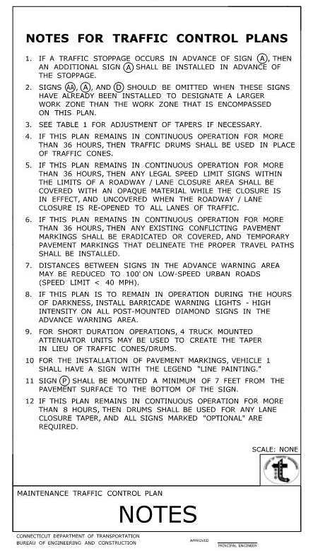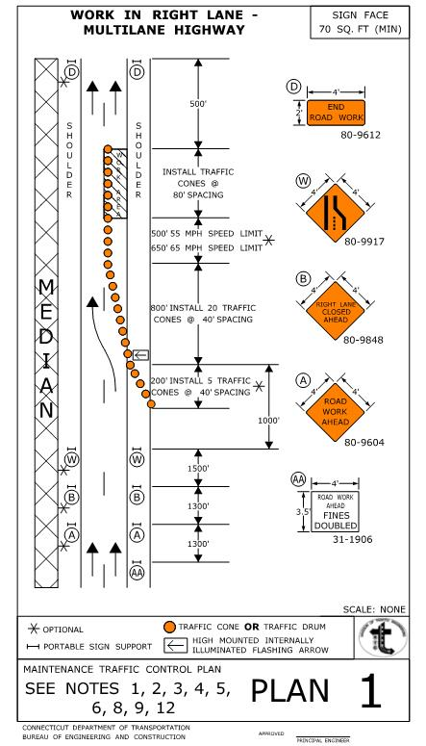
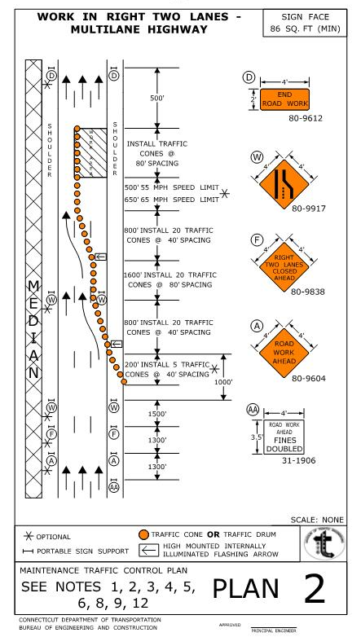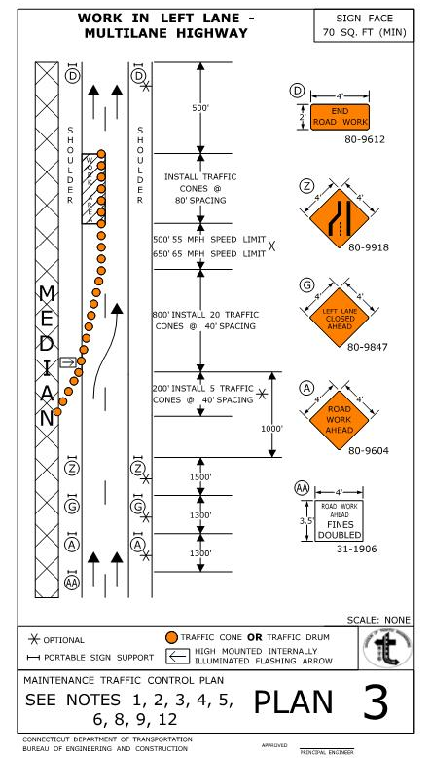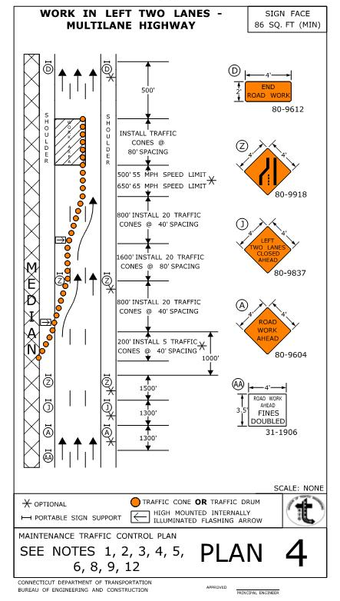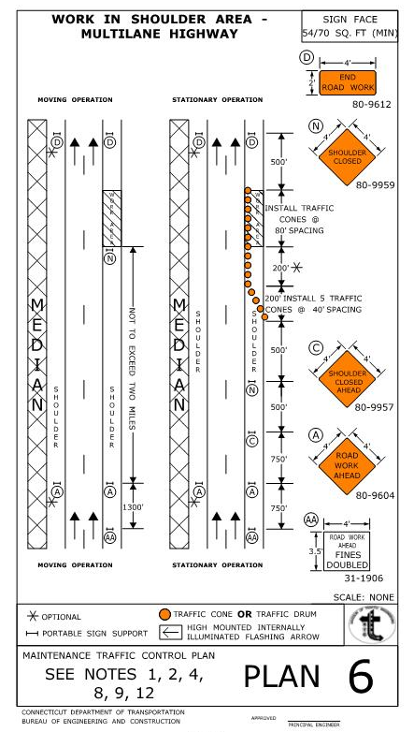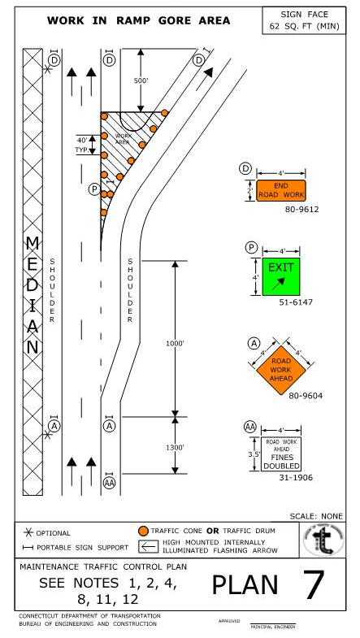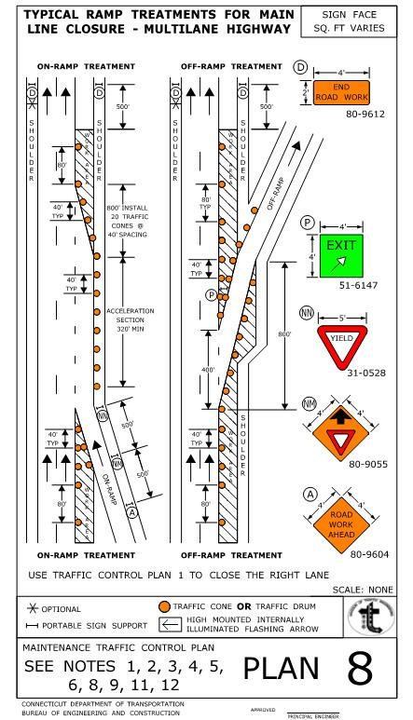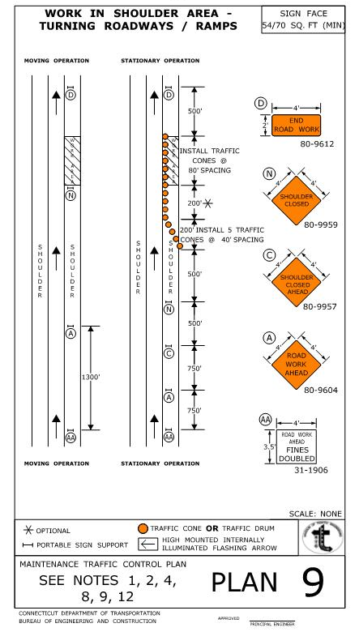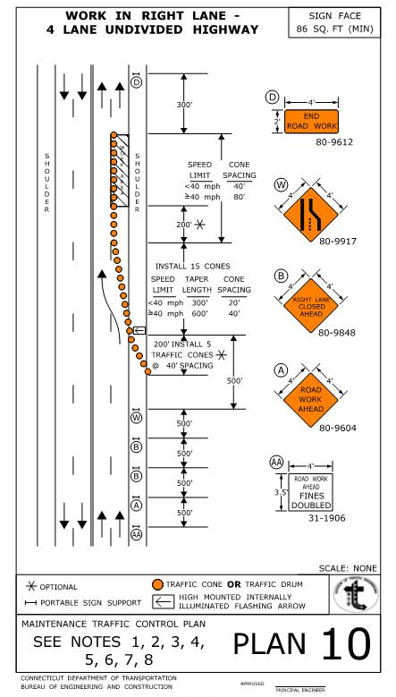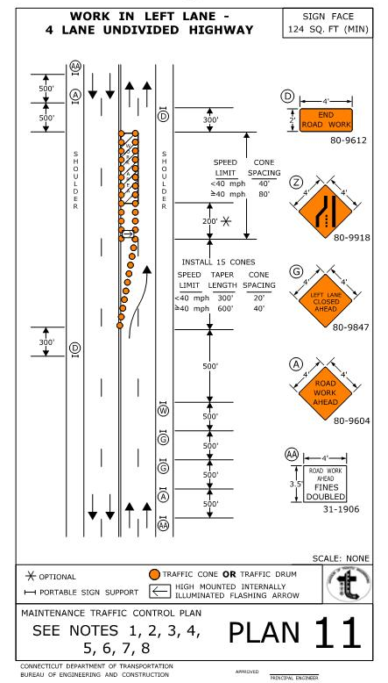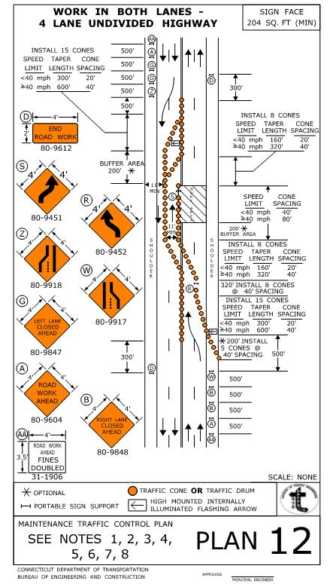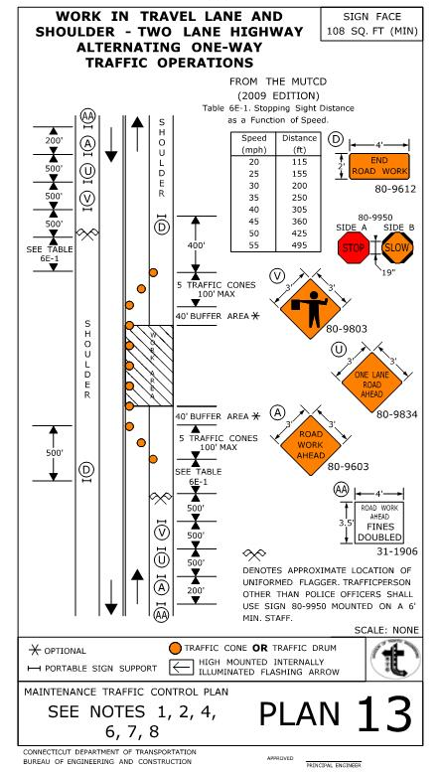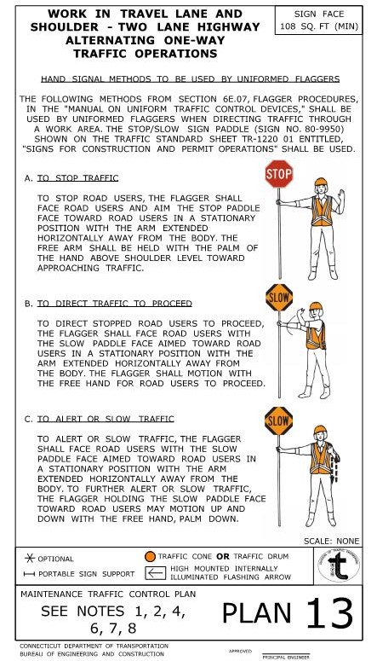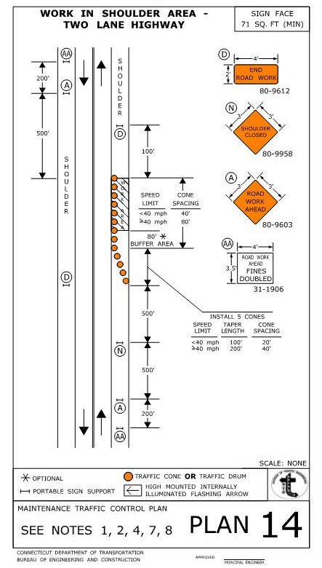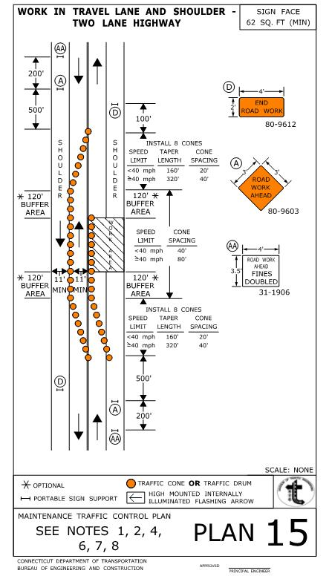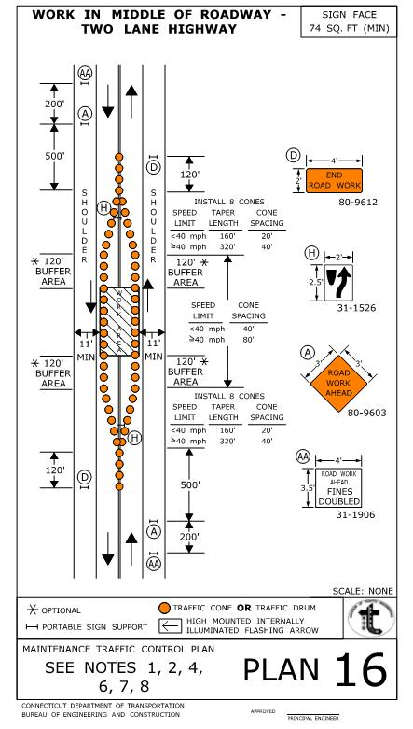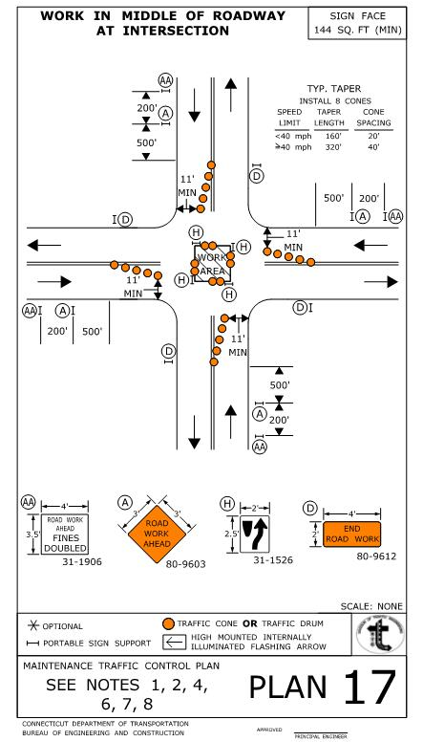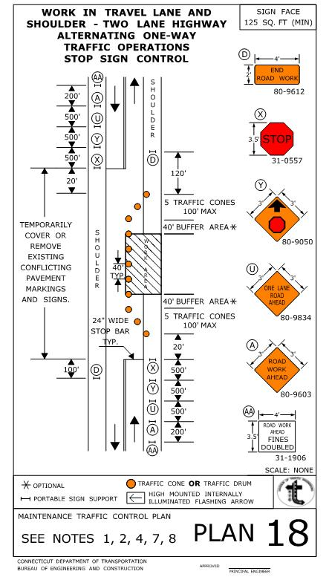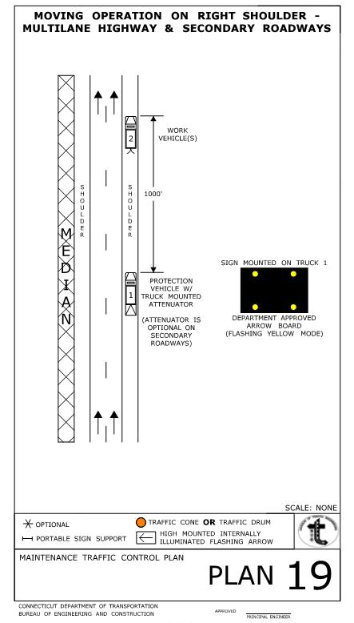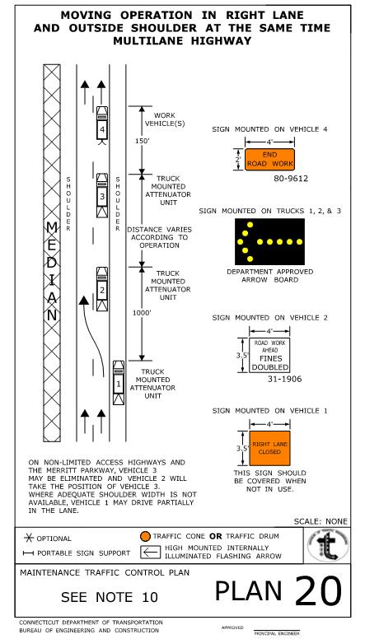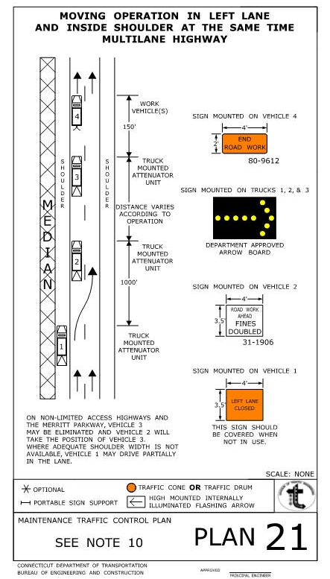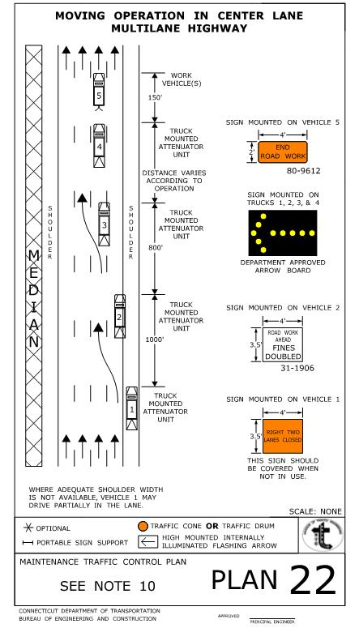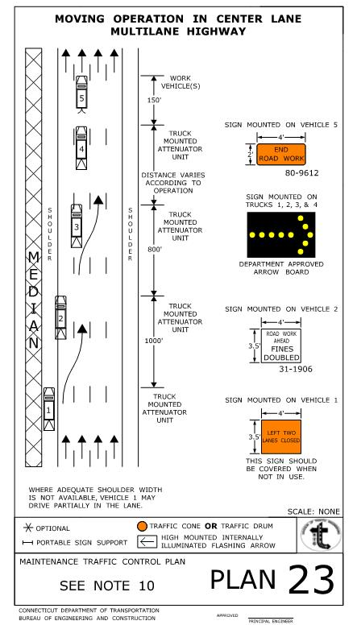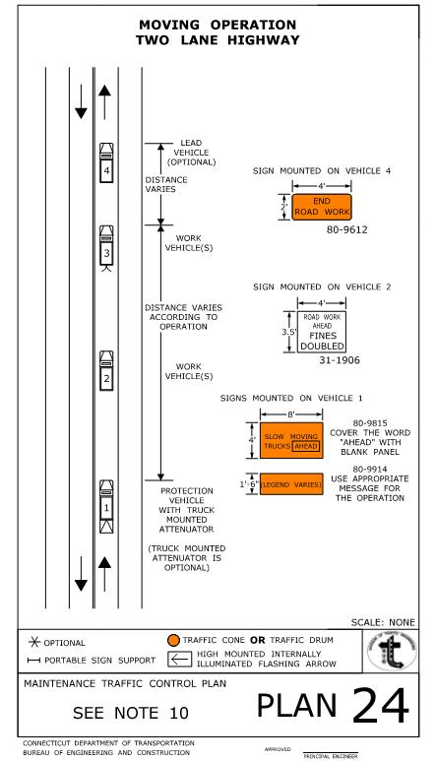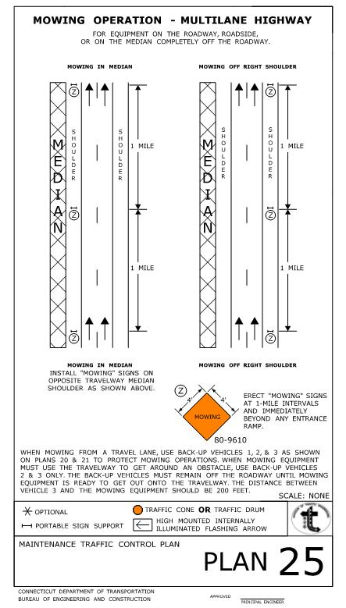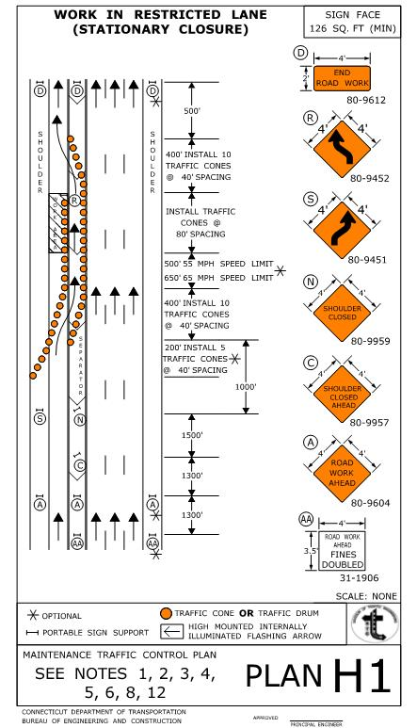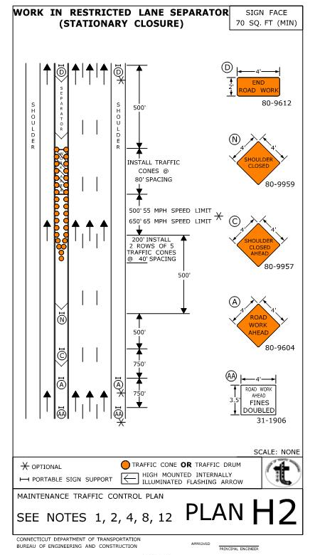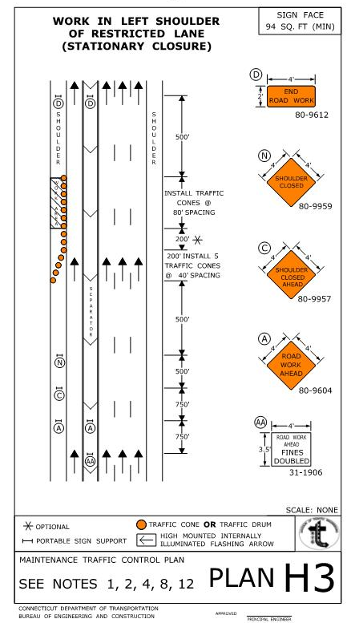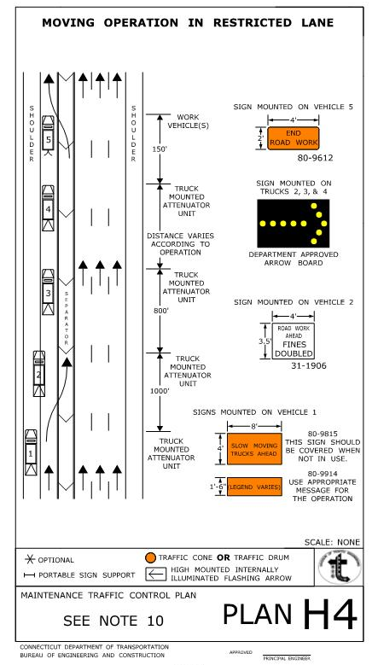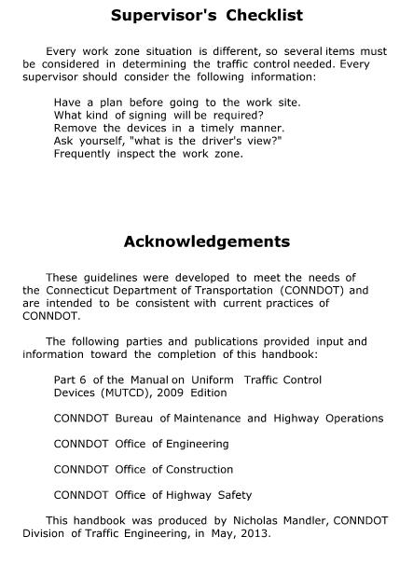

LIST OF ATTACHMENTS

Sample CDOT Boring Log

List Of Boring Contractors Interested In Submitting Bids

Sample CDOT Boring Log
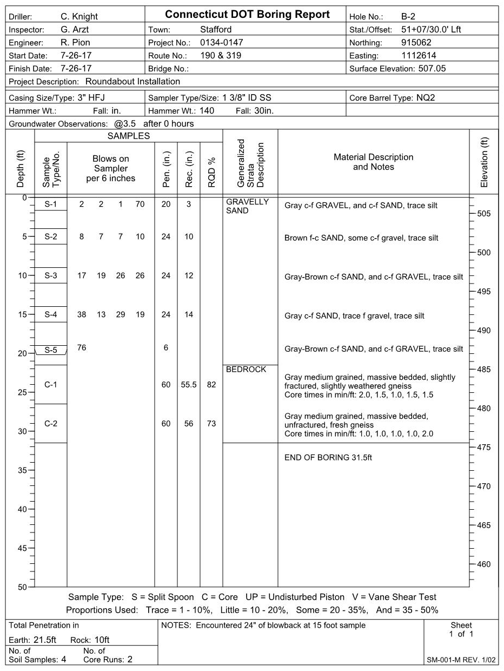
List of Boring Contractors
Who Are Interested In Submitting Bids
On Boring Work for CDOT Projects
(Revised Date 5/16/24)

Associated Borings Company, Inc.
119 Margaret Circle
Naugatuck, CT 06770
Contact Person: Jaime Lloret
E-mail: jlloret64@yahoo.com
203-729-5435

Atlantic Testing Laboratories, Limited
6431 U. S. Highway 11
P.O. Box 29
Canton, NY 13617-0029
Contact Person: Timothy Gavin or Aaron Woods
E-mail: TGavin@atlantictesting.com or AWoods@atlantictesting.com
315-386-4578

Clarence Welti Associates, Inc.
227 Williams Street
P.O. Box 397
Glastonbury, CT 06033
Contact Person: Max Welti
E-mail: mcwelti@weltiassoc.com
860-633-4623

Connecticut Test Borings, LLC
P.O. Box 776
Southbury, CT 06488
Contact Person: Christian DeAngelis or Steve White
E-mail: office@cttestborings.com
203-888-3857

General Borings, Inc.
201 Straightsville Road
Prospect, CT 06712 (Delivery)
P.O. Box 7135 (Mail)
Prospect, CT 06712
Contact Person: Daniel R. Tuccillo Jr.
E-mail: office@generalborings.com
203-758-5817

Hardiman Company & Associates, Inc.
10 Fox Hunt Road
Shelton, CT 06484
Contact Person: Tom Hardiman Jr.
E-mail: thomas.hardiman@snet.net
203-926-0106

New England Boring Contractors,
129 Krieger Lane
Glastonbury, CT 06033
Contact Person: Steve Preli
E-mail: steve.preli@NEboring.com
860-633-4649

Seaboard Drilling, LLC
649 Meadow Street
Chicopee, MA 01013
Contact Person: Mike Glynn or Eric Baron
E-mail: mike.glynn@seaboarddrilling.com or eric.baron@seaboarddrilling.com
1-800-595-1114 or 413-592-1114 or 860-847-1247

Soil X Corp
148 Pioneer Drive
Leominster, MA 01453
Contact Person: Severino Luna or Jacques Broulette
E-mail: luna@soilxcorp.com or Jacques@soilxcorp.com
978-840-0391

Soil Testing, Inc.
90 Donovan Road
Oxford, CT 06478
Contact Person: James DeAngelis
E-mail: james@soiltestinginc.net
203-262-9328

Terracon Consultants
201 Hammer Mill Road
Rocky Hill, CT 06067
Contact Person: Shawn Poff
E-mail: shawn.poff@terracon.com
860-929-7834

