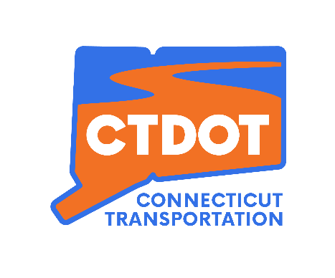
Section 5310 Program
FFY 2024 Grant Application Instructions

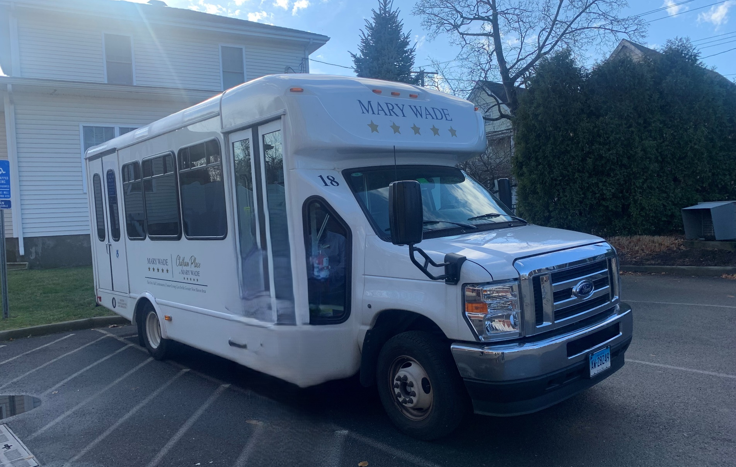
Picture goes in this square
Click here -> Shape Format -> Shape Fill -> Picture

January 2025

TABLE OF CONTENTS
Packet Overview 4
Authorizing Legislation 4
Section 5310 Program Overview 4
Eligible Recipients 4
Eligible Activities 4
Available Funding 5
Federal/Local Match Requirements 6
How to Fill Out the Application 6
How to Submit the Application 8
Section 5310 Application Guidelines – All Applicants 8
Section 5310 Application Guidelines – Applicants of Traditional Funding Only 9
Section 5310 Program Guidelines – Awarded Recipients 10
2024 Section 5310 Funding Cycle/Application Process Estimated Timeline 12
APPENDIX A – Definitions 13
APPENDIX B – Community-Based Transportation Planning 16
APPENDIX C – Coordinated Service 18
APPENDIX D – Estimating Costs of Providing Transportation Services 20
APPENDIX E – Evaluation Criteria 21
APPENDIX F – Vehicle Insurance 23
Appendix G – Regional Councils of Government 24
APPENDIX H – State of Connecticut Urbanized Areas Map 25
APPENDIX I – Approximate Vehicle Pricing & Specifications 26
APPENDIX J – Eligible Project Activities Detail 30
APPENDIX K – Traditional Applicant Public Notice Template 31
APPENDIX L – Traditional Notification to Transportation Operators Template 32

Packet Overview
This packet contains updated information about the Section 5310 program and instructions on how to complete the application for the 2024 cycle (using Federal Fiscal Year 2024 funds). It is for review and instruction only, and should not be submitted along with the application. Please contact the Connecticut Department of Transportation (CTDOT) with any questions: DOT.Section5310@ct.gov.

Authorizing Legislation

The Federal Transit Administration Circular C9070.1H incorporates provisions of the Infrastructure Investment and Jobs Act (IIJA: Pub. L. 117-58, signed into law on November 15, 2021. The legislation reauthorizes Surface Transportation Programs for Fiscal Year FFY 2022 through FFY 2026.

Section 5310 Program Overview
The Section 5310 program is intended to improve mobility for seniors and individuals with disabilities by removing barriers to transportation service and expanding transportation mobility options. This program supports transportation services planned, designed, and carried out to meet the special transportation needs of seniors and individuals with disabilities in all Urbanized Areas (UZAs) – large urbanized (over 200,000 people), small urbanized (50,000-200,000 people), and rural (under 50,000 people). Eligible projects include both traditional capital investment and nontraditional investment beyond the Americans with Disabilities Act (ADA) complementary paratransit services.

Eligible Recipients
Eligible subrecipients include:
- Private nonprofit organizations (NPOs)
- States or local government authorities
- Operators of public transportation

Eligible Activities
CTDOT must ensure that at least 55 percent of program funds are used on capital or “Traditional” 5310 projects.

- Traditional Section 5310 project examples include:
  - Accessible vehicles; wheelchair lifts, ramps, and securement devices; transit-related information technology systems including scheduling/routing/one-call systems; and mobility management programs.

  - Acquisition of transportation services under a contract, lease, or other arrangement. Both capital and operating costs associated with contracted service are eligible capital expenses.

Of the remaining 45 percent of program funds, up to 10% may be used by the State of Connecticut Department of Transportation (only) for State Administration. The rest can be dedicated to “Nontraditional” projects, which include public transportation services and alternatives beyond those required by the ADA, designed to assist individuals with disabilities and seniors. Nontraditional Section 5310 project examples include travel training, volunteer driver programs, taxi voucher programs to support rides in accessible taxis at half-fare and mobility management programs.
Appendix K contains additional detail on eligible Section 5310 project activities.

Available Funding
Based on Census data, the federal formula funds are apportioned to the State of Connecticut based on the number of older adults and individuals with disabilities and allocated by area.

Funds apportioned to large UZAs may not be transferred to other areas, though Small Urban UZA and Rural funds may be pooled together if all objectives in those regions are met, as approved by the Commissioner of CTDOT.

The table below shows the estimated amount of funding available to applicants for the 2024 cycle, itemized by region and project category. Please note figures may not add due to rounding.

URBANIZED AREA | 2024 FUNDING | TRADITIONAL MINIMUM | NONTRADITIONAL MAXIMUM | STATE ADMINISTRATION
Bridgeport/Stamford | $1,113,920 | $612,656 | $451,138 | $50,126
Hartford | $1,340,197 | $737,108 | $542,780 | $60,309
Springfield, MA | $100,053 | $55,029 | $40,521 | $4,502
New Haven | $784,242 | $431,333 | $317,618 | $35,291
Small Urban | $1,461,743 | $803,959 | $592,006 | $65,778
Rural | $553,862 | $304,624 | $224,314 | $24,924
Worcester, MA | $42,451 | $23,348 | $17,193 | $1,910
ESTIMATED TOTAL | $5,396,468 | $2,968,057 | $2,185,570 | $242,841

Estimated interstate split agreements with Springfield, MA and Worcester, MA, as well as estimated interstate funding obligations to New York 2024 Funding regional amounts are subject to change.

Federal/Local Match Requirements
Section 5310 funds may be used for capital and operating expenses.

Capital Projects - The federal share of Traditional vehicle costs in this application cycle is 80% with recipients responsible for a local match of not less than 20%. CTDOT may fund viable Nontraditional l vehicles as possible at 80% federal share. Mobility management projects and purchase of service projects are considered capital projects and are funded at 80% federal share.

Operating Projects - The federal share of eligible operating projects will not exceed 50%, with recipients responsible for a local or state match of 50%.

Service projects and Nontraditional capital projects -Will need to be acquired via a procurement process compliant with Federal Transit Administration (FTA) regulations https://www.transit.dot.gov/regulations-and-guidance/fta-circulars/third-party-contracting-guidance.

How to Fill Out the Application
Depending on the type of project your organization is requesting funding for, there are three (3) different Section 5310 applications that may be filled out and submitted: Traditional Section 5310, Nontraditional Section 5310 Capital, and Nontraditional Section 5310 Operating.

If your organization is requesting funding for multiple projects that fall into different categories, an application must be submitted for each type of project. The table below outlines the eligible project types and the corresponding application that should be filled out for each.

Application | Project Types | Maximum Federal Funding
Traditional 5310 Capital | This application should be filled out if your organization is a municipality or nonprofit organization requesting funding for:  - Accessible vehicles | 80%
Nontraditional 5310 Capital | This application should be filled out if your organization is a municipality, nonprofit organization or public transit operator requesting funding for:  - Equipment (i.e., hardware, etc.)  Or,  This application should be filled out by Transit District if your organization is Taxi operator. Taxi operators should partner with Transit District to request funding for:  - Accessible taxis | 80%
Section 5310 Operating | This application should be filled out if your organization is a municipality, nonprofit organization or public transit operator requesting funding for:  - Operating expenses  - Volunteer driver programs  - Supporting the administration and expenses related to voucher programs for transportation services offered by human service providers or taxi companies | 50%
Section 5310 Operating | This application should be filled out if your organization is a municipality or nonprofit organization requesting funding for:  - Mobility management programs  - Acquisition of transportation services under a contract (purchase of service). | 80%

How to Submit the Application

Applications must be sent to both CTDOT and the Regional Councils of Government (RCOG) no later than 4pm on Tuesday, April 1, 2025. Applications that are late, incomplete or from a prior year will not be reviewed.

The application and all supporting documentation should be submitted as a single attached file (PDF) via email only. Pages requiring signature should be printed, signed and then re-scanned into the application to form one (1) PDF file. The application must be submitted only once. Those applicants for whom this requirement causes undue hardship should contact CTDOT to discuss alternatives for submitting the application.

The application should be sent to the CTDOT email address included below. Appendix H contains a list of contact information and appropriate email addresses for each RCOG in the state.

CTDOT E-mail: DOT.Section5310@ct.gov

Section 5310 Application Guidelines – All Applicants

- Projects must be planned, designed, and carried out to meet the special transportation needs of seniors and individuals with disabilities.

- Projects must address a gap or a strategy identified in the Locally Coordinated Human Services Transportation Plan (LOCHSTP). A copy of the 2021 updated LOCHSTP, may be found here: https://portal.ct.gov/dot/-/media/dot/public-transportation/connecticutlochstpplan_12142021.pdf?rev=1fb03b493606435eb05db4bca4be3626&hash=EC3B4564A05ABCDF7215A73BDF57D17B

- Applicants may apply for funding for multiple project types using Traditional Capital, Nontraditional Capital and Operating applications. Different projects should be submitted on a separate application (i.e. do not combine mobility management with vouchers), in other words, only one project per application.

- Applications will be reviewed and prioritized for funding by CTDOT and the RCOGs utilizing a competitive selection process. CTDOT attempts to maximize funding of projects whenever possible.

- Applications must be completed in full; every question and section should be answered. If a particular question is not relevant to the applicant, the applicant should note that and explain why. “N/A” is never an appropriate response.

- All NPOs that submit an application must be registered with the Secretary of the State’s office.

- Applications must be submitted via email only as a single PDF. The application must be sent to CTDOT with a cc to the applicant’s local Regional Council of Governments. A list of RCOGs and their contact information is included in Appendix G.

- CTDOT’s criteria for evaluating the applications can be found in Appendix E.

- Each applicant must sign off on and acknowledge the Title VI compliance required of all organizations that receive a funding award.

Section 5310 Application Guidelines – Applicants of Traditional Funding Only

Replacement Vehicles

- In order to be eligible for replacement, a vehicle must have reached the end of its useful life prior to submittal of this application or the vehicle must have excessive maintenance costs that are documented and submitted with the application. Maintenance documentation should not be submitted if the vehicle being replaced has reached the end of its useful life (see Appendix A for Definitions). Vehicles to be replaced do not need to have been previously awarded under Section 5310.

- An applicant is not restricted to applying for a new (replacement) vehicle that conforms to the size and passenger capacity of the vehicle being replaced – the replacement may be a different size, a different type of vehicle or have different accessibility features than its predecessor.

- A recipient can continue to operate the vehicle that has met its useful life requirements, even if they have been awarded a new replacement vehicle for the same vehicle remaining in operation. The ‘replaced’ vehicle does not have to be taken out of service simply because funding for a new vehicle has been awarded.

- Once a recipient has been awarded a new (replacement) vehicle, the vehicle that met the useful life requirements and was ‘replaced’ may no longer be used as an eligible vehicle to be replaced in future Section 5310 applications.

Public Notice & Letters of Notification

- A Public Notice must be published (printed) in a major newspaper with the greatest appropriate readership in the proposed service area. The public notice must be published no later than Friday March 14, 2025. Any public notice that appears after this date will render the grant application incomplete and ineligible for CTDOT/RCOG review. Both a copy of the Public Notice and a copy of the paid invoice from the newspaper (tear sheet) must be submitted as part of the application packet. The Public Notice only needs to be published one (1) time. A template for the Public Notice can be found in Appendix K.

- Emails or letters of notification must be sent to private and paratransit operators in the proposed service area one (1) week before the Public Notice is placed in a major newspaper. Private transit and paratransit operators include taxi operators, public transit operators, providers of ADA paratransit service, nonprofit organizations that provide transportation, municipalities or public entities that provide transportation and livery operators. A template for the letters of notification to transportation operators can be found in Appendix L.

- Emails or letters of notification should be sent to all operators that provide transportation services within a 15-mile radius of the proposed service area. A copy of this email or letter as it was sent must be included with the application; CTDOT will not accept a listing of individuals to whom the letter was sent as sufficient confirmation. A minimum of five (5) emails or letters should be included in the application. CTDOT will accept less from applicants whose proposed service area is rural and/or has limited existing transportation options.

- Applicants that need assistance identifying transportation operators in their proposed service areas may contact their Regional Mobility Manager (RMM) or consult the United Way 211 (https://www.211ct.org).

Section 5310 Program Guidelines – Awarded Recipients

- Insurance requirements for vehicle grant or transportation service providers can be found in Appendix F.

- Recipients of Traditional vehicle funding are required to submit quarterly operating/maintenance reports on all vehicles during their useful life. Recipients of operating funding are required to submit an operations report on a monthly basis. The specific reporting requirements will be based on the project awarded.

- Recipients of Traditional vehicle funding are subject to oversight by CTDOT to ensure program compliance with federal regulations. This includes an annual Use of Project Equipment certification, monitoring of awarded recipients and site visits.

- Recipients may not initiate service or purchase vehicles or equipment without a fully executed agreement. CTDOT will send an agreement to be executed between the State and your organization upon acceptance of a grant award and fulfillment of Title VI requirements. CTDOT is not able to reimburse costs incurred prior to execution of the agreement.

- Donations may be collected from passengers riding a vehicle purchased with Section 5310 Traditional funding but recipients must not refuse a senior or individual with disability a ride if a passenger does not make a donation. Fares may not be charged to passengers riding a vehicle purchased with Section 5310 Traditional funding.

- For vehicles purchased with Section 5310 Traditional funding, CTDOT must be listed as first lien holder on the motor vehicle registration. Vehicle titles will be retained by CTDOT until the Recipient requests to dispose the vehicle and receives CTDOT’s approval. Vehicles must be registered in accordance with the rules and regulations of the CT Department of Motor Vehicles.

- The Connecticut Rural Transit Assistance Program (CTRTAP) offers a scholarship program which is available to Section 5310 recipients for the purpose of sending administrative staff, drivers and/or maintenance personnel to training events that are directly related to the operation and maintenance of Section 5310 vehicles and services. Scholarship funds are only available for the reimbursement of registration fees, travel/transportation, lodging and meals related to such training events, conferences and seminars, and may not exceed $1,000 per trip per individual. The scholarship application and requirements are available at the following website www.ctrtap.com.

FFY 2024 Section 5310 Funding Cycle/Application Process Estimated Timeline

APPENDIX A – Definitions

Americans with Disabilities Act (ADA): A wide-ranging civil rights law that prohibits discrimination based on disability and recognizes that people with disabilities have the same rights as other citizens to access services and facilities that are available to the public, including transportation.
Applicant: An entity that is seeking, but has not yet been awarded, Section 5310 funding.
Capital Asset: Facilities or equipment with a useful life of at least one year.
Capital Project: A category of reimbursable project expenses that includes all activities identified in 49 U.S.C. 5302(4) Eligible activities under this project category are outlined in this Application Instructions packet.
Coordinated Plan: See definition of LOCHSTP, below.

Disability: The term disability has the same meaning as in section 3(1) of the ADA. The term “disability” means, with respect to an individual—
(A) a physical or mental impairment that substantially limits one or more major life activities of such individual;
(B) a record of such an impairment; or
(C) being regarded as having such an impairment.

Grant: An award of financial assistance in the form of money, or property in lieu of money, by the State of Connecticut as received from the federal government.
Grant Application: A complete application for an award of financial assistance in the form of money, or property in lieu of money, by the State of Connecticut as received from the federal government.
Human Service Transportation: Transportation services provided by or on behalf of a human service agency to provide access to agency services and/or to meet the basic, day-to-day mobility needs of transportation-disadvantaged populations, especially individuals with disabilities, seniors, and people with low incomes.

Large Urbanized Area: An urbanized area (UZA) with a population of 200,000 or more individuals, as determined by the Bureau of the Census.
Limited English Proficient Individual: Individuals who do not speak English as their primary language and who have a limited ability to read, speak, write, or understand English. These individuals may be entitled language assistance with respect to a particular type of service, benefit, or encounter.

LOCHSTP (Locally Coordinated Public Transit Human Services Transportation Plan): A locally developed, coordinated transportation plan that identifies the transportation needs of individuals with disabilities, seniors and people with low incomes, provides strategies for meeting those needs, and prioritizes transportation services for funding and implementation.

Mobility Management: Consists of short-range planning and management activities and projects for improving coordination among public transportation and other transportation service providers.

Nonprofit Organization: A corporation or association determined by the Secretary of the Treasury to be an organization described by 26 U.S.C. 501(c) which is exempt from taxation under 26 U.S.C. 501(a) or one which has been determined under state law to be nonprofit and for which the State of Connecticut has received documentation certifying the status of the nonprofit organization.
Operating Expenses: Those costs necessary to operate, maintain, and manage a public transportation system. Operating expenses usually include such costs as driver salaries, fuel, etc.

Paratransit Service: In the context of this Application Instructions packet, a specialized, door-to-door transport service required under the ADA for people with disabilities who are not able to ride fixed-route public transportation.
Passenger Trip: A one-way passenger trip consists of transporting one individual from a pick-up point to his/her destination. When an individual boards and disembarks from the vehicle, it is counted as one (1) trip. (e.g. ten individuals transported to a medical site and returned to their homes would constitute twenty ‘one-way’ passenger trips).
Public Transportation: Regular, continuing shared-ride surface transportation services that are open to the general public or open to a segment of the general public defined by age, disability, or low income, and does not include: intercity passenger rail transportation provided by Amtrak, intercity bus service, charter bus service, school bus service, sightseeing service, courtesy shuttle service for patrons of one or more specific establishments, or intraterminal or intrafacility shuttle services.
Subrecipient: An applicant that receives funds under Section 5310 Program.
Rural Area: An area encompassing a population of fewer than 50,000 people that has not been designated in the most recent decennial census as an urbanized area by the Secretary of Commerce.
Seniors: An individual who is 65 years of age or older.
Small Urbanized Areas: A UZA with a population of at least but less than 200,000, as determined by the Bureau of the Census.
Useful Life (of a vehicle): Defined as 4 years of age or 100,000 miles for a van or mini-van and 5 years of age or 150,000 miles for a bus or mini-bus. In order for a vehicle to be eligible for replacement in the Section 5310 program, a vehicle must have met its useful life and your organization must have the title to the vehicle. The exception is if the vehicle has required excessive maintenance, in which case copies of the repair bills and letters that have been submitted to the vendor or original manufacturer must be submitted with the application.

APPENDIX B – Community-Based Transportation Planning

The Connecticut Department of Transportation and the Regional Councils of Government throughout the state have worked together on a community planning process for Federal Transit Administration (FTA)-funded transportation of older adults (65+), persons with disabilities and individuals with low incomes. The resulting plan helps determine how those funds will be spent in Connecticut and was developed through a process that includes representatives of public, private and nonprofit human services transportation providers and participation by the public.

Frequently Asked Questions

What is Human Services Transportation?
For the purposes of this planning effort, it is defined as transportation services for persons with disabilities, older adults (65+), and individuals with lower incomes. This could include services provided by public transit agencies, municipalities, human service agencies and private providers such as taxi or medical livery companies.

Why did we start doing community-based transportation planning?
The Moving Ahead for Progress in the 21st Century (MAP-21) was the authorizing legislation that preceded FAST Act and Bipartisan Infrastructure Law. It required that projects selected for funding under the Section 5310 program be “included in a locally developed, coordinated public transit-human services transportation plan” and that the plan be “developed and approved through a process that included participation by seniors, individuals with disabilities, representatives of public, private and nonprofit transportation and human services providers and other members of the public.” Community-based transportation planning continues to be a requirement under Bipartisan Infrastructure Law.

How much funding is there?
For the 2024 application cycle, estimated funding is as follows:

URBANIZED AREA | 2024 FUNDING
Bridgeport/Stamford | $1,113,920
Hartford | $1,340,197
Springfield, MA | $100,053
New Haven | $784,242
Small Urban | $1,461,743
Rural | $553,862
Worcester, MA | $42,451
ESTIMATED TOTAL | $5,396,468
What can the communities and the state do with these funds?
Support public transportation projects planned, designed, and carried out to meet the special needs of seniors and individuals with disabilities when public transportation is insufficient, inappropriate, or unavailable. Support public transportation projects that exceed the requirements of the ADA, Public transportation projects that improve access to fixed route service and decrease reliance by individuals with disabilities on complementary paratransit; and alternatives to public transportation that assist seniors and individuals with disabilities with transportation.

When did the planning process happen?
The first plan was in place in spring 2007, the first update was completed in 2009 and the latest in 2021.

Can I get involved? Why should I get involved now?
CTDOT works to identify existing gaps in transportation for seniors, people with disabilities and persons earning low-income, and devise strategies to address those gaps and improve coordination of services. Your organization represents the needs of the people it serves and can help make those needs a part of future program priorities by being involved.

How do I get involved?
Send an email to DOT.Section5310@ct.gov to express your interest in participating in the future round of coordinated planning.

Do I have to attend meetings to stay updated?
No. There are various ways to become involved, including taking a survey to provide input on transportation needs in your region.

APPENDIX C – Coordinated Service

CTDOT encourages Section 5310 applicants and recipients to coordinate with other local providers of transportation services, in order to enhance opportunities for cost-effective operations.

Coordination is equal parts cooperation, calculation, negotiation and flexibility, resulting in reduced costs and fewer headaches in providing needed transportation services for your clients. Above all, coordination begins with...."we."

How much coordination an organization wants depends on its organizational structure, its budget and the transportation needs of its clients.

Below are a few of the more common coordination approaches and definitions.

Ride Share:

Two or more separate agencies transporting to the same general vicinity alternate to pick up all clients in that area. Each agency retains management functions for vehicle operation, maintenance and administration of their own transportation system. Cost savings are realized from making fewer vehicle trips for the same number of passenger trips.

Vehicle/Time Share:

One agency allows another agency to use a vehicle during idle times on a cost reimbursement basis. The agency retains management functions for vehicle operations, maintenance and administration of the transportation system. Costs to the owner agency are reduced by the income received from sharing the vehicle with the other agency. The renting agency has fewer headaches since they won’t need to purchase and maintain their own vehicle.

Operations Coordination:

Two or more separate agencies combine or centralize all activities necessary to transport passengers (routing, scheduling, dispatching). Or, an agency contracts this function out to a specified transportation provider via a purchase of service agreement. Participating agencies retain management functions for maintenance and administration. Vehicle operations functions are delegated. Cost savings are realized either through increased productivity, which reduces cost per passenger, trip, a reduction in necessary staff positions or through the income received from the purchase of service agreement, depending on the type and extent of participation by the agency.

Maintenance Coordination:

Two or more separate agencies combine or centralize all or part of activities related to taking care of vehicles (maintenance, parts purchasing, vehicle storage). Or, an agency contracts this function out to a specified transportation provider. Participating agencies retain management functions for operations and administration and any portion of maintenance responsibilities retained. Cost savings result from pooling space requirements for storage and bulk purchasing of parts as well as possible reduction of staff positions.

Administrative Coordination:

Two or more separate agencies combine all activities related to ensuring that transportation is provided safely, reliably and efficiently under a single transportation manager, whose responsibilities include personnel (drivers, dispatchers), training, major purchases, or insurance. Or, an agency contracts this function out to a professional transportation manager or firm. Participating agencies may retain management functions related to operations and maintenance, although this approach is more successful when combined with operations and/or maintenance coordination.

Coordinated Transportation System:

Combining all the parts shown previously by contracting with a separate organization for the complete responsibility of providing transportation services. The terms, cost, accountability and reporting requirements are spelled out in a negotiated purchase of service agreement, which also can include management of a participating agency's vehicles. Savings include increased productivity, which reduces cost per trip, as well as reductions in costs for transportation staff, overhead, maintenance, insurance and many other areas.

Additional resources include the following:

National Aging & Disability Transportation Center
http://www.nadtc.org/resources-publications/2728/

Community Transportation Association of America
https://ctaa.org/resources/

Connecticut Association for Community Transportation
www.cact.info

Connecticut Rural Transit Assistance Program
www.ctrtap.org

APPENDIX D – Estimating Costs of Providing Transportation Services

A detailed cost analysis is not always necessary for determining how much and what type of coordination best meets the needs of your organization. Several basic formulas can provide enough information to decide how coordinating will save you money.

To calculate the cost per trip:

- Determine your organization’s annual expenses to provide transportation.
- Determine the annual number of passenger trips provided by your organization. A passenger trip is a one-way trip for one person from origin to destination.
- Divide the total annual expense by the annual number of passenger trips.

For example, if your agency provides 10,000 annual passenger trips at an annual cost of $40,000, you have a current cost of $4 per trip.

To determine a starting point for negotiating costs under a coordination agreement, your organization would want to back out unavoidable costs, such as a share of the agency insurance premium, or agency overhead. Assuming $2,000 of the total annual expense is unavoidable, a cost of up to $3.80 per trip could be negotiated without any change to your organization’s current budget. Purchasing services from a transportation provider frees an organization from responsibilities like routing, scheduling, maintenance, hiring drivers and other activities involved in operating a transportation system.

To calculate the cost per hour,
- Determine your organization’s annual expenses to provide transportation.
- Determine the annual number of vehicle hours needed to provide those trips. A vehicle hour is the sum of the hours when a vehicle is being used to transport clients, plus the hours when a vehicle is not carrying passengers but has a driver on duty.
- Divide the total annual expense by the number of vehicle hours.

As an example, an organization with a $40,000 annual cost and 2,000 vehicle hours required to provide 10,000 passenger trips would have a $20 cost per vehicle hour.

With coordination, the cost per hour would be offset by the increased use of the vehicle made possible by contracting the vehicle management to a transportation provider. Under the terms of a purchase of service agreement, the transportation provider could also be responsible for all the costs associated with providing a fully-trained driver. This is particularly attractive to organizations that utilize professional or para-professional staff to also perform the duties of a driver.

“Section 5310 Operating Application - Estimated Annual Statistics Worksheet” is provided with Application Materials. Please complete it and submit with your Operating Application.

APPENDIX E – Evaluation Criteria

Traditional Section 5310

Scoring Section | Criteria | Maximum Points
Legal Notice, Complete Application and Submission Deadline | Application must be submitted prior to the deadline, signed and completed entirely with one Legal Notice published within the required timeframe. Projects must fill a gap identified in the 2007, 2009 and 2021 LOCHSTP plans. | 15
Eligibility for Replacement & Service Initiation/Expansion | Vehicles proposed for replacement must be 4 years old for a van (mini-van) or have 100,000 miles, or 5 years old for a bus (mini-bus) or have 150,000 miles, or have documentation of excessive maintenance costs. Equal consideration will be given to applicants that do not have a vehicle to replace but are expanding service or starting a new service. | 5
Planning Process | Priority will be given to nonprofit organizations and local municipalities whose project serves the target group by limiting restrictions on access to service. Priority will be given to applicants that performed and demonstrated outreach to local transportation operators regarding their intent to apply for Section 5310 funding to obtain a vehicle. | 15
Limited English Proficiency | Priority will be given to applicants that indicate how people with Limited English Proficiency will be informed about the service. | 5
Utilization of Equipment | Effective utilization of the equipment should be demonstrated with reliable estimates of the number of individuals that will receive service, and the total number of passenger trips to be provided. Priority will be given to vehicles that will be utilized evenings, weekends, out of region, more than six hours per day, serve a large service area and/or are available for off-peak use by another organization. | 20
Degree of Need (in the Applicant's Proposed Service Area for Transportation Services) | Priority will be given to applicants that clearly explain the lack of accessible transportation through existing public and private transportation providers. | 10
Coordination | Priority will be given to applicants that propose to coordinate with another municipality or nonprofit organization to provide service and note how other sources of funding or grants complement the request for vehicle funding. | 15
Transportation Budget | Priority will be given to applicants that indicate they have sufficient operating income to cover estimated operating expenses and include a vehicle total within the estimated price range for the vehicle classification requested. | 15
 |  | 100
Nontraditional Section 5310

The proposed strategy must:

- Serve the target population categories and address an identified gap.
- Achieve efficiency in service delivery.
- Not replace other funding programs or resources.
  - If the strategy has been funded in prior years by a different resource, in order to be eligible for FTA funding programs, the strategy must have been rejected for future funds or had funding for the specific strategy reduced.
- Be able to start up in a reasonable period of time.
- Provide regional/geographical equity.
  - Each community should be able to share in the benefits from these funds.
- Maximize the use of available local, state and federal-funded public transportation resources.
  - This will allow CTDOT to make use of resources already in place and will prevent the creation of a secondary layer of services.
- Be subcontracted with a subrecipient that has the technical and managerial capabilities to conduct the project.
- Have appropriate resources available to provide the service.
  - This would include wheelchair accessible vehicles, and could possibly include resources such as dispatch capabilities or other resources as determined by the strategy.
- Have an adequate plan to make the target population aware of the available service.
- Demonstrate adequate ability and oversight of the operation of the service, including historical record keeping and proficiency with invoicing where applicable.

To receive “extra points”, the proposed strategy must:

- Provide continued operating funding for a service which is already in operation
- Provide a service where or when no other service is available
- Have matching funding available from sources other than CTDOT
- Coordinate with other public and private programs to maximize resources.
- Attain any other regionally determined productivity measures.

APPENDIX F – Vehicle Insurance

Vehicle grantees must include the State of Connecticut as an additional insured on coverage. The “Acord” Certificate of Liability Insurance form must state: “The State of Connecticut is named as an additional insured as required by written contract” in the Description of Operations/Locations/Vehicles section. The following requirement will be included in the agreement between the State of Connecticut and applicants selected for funding.

Commercial General Liability Insurance, including Contractual Liability Insurance, providing for a total limit of not less than One Million Dollars ($1,000,000) single limit for all damages arising out of bodily injuries to or death of all persons in any one accident or occurrence, and for all damages arising out of injury to or destruction of property in any one accident or occurrence, and, subject to that limit per accident or occurrence, a total (or aggregate) limit must be at least Two Million Dollars ($2,000,000) for all damages arising out of bodily injuries to or death of all persons in all accidents or occurrences and out of injury to or destruction of property during the policy period.

Automobile Liability Insurance providing for a total limit of not less than (a) One Million Dollars ($1,000,000) for vehicles with a seating capacity of ten (10) or less passengers, (b) One Million Five Hundred Thousand Dollars ($1,500,000) for vehicles with a seating capacity of eleven (11) through fourteen (14) passengers, and (c) Five Million Dollars ($5,000,000) for vehicles with a seating capacity of fifteen (15) or more passengers, for all damages arising out of bodily injuries to or death of all persons in any one accident or occurrence, and for all damages arising out of injury to or destruction of property in any one accident or occurrence.

Workers’ Compensation Insurance and, as applicable, insurance required in accordance with the U.S. Longshore and Harbor Workers’ Compensation Act, in accordance with the requirements of the laws of the State of Connecticut and the laws of the United States, respectively.

Umbrella Liability, providing for a total limit of not less than Three Million Dollars ($3,000,000) per occurrence, following form coverage, excess of underlying Commercial General Liability, Automobile Liability and Employer’s Liability policies.

Appendix G – Regional Councils of Government

Regional Councils of Government | Address | Website | Section 5310 Contact | Telephone | Contact Email:
Capitol Region Council of Governments (CRCOG) | 241 Main Street, 4th Floor Hartford, CT 06106-5310 | www.crcog.org | Cara Radzins  Dagmar Noll  Chris Seeger | 860-724-4251  860-724-4321  860-488-0692 | cradzins@crcog.org  dnoll@crcog.org  cseeger@crcog.org
Connecticut Metropolitan Council of Governments (Metro COG) | 1000 Lafayette Boulevard, Suite 925 Bridgeport, CT 06604 | www.ctmetro.org | Devin Clarke | 203-366-5405 x. 21 | dclarke@ctmetro.org
Lower CT River Valley Council of Governments | 145 Dennison Road Essex, CT 06426 | www.rivercog.org | Robert Haramut | 860-581-8554 x. 708 | rharamut@rivercog.org
Naugatuck Valley Council of Governments | 49 Leavenworth Street, Suite 303 Waterbury, CT 06702 | www.nvcogct.gov | Richard Donovan | 203-489-0361 | rdonovan@nvcogct.gov
Northeastern CT Council of Governments | 125 Putnam Pike Dayville, CT 06241 | www.neccog.org | Jim Rivers | 860-774-1253 x. 14 | Jim.rivers@neccog.org
Northwest Hills Council of Governments | 59 Torrington Road, Suite A-1, Goshen, CT 06756 | www.northwesthillscog.org | Robert Phillips | 860-491-9884 | rphillips@northwesthillscog.org
South Central Regional Council of Governments | 127 Washington Avenue 4th Floor West, North Haven, CT 06473 | www.scrcog.org | James Rode | 203-466-8623 | jrode@scrcog.org
Southeastern CT Council of Governments | 5 Connecticut Ave, Norwich, CT 06360 | www.seccog.org | Kate Rattan | 860-889-2324 x. 111 | krattan@seccog.org
Western CT Council of Governments | 1 Riverside Rd. Sandy Hook, CT 06482 | www.westcog.org | Kristin Hadjstylianos | 475-323-2073 | khadjstylianos@westcog.org

APPENDIX H – State of Connecticut Urbanized Areas Map
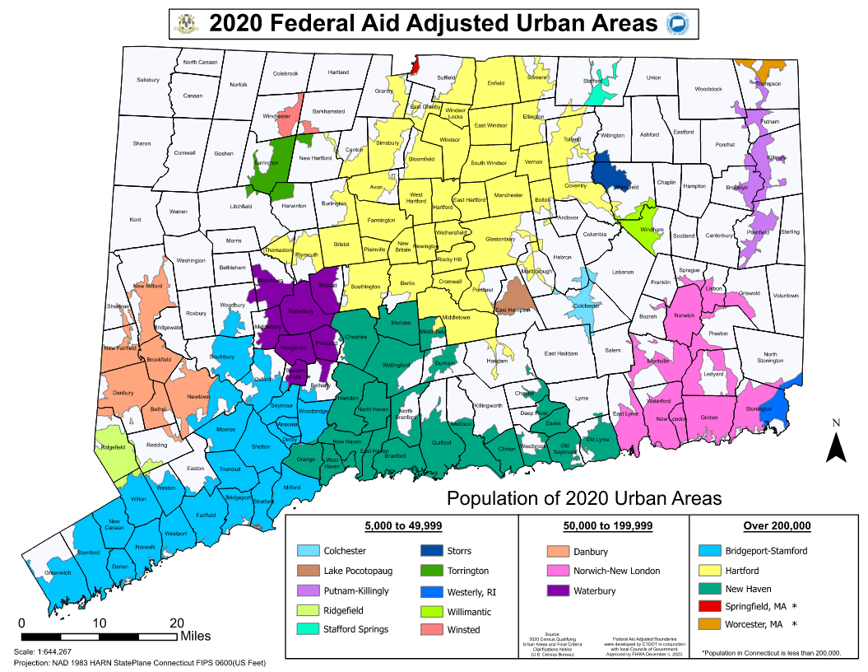

APPENDIX I – Approximate Vehicle Pricing & Specifications

Please note that the prices listed below are estimates and are subject to change.

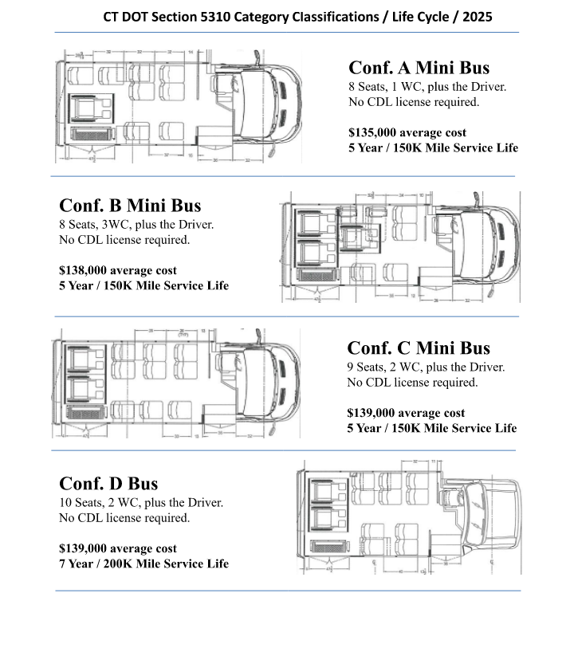

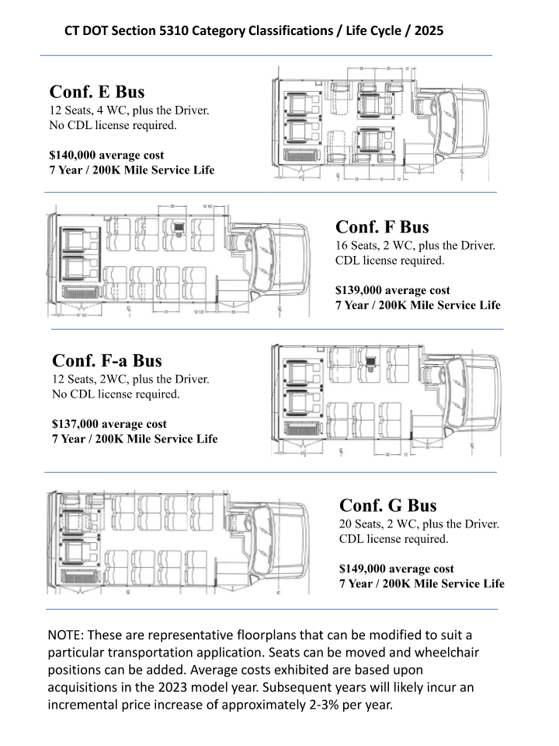

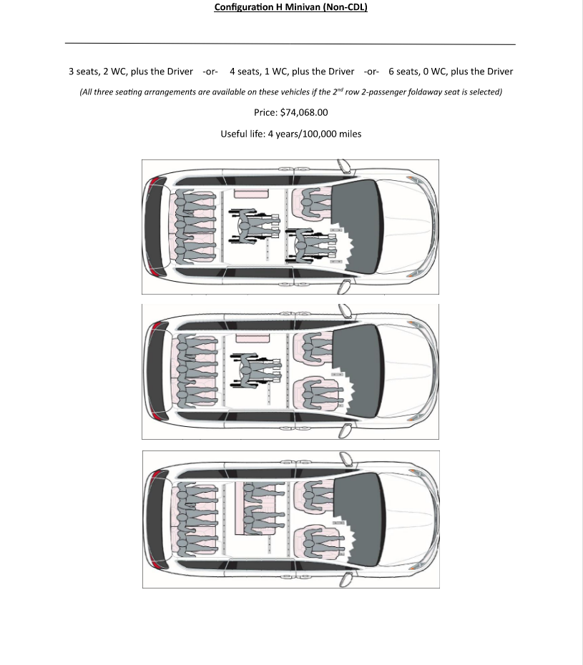

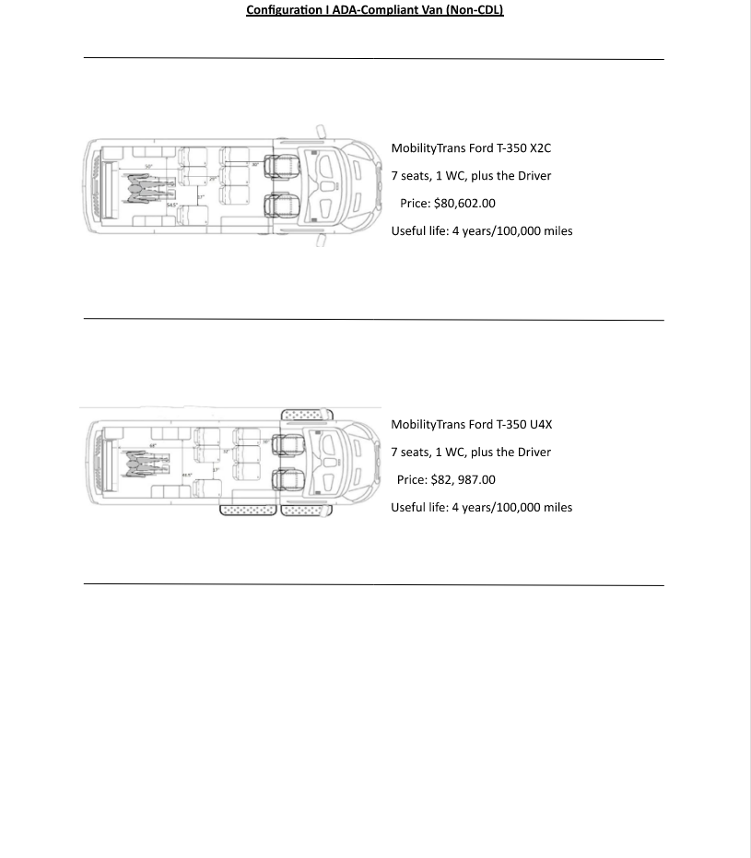

APPENDIX J – Eligible Project Activities Detail

Additional detail regarding eligible project activities may be found in the FTA Section 5310 program guidance, Circular 9070.1H.

Enhanced Mobility of Seniors and Individuals with Disabilities Program Guidance | FTA

APPENDIX K – Traditional Applicant Public Notice Template

A public notice must be published (printed) in a major newspaper with the greatest appropriate readership in the proposed service area no later than March 14, 2025. Any public notice that appears after this date will render the grant application incomplete and ineligible for CTDOT/RCOG review. Both a copy of the public notice and a copy of the paid invoice from the newspaper (tear sheet) must be attached to this application.

References in parentheses () should be changed to reflect the information applicable to your organization and the proposed service.

The notice should be consistent with the following format:

Public Notice to Transportation Operators

(Name of Your Organization) is applying for a capital grant under Section 5310 Enhanced Mobility of Seniors and Individuals with Disabilities of the Federal Transit Act, as amended by the Bipartisan Infrastructure Law legislation, to (replace/acquire) vehicles to be used in meeting the special transportation needs of seniors and/or individuals with disabilities in the (geographic area to be served).

Any interested transit or paratransit operator in the proposed service area may review the proposed application by contacting (Name, Address, and Phone Number of person in your organization to be contacted).

A public hearing will be held if requested by interested parties.

Any comments should then be sent to (Name of your Organization) with a copy to the (Regional Council of Governments). Comments must be received no later than seven (7) days following publication of the Legal Notice.

APPENDIX L – Traditional Notification to Transportation Operators Template

Below is a sample letter of notification that should be sent to transportation operators in your organization’s proposed service area at least one (1) week before the Public Notice is placed in a major newspaper. An email may be sent in place of a letter. A copy of the email or letter as it was sent must be included with your application; CTDOT will not accept a listing of individuals to whom the letter was sent as sufficient confirmation.

Transportation operators include taxi operators; public transit operators; providers of ADA paratransit service; nonprofit organizations that provide transportation; municipalities, senior centers or public entities that provide transportation; and livery operators.

Letters of notification should be sent to all operators that provide transportation services within a 5-15 mile radius of your proposed service area. CTDOT would like to see a minimum of five (5) copies of emails or letters included in the application but recognizes rural areas and/or those with limited existing transportation options may have less.

If your organization needs help finding information on the transportation services available in your proposed service area, please consult the United Way 211 (https://www.211ct.org) and/or your local mobility manager.
------------------------------------------------------------------------------------
Date

Private Transit and
Paratransit Operators
Proposed Service Area, CT

To Whom It May Concern:

I have enclosed a copy of the legal notice that will appear on (date) in the (major newspaper in proposed service area).

Please email or call me if you have any questions.

Very truly yours,

Executive Director/Authorized Official
Private Nonprofit Organization/ Public Body

Enclosure

