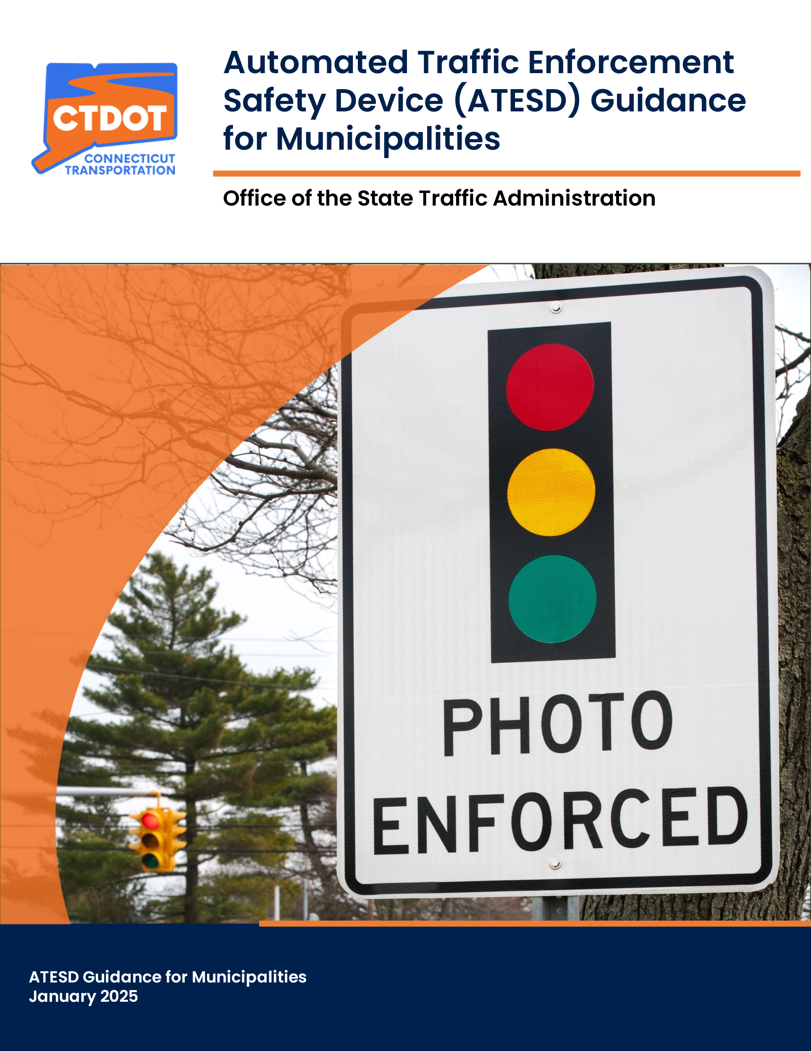
Table of Contents
INTRODUCTION 1
PURPOSE 2
1. LOCATION SELECTION AND JUSTIFICATION 3
1.1. FACTORS TO BE CONSIDERED BY THE MUNCIPALITY 3
1.2. REQUIREMENTS FOR ALL LOCATIONS 4
1.3. REQUIREMENTS BY LOCATION TYPE 4
1.4. LIMITATIONS ON THE PLACEMENT OF ATESDS IN OR ADJACENT TO ECONOMICALLY DISADVANTAGED COMMUNITIES 8
2. ADDITIONAL REQUIREMENTS 9
3. SUBMISSION AND APPROVAL 10
3.1. SUBMISSON 10
3.2. REVIEW AND APPROVAL PROCESS 10
4. DURATION OF THE ATESD PLAN APPROVAL 11
5. REPORTING 11
5.1 INITIAL REPORT 11
5.2 SUBSEQUENT ANNUAL REPORTS 12
5.3 COMPLIANCE WITH REPORTING REQUIREMENTS 13
6. MODEL PRIVACY POLICY AND PROTOCOL 13
7. NOTIFICATION TO OPERATORS OF NAVIGATION APPLICATIONS 14
APPENDIX 16
ATTACHMENT A (REQUIRED SIGNAGE) 16

INTRODUCTION
Public 23-116, which has been codified under Sections 14-307b through 14-307h of the General Statutes of Connecticut (Statutes), authorizes municipalities to use automated traffic enforcement safety devices (ATESDs) at locations within school zones, pedestrian safety zones, and other locations in such municipality pursuant to (1) an ordinance adopted by the municipality in accordance with the Statute’s requirements and (2) a plan approved every three years by CTDOT. The Statutes define an “automated traffic enforcement safety device” as a device designed to detect and collect evidence of alleged violations of the ordinance by recording images that capture the license plate, date, time, and location of a vehicle that (1) exceeds the posted speed limit by 10 or more miles per hour or (2) runs a red light.
The Statutes further requires CTDOT to develop, and revise as necessary, two sets of guidance for municipalities developing ATESD plans and seeking CTDOT approval. The first set of guidance covers initial ATESD plan development and submission and the criteria CTDOT will use when evaluating plans submitted for approval. The Statutes require this guidance be consistent with the goals of (1) installing ATESDs in locations where they are likely to improve traffic safety and (2) ensuring that the ATESD distribution throughout the municipality is equitable. (Under the Statutes, “equitable” means intended to ensure that patterns of discrimination and disparities of race, ethnicity, and socioeconomic status, whether intentional or unintentional, are not reinforced or perpetuated and prevent the emergence and persistence of foreseeable future patterns of discrimination or disparities of race, ethnicity, and socioeconomic status.)
The second set of guidance, which will be issued by CTDOT by January 1, 2026, must instruct municipalities on evaluating ATESD effectiveness and submitting subsequent plans for approval.
Note: ATESDs cannot be installed until the municipality’s ATESD plan has been approved by CTDOT’s Office of the State Traffic Administration (OSTA) and the municipality has met all other requirements in the Statutes.

PURPOSE
As required by CGS Section 14-307d, this guidance addresses ATESD plan development and submission and the criteria CTDOT will use when evaluating ATESD plans for approval. The guidance also restates other requirements of the Statutes which relate to CTDOT. A Public Act summary, which includes all of the requirements for municipal use of ATESDs, is available here. This guidance document provides information on the following:
- The factors a municipality must consider when selecting potential ATESD locations.
- Documentation municipalities must submit to CTDOT to demonstrate that the selected locations will improve safety.
- Limitations on the placement of ATESDs in economically disadvantaged communities.
- The process for municipalities to submit the ATESD plan to CTDOT.
- The OSTA’s review and approval process for the ATESD plan, including the criteria to be used by the OSTA when evaluating the plan for approval.
- Duration of the ATESD plan approval.
- Reporting requirements, as required by the Statutes.
- A model privacy policy and protocol, as required under the Statutes, regarding the privacy, security, collection, and destruction of personally identifiable information and other data gathered from ATESDs.
- The process by which municipalities should notify the persons, firms, or corporations designated by CTDOT that operate a mobile application that is used for navigation purposes or real-time information on motor vehicle traffic regarding an active ATESD.

1. LOCATION SELECTION AND JUSTIFICATION
CTDOT recommends the Automobile Association of America’s “Automated Enforcement Program Checklist” to assist municipalities in following best practices when developing a plan to install and use ATESDs.

1.1. FACTORS TO BE CONSIDERED BY THE MUNCIPALITY
A municipal plan proposing the use of ATESDs must identify the proposed location(s) of such devices. When selecting a location for an ATESD, the municipality must, at a minimum, consider the factors below, which are enumerated in CGS Section 14-307d. When preparing the written justification explaining how and why an ATESD was selected for installation at each location the municipality should document how these factors were considered:
- The history of traffic crashes caused by speeding or failing to obey a traffic control sign or signal at the location and the history of traffic crashes that resulted in a person’s death or serious injury at the location. CTDOT recommends that municipalities use data from the CT Red Light Intersection Evaluation Tool (CT-REDV) and/or review three years of crash data from the Connecticut Crash Data Repository.
- The average daily traffic (ADT) at the location. Resources for ADT data include Traffic Monitoring Station Viewer and machine counts taken by the municipality. The CT Training and Technical Assistance Center at UCONN has manual traffic counters available for loan to municipalities.
- The history of traffic stops conducted in the municipality and reported to the Office of Policy and Management under the Alvin W. Penn Racial Profiling Prohibition Act (CGS Sections 54-1l and 54-1m).
- The municipality’s poverty rate and the percent of occupied housing units with vehicles, as determined by the five-year estimates of the U.S. Census Bureau’s most recent American Community Survey.
- The location’s roadway geometry.

1.2. REQUIREMENTS FOR ALL LOCATIONS
The municipality must include the following in the ATESD plan submitted to the OSTA for all potential ATESD locations:
- A written justification, with supporting documentation, explaining how and why an ATESD was selected for installation at each location.

- A scaled roadway plan or an aerial image showing the location for the ATESD at a traffic control signal, School Zone, Pedestrian Safety Zone, or other location(s). The plan or aerial image must also show the proposed location and sign description of the required two conspicuous signs to be installed on every approach at a reasonable distance in advance of the ATESD. See Attachment A for the details regarding the required signs. Such required conspicuous signs are only permitted to be installed at locations where the ATESD is currently operational.
NOTE: A single ATESD location may consist of multiple devices on multiple approaches to properly capture images of license plates at that location.

1.3. REQUIREMENTS BY LOCATION TYPE

1.3.1. Traffic Control Signals
- If a municipality intends to install an ATESD at a traffic control signal, the submitted ATESD plan must include a traffic signal control plan showing the roadway geometry, phasing/sequence, and timing for an ATESD at a traffic control signal(s).
- At locations where the CTDOT owns the traffic control signal, a copy of the current plan of record can be requested via email at DOT.TrafficEngineering@ct.gov.
- At locations where the municipality owns and maintains the traffic control signal, the municipality must submit a copy of the current plan of record.
- The following conditions must be met for the OSTA to approve an ATESD at a traffic control signal:
- There are at least two crashes, over a three-year period, where an operator failed to stop at a red traffic signal indication. Municipalities are encouraged to use the CT Red Light Intersection Evaluation Tool (CT-REDV) which displays the number and location of red-light running crashes.
  - The location selected for an ATESD must appear on the list of intersections from the CT-REDV tool. In cases where there are numerous intersections involving operators running a red light, municipalities are encouraged to select intersection(s) where other countermeasures have already been implemented but have not been effective. Such countermeasures include, but are not limited to, increasing size of the signal indications from 8 inches to 12 inches, optimization of the traffic signal clearance intervals, use of LED lamps, use of signal backplates with retroreflective borders, trimming of vegetation that obstruct the view of the signals, coordination with adjacent traffic signals.
  - Traffic control signals that were recently upgraded within the last 12 months or scheduled to be upgraded within the next 12 months are not good candidates for an ATESD since the crash history associated with the location may not reflect current conditions.
- The most recent traffic control signal plan of record for the location has been approved by the OSTA. Note: Under CGS Section 14-299, all revisions to municipally owned traffic control signals must be reviewed and approved by the OSTA prior to implementation.
- For municipally owned traffic signals, the traffic signal change intervals (e.g. yellow/red/pedestrian clearance timings) must have already been optimized in accordance with Chapter 6 in CTDOT’s Traffic Control Signal Design Manual: State-owned traffic signals have already been optimized.
- The written justification required in Section 1.2 demonstrating that an ATESD will improve safety at that location. At a minimum, the written justification should include an explanation regarding how all the required elements in Section 1.1 were considered and how selected intersections were prioritized in cases where there are numerous intersections involving red-light running crashes.

1.3.2. School Zones
The following conditions must be met for the OSTA to approve an ATESD in a school zone:
- The location meets the definition of a school zone pursuant to CGS 14-212b.
- The school zone has been approved by the appropriate statutory authority – either the OSTA or the Local Traffic Authority.
- The school zone signage is consistent with Federal Highway Administration’s Manual on Uniform Traffic Control Devices (MUTCD).
- The written justification required in Section 1.2 demonstrating that an ATESD will improve safety at that location. At a minimum, the written justification should include an explanation regarding how all the required elements in Section 1.1 were considered. Additional information, if available, may include recommendations from a Road Safety Assessment (RSA), findings from a speed study, and how other speed reduction measures are not feasible or have not been effective.

1.3.3. Pedestrian Safety Zones
The following conditions must be met for the OSTA to approve an ATESD in a pedestrian safety zone:
- The location(s) meets the definition of a pedestrian safety zone pursuant to CGS 14-307a;
- The Pedestrian Safety Zone has been approved or established as such by the appropriate statutory authority – either the OSTA or the Local Traffic Authority.
- The Pedestrian Safety Zone signage is consistent with the MUTCD.
- The written justification required in Section 1.2 demonstrating that an ATESD will improve safety at that location. At a minimum, the written justification should include an explanation regarding how all the required elements in Section 1.1 were considered. Additional information, if available, may include recommendations from an RSA, findings from a speed study, and how other speed reduction measures are not feasible or have not been effective.

1.3.4. Other Locations
The following conditions must be met for the OSTA to approve an ATESD in other location(s):
- Other locations include, but are not limited to, roadways adjacent to central business districts, community centers, public parks, and hospitals. The length of the segment of roadway for this location type should not exceed 0.50 miles.
- The location or roadway segment has a history of speed related crashes or speeding violations.
- The written justification required in Section 1.2 demonstrates that an ATESD will improve safety at that location. At a minimum, the written justification should include an explanation regarding how all the required elements in Section 1.1 were considered. Additional information, if available, may include recommendations from an RSA, findings from a speed study, and how other speed reduction measures are not feasible or have not been effective.

1.4. LIMITATIONS ON THE PLACEMENT OF ATESDS IN OR ADJACENT TO ECONOMICALLY DISADVANTAGED COMMUNITIES
- To ensure that the ATESD distribution throughout a municipality is equitable as defined in CGS Section 14-307d, CTDOT will not approve more than two ATESD locations within a Qualified Census Tract (QCT) as designated by the United States Department of Housing and Urban Development. Additionally, CTDOT will not approve more than one ATESD location within a QCT that is a quarter of a square mile or less in size. Click here for a map showing the QCTs in CT for 2025.
- For the purposes of this section, if a proposed ATESD location is on a road that is a border of two or more QCTs, a municipality may choose one of the QCTs with which to associate the ATESD location. If a proposed ATESD location is on a road that is a border of one or more QCTs and a census tract that is not designated as a QCT, the municipality must choose to associate the location with one of the QCTs.
- The ATESD plan of any municipality that borders a neighboring municipality in which the majority of the census tracts are QCTs will be evaluated by CTDOT to ensure that the proposed ATESD locations are not overconcentrated at or near the border of the neighboring municipality. If the ATESD locations are only proposed near the border with the neighboring municipality, it’s likely that the ATESD plan will be rejected.
- CTDOT may reject any proposed ATESD locations if it determines that the overall distribution of ATESDs throughout the municipality violates the principles of equity described in CGS Section 14-307d.

2. ADDITIONAL REQUIREMENTS
As part of its ATESD plan, a municipality must also include:
- A copy of the signed Self-Certification form which states that the municipality’s Chief Elected Official has read CGS Sections 14-307b through Section 14-307h concerning the requirements associated with implementation of an ATESD program.
- A copy of the ordinance adopted by the municipality authorizing the use of ATESDs as required by CGS Section 14-307c.
- A copy of the notice of the public hearing conducted on the municipality’s ATESD plan as required by CGS Section 14-307e.
- A copy of minutes of the meeting at which the municipality's legislative body or board of selectman voted to approve the ATESD plan as required by CGS Section 14-307e.
- A copy of the municipality’s Comprehensive Safety Action Plan (CSAP), required by CGS Section 14-307c. Per the Statutes, the plan must “ensure that the streets located in the municipality safely and conveniently serve road users of all ages and abilities, including pedestrians, transit users, bicyclists, persons using wheelchairs or other assistive device and motor vehicle operators.” CTDOT will also accept the following as a CSAP, provided it satisfies the requirements as quoted above:
- The section in the Regional Transportation Safety Plan, which was prepared for all nine Council of Governments, that is specific to the municipality.
- A municipality’s Vision Zero Action Plan.

3. SUBMISSION AND APPROVAL

3.1. SUBMISSON
All ATESD plans (original or revised) must be submitted electronically by the municipality to CTDOT’s Office of the State Traffic Administration (OSTA) via email at DOT.OSTA@ct.gov. The OSTA will send an email confirmation acknowledging receipt of the ATESD plan.

3.2. REVIEW AND APPROVAL PROCESS
Step 1:
The OSTA will determine if the submitted ATESD plan contains the required elements as described in Sections I & II of this guidance. If the submitted ATESD plan is determined to be incomplete, the OSTA will notify the municipality, in writing, what elements are missing or incomplete and what needs to be submitted.
Note: The statutory 60-day review period does not start until the OSTA confirms, in writing, that the ATESD plan contains all the required elements.

Step 2:
Once the OSTA determines that the ATESD plan contains all the required elements, the OSTA has 60 days to determine (1) if the ATESD plan is likely to improve traffic safety at the proposed location(s) and (2) if the ATESD distribution throughout the municipality is equitable. The OSTA will either approve or reject the ATESD plan in whole or in part. If the ATESD plan is rejected in whole or in part, the OSTA will provide a written explanation of its reasoning, as well as guidance for revising the ATESD plan for resubmission.
Note: The 60-day period may pause if the OSTA provides review comments on the municipality’s ATESD Plan during Step 2. The review period will resume when the ATESD Plan has been resubmitted to the OSTA.

4. DURATION OF THE ATESD PLAN APPROVAL
The municipality’s initial ATESD plan is valid for three years after the first device becomes operational. Subsequent ATESD plans are valid for three years from the date of CTDOT approval. Municipalities may submit a modification to the ATESD plan to propose the use of ATESDs at additional locations, provided that the ATESD plan has not expired. It is not necessary for a municipality to submit a modification proposal to terminate the use of an ATESD at a particular location. All modifications to the ATESD plan must follow the same submittal, review, and approval processes as the initial ATESD plan. Approval of any modifications to the ATESD plan expires on the same date the approved ATESD plan expires.

5. REPORTING

5.1 INITIAL REPORT
Not later than 18 months after an ATESD becomes operational, the municipality must submit a report to CTDOT via email at DOT.OSTA@ct.gov and to the joint standing committee of the General Assembly having cognizance of matters related to transportation. The report must include, but need not be limited to, the following elements which are outlined in CGS Section 14-307g:
- The number of violations of CGS Section 14-218a, CGS Section 14-219, and CGS Section 14-299(b)(3) that occurred at the locations where such automated traffic safety devices were installed at least 1 year prior to the use of such devices;
- The number of violations where a motor vehicle exceeded the posted speed limit by ten or more miles per hour that were captured at such locations by an ATESD.
- The number of violations where a motor vehicle failed to comply with CGS Section 14-299(b)(3) when facing a steady red signal on a traffic control signal that were captured at such locations by an ATESD.
- If available, the number and type of related traffic violations and crashes that occurred at each location where an ATESD was installed at least 1 year prior to such installation and during the use of an ATESD.
- The number of violations of CGS Section 14-218a, CGS Section 14-219, and CGS Section 14-299(b)(3) and related traffic violations and crashes that occurred at locations where an ATESD was used and at similar locations where an ATESD was not used. A similar location is defined as having approximately the same conditions (e.g. traffic control device, functional classificational, number of lanes, speed limit, traffic volumes, etc.).
- A description of situations where recorded images could not be used or were not used.
- The number of leased or rented motor vehicles, out-of-state motor vehicles or other vehicles, including trucks, where enforcement efforts were unsuccessful.
- The amount of revenue from the fines and associated fees retained by the municipality, including the percentage of fines collected from residents and the percentage of fines collected from non-residents.
- The cost to the municipality to use an ATESD.

5.2 SUBSEQUENT ANNUAL REPORTS
No later than one year after the municipality submits its initial report after the ATESD becomes operational, and every year thereafter until the ATESD is no longer operational in the municipality, the municipality must submit a report to CTDOT via email at DOT.OSTA@ct.gov and joint standing committee of the CT General Assembly having cognizance of matters related to transportation. At a minimum, the report must include the following elements which are outlined in CGS Section 14-307g:
- The number of motor vehicles that were subject to one citation, two citations, three citations or four or more citations.
- In the case of an ATESD that records images of motor vehicles failing to comply with the provisions of subdivision (3) of subsection (b) of Section 14-299 of the CGS when facing a steady red signal on a traffic control signal, the number of citations at each location that were issued to motor vehicles making a right turn, to motor vehicles proceeding through the intersection and to motor vehicles making a left turn.
- A list of engineering and educational measures undertaken by the municipality to improve safety in locations when an ATESD is operational.
- Data regarding how many citations were issued, how many hearings were requested and the results of any such hearings.

5.3 COMPLIANCE WITH REPORTING REQUIREMENTS
If a municipality fails to report data on any ATESD location as required by CGS Section 14-307g, the OSTA will decline to re-authorize such ATESD location once the initial plan has expired.

6. MODEL PRIVACY POLICY AND PROTOCOL
Pursuant to CGS Section 14-307f, municipalities that adopt an ordinance authorizing the use of ATESDs, must also adopt a written privacy policy that meets or exceeds the standards of CTDOT’s model privacy policy and protocol, as written below:
Personally identifiable information about a person who is alleged, through the aid of an ATESD, to have committed a traffic violation, is protected information, with exceptions noted below. While information and data gathered from ATESDs is subject to disclosure under Connecticut’s Freedom of Information Act, no personally identifiable information may be disclosed.
Personally identifiable information (“PII”) as defined under Section 14-307f includes, but is not limited to, the motor vehicle owner’s address, telephone number, license plate numbers, photograph, bank account information, credit card number, debit card number, or the date, time, location, or direction of travel on a highway. No such PII is permitted to be disclosed, stored, or retained by a municipality or an ATESD vendor unless the disclosure is made in connection with, or retention is necessary for, the charging, collection and enforcement of the fines imposed pursuant to an ordinance adopted according to the requirements of Section 14-307f.
Violation data and images should be electronically encrypted at the time of their capture to prevent unauthorized access or tampering. All violation evidence, whether PII or not, should be securely stored and managed according to standard rules and requirements for the security and preservation of legal evidence. Only authorized and trained program staff should have access to the data. Sensitive personal information such as social security numbers should not be used or linked with names and should never be printed on violation notices mailed to recipients. Furthermore, any identifying data for non-infracting vehicles, such as license plate information, should not be stored.
Within 30 days after any fine is collected or there has been a resolution of a hearing conducted for the alleged traffic violation, whichever is later, except a municipality or vendor may retain a portion of PII for the limited purpose of determining whether a person committed a second or subsequent violation of the municipal ordinance. The municipality or vendor shall destroy PII not later than one year after the date of such person’s most recent violation.

7. NOTIFICATION TO OPERATORS OF NAVIGATION APPLICATIONS
Pursuant to CGS Section 14-307c, prior to the in-service operation of an ATESD, the municipality shall provide notification of such location to persons, firms or corporations that operate a mobile application that is used for navigation purposes or to provide real-time information on motor vehicle traffic. Such notification shall include appropriate detail as to the nature and hours of operation of the enforcement device, and how the municipality will support such location-based applications through baseline mapping platforms. CTDOT will designate which such persons, firms or corporations shall be notified and provide technical guidance to such municipalities regarding how to provide such notification. This list of persons, firms, or corporations is subject to change throughout the duration of the approval and, upon request from CTDOT, the municipality shall furnish the applicable information on in-service devices to the newly designated persons, firms, or corporations in a timely manner, not to exceed 30 days from the date the municipality receives notice of such change. The municipality shall provide a copy of such notification to CTDOT pursuant to Section II of this guidance.

APPENDIX

ATTACHMENT A (REQUIRED SIGNAGE)
Sign detail options for “Photo Enforced“ to be installed below a speed limit sign.
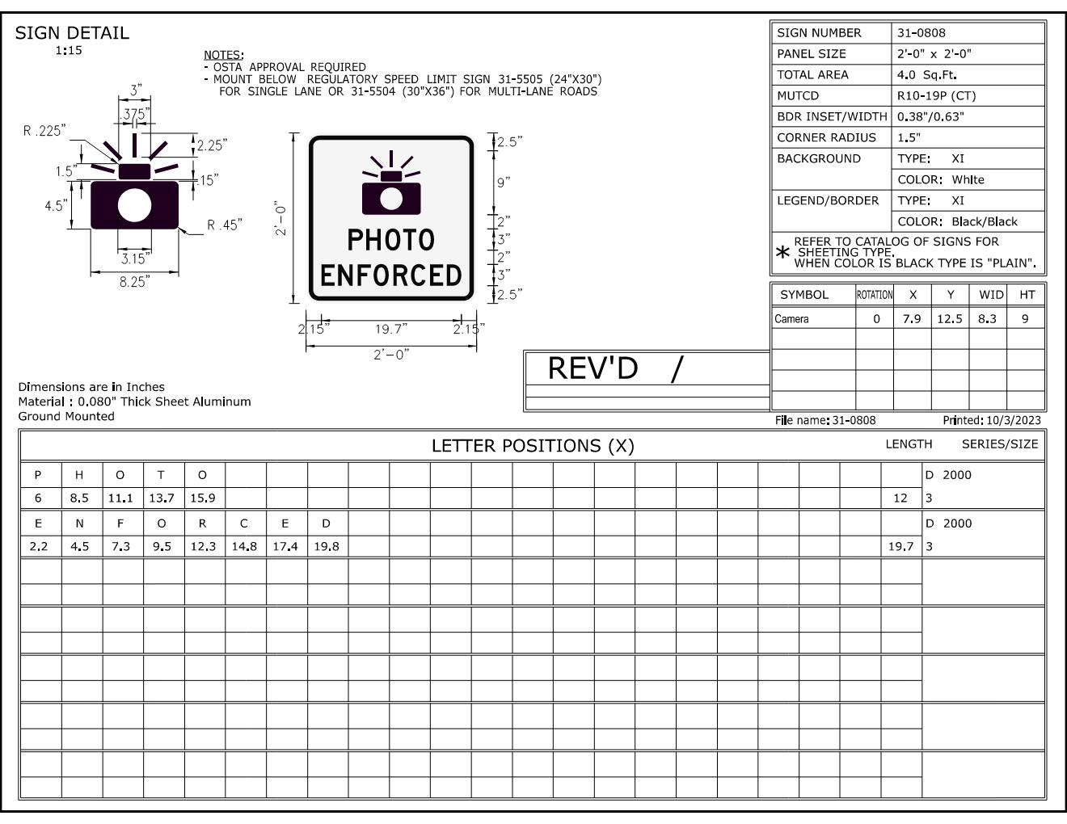
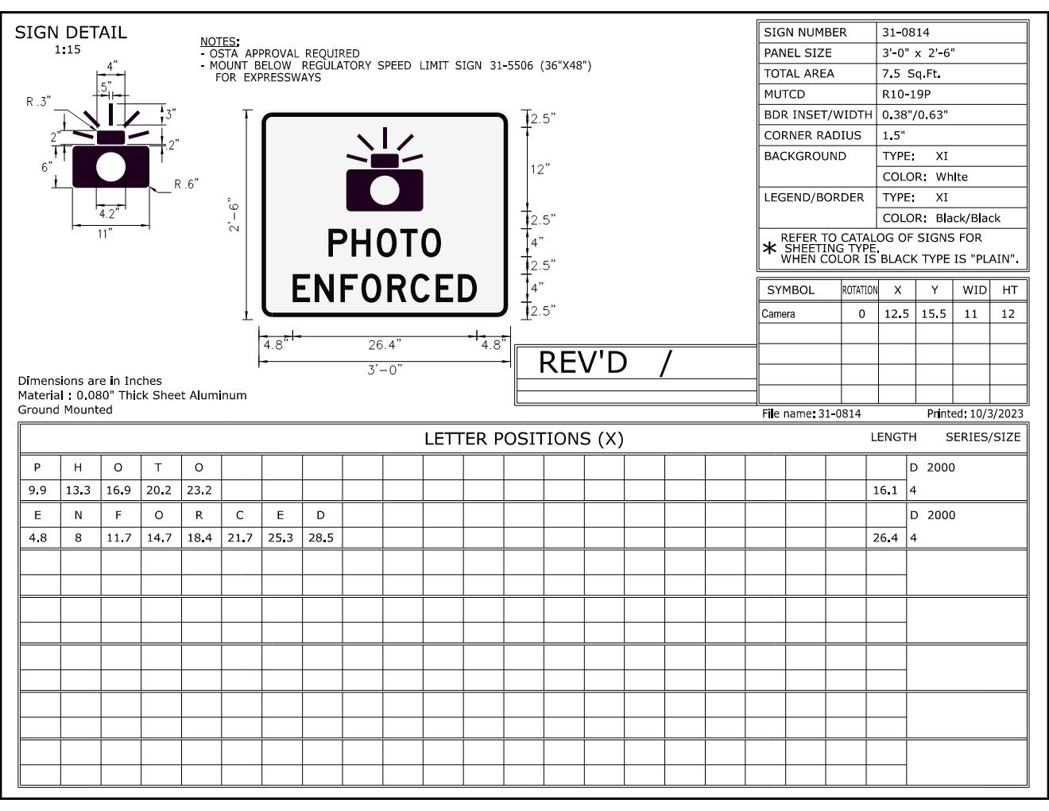
Sign detail options for “Speed Limit –Photo Enforced” stand alone sign.
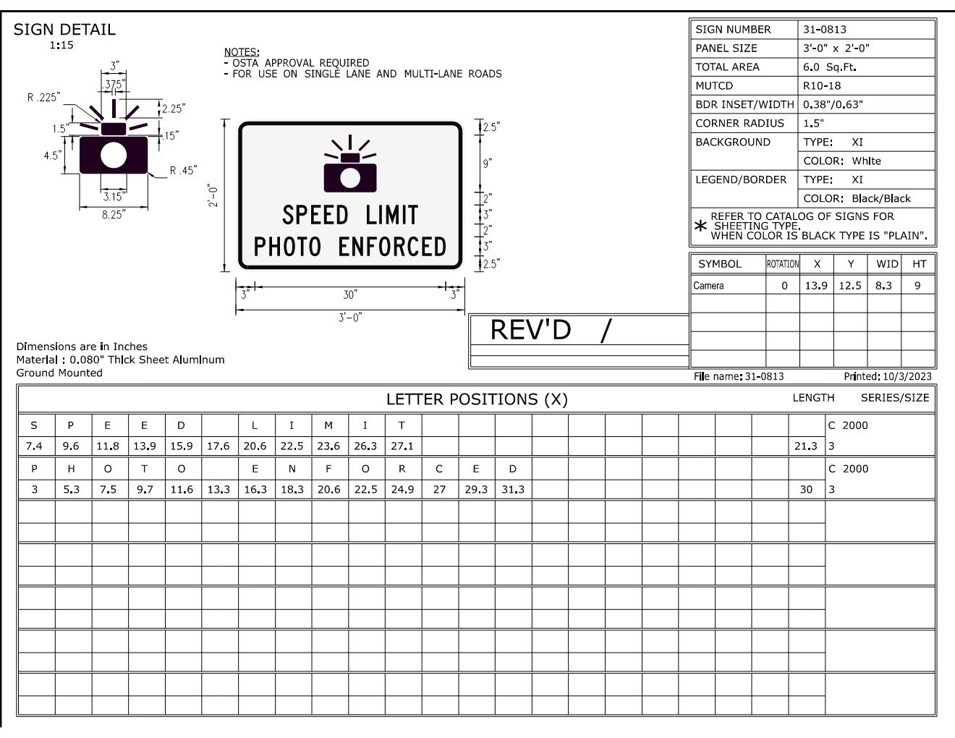
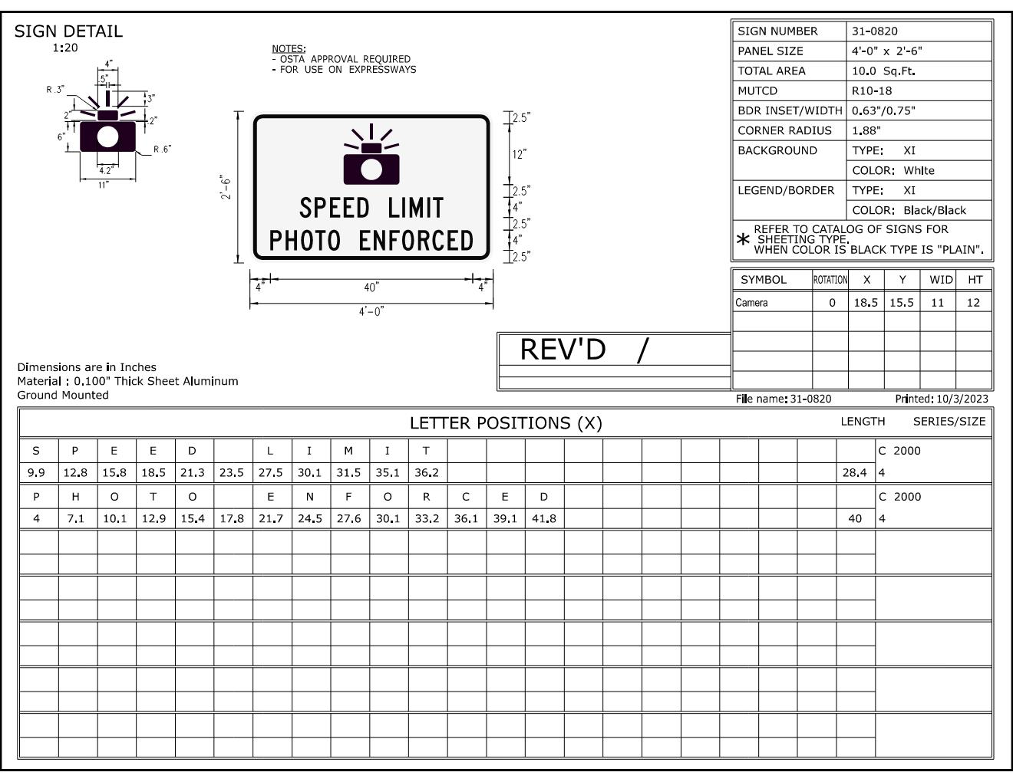

Sign detail options for “Photo Enforced“ to be installed at a traffic control signal.
