DOL-128 (Rev. 10/2021) CONNECTICUT DEPARTMENT OF LABOR
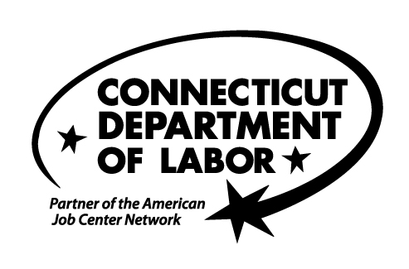
YOUR JOB SEARCH SKILLS ASSESSMENT

The questions below are intended to help determine what services will be beneficial to you in your job search. Please answer all questions. There are no wrong answers.

Your Job Target

 |  | Yes | No
1. | Do you know the type of work you are seeking?
2. | Do you believe that your skills may be transferable to other jobs or occupations?
3. | Do you believe that your skills may be outdated?
4. | Do you believe that you may need to make a career change?
5. | Are you finding job postings that require the skills that you have?

Your Computer Skills

 |  |  | Yes | No
6. | Do you know how to use the Internet for your job search?
7. | Are you able to complete online applications without assistance?
8. | Are you able to use any of the following Microsoft software programs? (Check all that apply.)
 | Word Access Excel PowerPoint Outlook None
9. | Do you have an email address? If yes, please list:

Your Résumé, Job Search Strategy and Interviewing Skills

 |  |  |  |  |  | Yes | No
10. | Do you have a résumé? If no, skip to #17.
11. | Is your résumé up-to-date?
12. | Has your résumé been reviewed or critiqued by a certified professional résumé writer? - If unsure, check “No.”
13. | When you send your résumé to an employer, are you often contacted for an interview?
14. | Do you send a cover letter with your résumé?
15. | When you send your résumé to an employer, do you usually send it to a specific person?
16. | Is your résumé posted on any of the following websites? (If yes, check all that apply.)
 | CT.jobs Career Builder Monster Indeed LinkedIn
17. | Which of these methods do you utilize for your job search?
 | Networking | Internet | Applying in person/cold calling | Newspaper | None

 |  |  |  |  |  | Yes | No
18. | Do you sometimes have difficulty completing job applications? (For example, do you leave sections blank because you are unsure about what to include or lack the information needed to answer certain questions?)
19. | Do you research companies before interviewing with them?
20. | Do you know what questions an employer may ask you during an interview?
21. | Do you have difficulty answering interview questions?
22. | During an interview, are you able to explain why you want to work for the employer?
23. | Do you know what questions to ask during an interview?
24. | After an interview, do you send the employer a thank-you letter?
25. | Following your first interview with an employer, are you sometimes contacted for a second interview?
During the past six months, have you participated in a workshop or seminar about any of the following? (Check all that apply.)
 | Résumés Interviewing skills Job search strategies
If so, who provided these services?
What, if anything, would be most helpful to you concerning your efforts to find work?
Print Name |  |  |  | Your typed name can substitute for a handwritten signature. |  | Date
Department of Labor Representative |  |  |  | Signature |  | Date
Program: ERS UI REA TAA
NOTES:

