
2024 Application Handbook

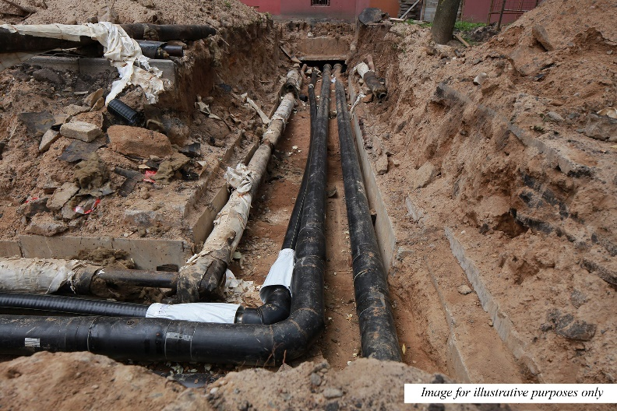
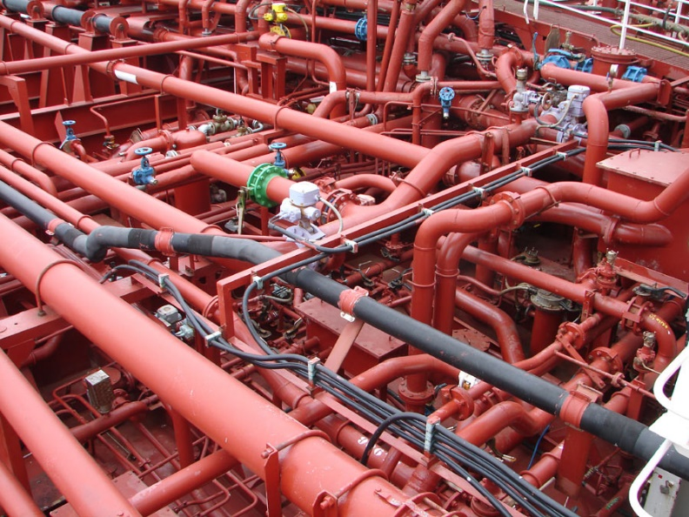
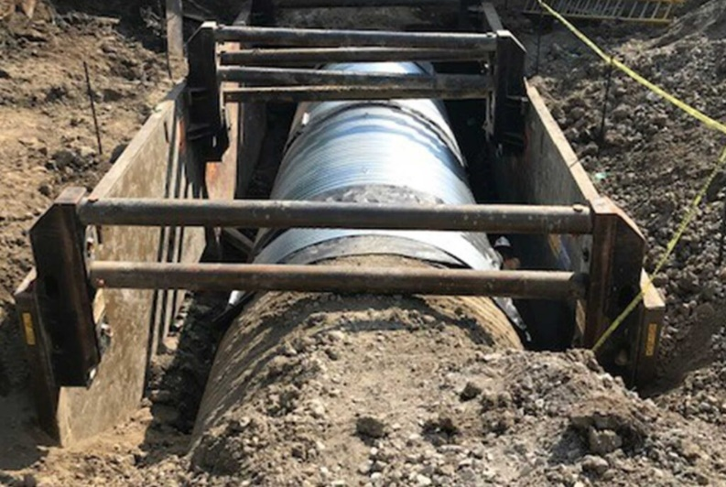
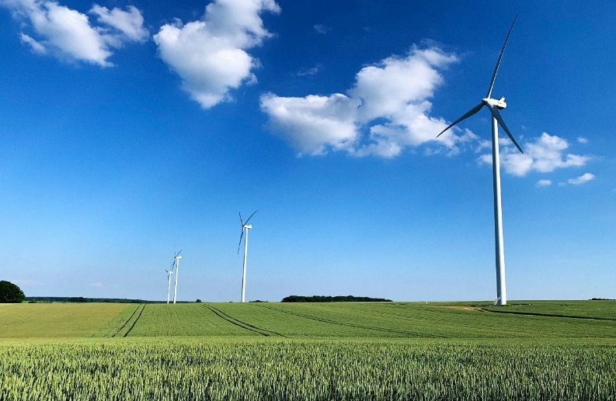

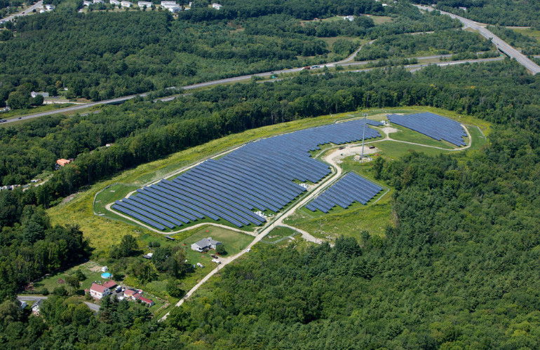
Connecticut Department of Housing
Small Cities CDBG
Salem, CT - Before
Pomfret, CT - Roof
Salem, CT - After
Salem, CT - Before

Governor Ned Lamont, State of Connecticut

Commissioner Seila Mosquera-Bruno, Department of Housing

Department of Housing
505 Hudson Street Hartford, Connecticut 06106 860-270-8262

Table of Contents
Section I: General CDBG Information and Instructions 3
Minimum Requirements 3
Maximum Award Amounts 4
Citizen Participation Requirements 4
Consultants & Grant Administration 5
Meeting a National Objective of the Federal Act 5
Eligible and Ineligible Activities 8
Completing the Application 12
***Application Submission*** 13
Award and Feedback 14
Other Considerations 14
Section II: Detailed Application Instructions 16
General Information 16
Project Information 21
Project Need 22
Applicant Capacity 23
Project Feasibility and Merits 24
Community Impact 32
Fair Housing and Equal Opportunity 33
Fiscal and Grants Management 34
Consistency with Connecticut Consolidated Plan 35
DOH Training 35
Section III: Appendices 36
Appendix A – Additional Guidance 36
Appendix B – Eligible Applicants 42
Appendix C – Follow link for Application Exhibits/Uploads Checklist 42
Appendix D- Follow link for Application Exhibits 42

Section I: General CDBG Information and Instructions

The purpose of this handbook is to provide assistance to eligible municipalities in the preparation of applications to the Connecticut Department of Housing (DOH) for funds under the Small Cities Community Development Block Grant Program (CDBG).

The Handbook contain information and Exhibits that are critical for a completing a competitive application. It is important for prospective applicants to read it carefully and to also become familiar with Small Cities Program requirements found in HUD regulations at 24 CFR 570, Subpart I.

Technical Assistance will be provided by the State Department of Housing in answering questions regarding program design, application requirements, and eligible activities. The Small Cities Program application process is in compliance with the State’s 2024-2025 Action Plan, which can be found on DOH’s website DOH Small Cities Action Plan

Minimum Requirements

To be eligible for CDBG assistance, projects must meet the following minimum requirements:

- The lead applicant must be a non-entitlement city, county or incorporated town that possesses the legal capacity to carry out the proposed program.

- The lead applicant may contract with a 501(c)(3) not-for-profit organization to carry out the activities of an eligible project, provided that the organization can document its not-for-profit status with the U.S. Internal Revenue Service, the Connecticut Department of Revenue Services.

- The proposed project must meet a national objective and be an eligible activity under the federal Community Development Block Grant (CDBG) Act. In general, the project must either:
- benefit an area or clientele whose population is at least 51% low- and moderate-income
- aid in prevention or elimination of slums or blight

- Applicant must provide certification of compliance with citizen participation criteria.

- Applicant must identify how the project is consistent with the goals and strategies of the Consolidated Plan.

- Applicant must submit a Fair Housing Action Plan that complies with DOH’s guidelines/policies.

- Applicant must be in compliance with all existing DOH agreements and cannot be in default under any CHFA or HUD-administered program.

- Applicant must be in compliance with established expenditure rate requirements:

- Applicant must be in compliance with established expenditure rate requirements for the Current Year of 2024:

- Grants for the year immediately preceding the current year must be 10% expended by the last business day of February of the current year. Request for waivers will be reviewed on a case-by-case basis.

- Grants awarded two years prior to the current year must be 50% expended by the last business day of February of the current year.

- Grants awarded three years prior to the current year must be 100% expended, have a Pre-closeout Certificate, and submitted the Final Semi-Annual Report by the last business day in February of the current year.

- Grants awarded four years prior, or longer, must have been closed out with a Certificate of Completion by the last business day of February of the current year. DOH may issue a waiver to this requirement on a case-by-case basis.

Please Note, no more than two open grants are allowed per applicant.

- Applicants “terminated for cause” in the last 5 years are ineligible.

- Any CDBG Program Income accumulated from a previous CDBG grant must be committed for use according to an approved Program Income Reuse Plan before another CDBG grant will be approved. Additional information regarding Program Income and Program Income Reuse Plans can be found in the CDBG Manual at CDBG Grant Management Manual

Maximum Award Amounts

- Up to $2,000,000 for Public Housing Modernization (including pre-development and construction); with priority to State Sponsored Housing Portfolio (SSHP)
Opportunity exists to access additional funds of up to $4 Million State bond funds; further defined as Blended projects.
- Up to $1,000,000 for Infrastructure associated with the development of Affordable Housing (e.g., streets sidewalks, sewer lines, windmills);

Citizen Participation Requirements

Prior to application submission, applicants must develop a Citizen Participation Plan and conduct the first of two (2) required public hearings. Detailed information on Citizen Participation Requirements can be found in the CDBG Grants Management Manual at: CDBG Grant Management Manual

Consultants & Grant Administration

The Community Development Block Grant (CDBG) program allows for use of the Request for Qualifications (RFQ) procurement method for architectural and engineering services only. A/E services may be procured utilizing either the RFQ or Request for Proposal (RFP) method. All other professional services must be procured using the RFP method, if being paid with CDBG funds. Detailed information on the CDBG procurement policies can be found in the CDBG Small Cities Manual at: CDBG Grant Management Manual

There is a possibility for conflicts of interest if a person or business entity manages or administers a CDBG program for a grantee while providing a service or product under that particular grant. All grantees will be required to inform this Department entering into any contractual obligations where a person or business entity manages or administers a CDBG program while at the same time providing a service or product under that particular grant. This Department will make a case-by-case determination whether there are adequate controls to ensure that a conflict would be avoided.

NOTE: On call or per diem professional services contracts and/or amended contracts from previous projects must be pre-approved by DOH.

If paid from CDBG funds, Grant Administrators may charge the following:
- Application Development $3,000 maximum
- Environmental Review $3,000 maximum
- Total Administration $33,000 or 8% of the grant, whichever is less.

Meeting a National Objective of the Federal Act

Section 101(c) of the Housing and Community Development Act (HCDA) sets forth the primary objective of the program as the development of viable communities by the provision of decent housing and a suitable living environment and expanding economic opportunities, principally for persons of low- and moderate- income. This is to be achieved in the CDBG program by ensuring that each funded activity meets one of three named national objectives.

Those three objectives are identified as:
- Benefitting Low-and Moderate-Income families (LMI);
- Aiding in the prevention or elimination of slums or blight (Slum/Blight);
- Activities designed to alleviate existing conditions that pose a serious and immediate threat to the health or welfare of the community (Urgent Need).

Following is a description of how activities can qualify under each of the national objectives. This is a summation of the regulations and should only be used as a guideline for determining if a national objective can be met for a proposed activity. The applicant will need to demonstrate that it meets the required objective by providing all relevant documentation and answering all relevant questions.

- Low/Moderate Income Benefit
Low- and Moderate-income persons are defined as those persons whose household income is at or below 80% of the median income for the area in which they reside. You must use the CDBG income limits that are designated for your community. Activities can qualify under the Low/Mod Benefit National Objective in one of three ways. They are:
Area-wide Benefit – Activities that benefit all of the residents of a particular area where at least 51% of the residents are low and moderate income persons. Activities that qualify under area-wide benefit include but are not limited to street, sidewalk, sewer, or waterline construction.

To show that a project benefits an area of low and moderate income people, the following questions must be answered in the application on the National Objective Identification page:
1. What are the boundaries of the service area?
2. How do the boundaries correspond to the project’s intended beneficiaries?
3. Using HUD Census data or a certified income survey, what percentage of persons in the service area are of low-to-moderate income?
4. How were the income characteristics of the target population determined?
5. Is the proposed facility available to all service area residents?

The following documentation MUST be provided in the application:
- Detailed map(s) showing the location and boundaries of the service area, including street names.
- HUD LMI Data Maps and Worksheet
- For income Surveys
  - The methodology of the income survey
  - The low-to-moderate income worksheet, and
  - The sample survey instrument must be included.

Limited Clientele – There are eight groups of people that are presumed by federal regulations to be of be made up of at least 51% low and moderate income persons. Those groups are as follows:

• Senior citizens (people who are 62 years of age or older) • Severely handicapped adults
• Migrant farmworkers • Battered spouses
• Abused children • Illiterate adults
• Homeless persons • Persons with AIDS

For Limited Clientele projects serving other persons, the benefit to low- and moderate-income persons must be documented by an income verification process and should include at least three (3) months of data.

For a limited clientele project, the following questions will need to be answered in the application on the National Objective Identification page:
1. Who will use the proposed facility? Are the beneficiaries in a group presumed to be low- and moderate-income, or will beneficiaries be qualified based on income?
2. Will any other groups or the general public also use the facility? If so, to what extent?
3. If the facility is to be used on an income-eligible basis, how will income and family size information of users be documented? How was the percentage of low- to moderate-income users determined or estimated?

Housing – An LMI Housing activity is one carried out for the purpose of providing or improving permanent, residential structures that will be occupied by LMI households upon completion. This would include, but not necessarily be limited to, the acquisition or rehabilitation of residential property, or the conversion of nonresidential property to residential.

For activities to qualify under the LMI Housing National Objective, it must result in housing that will be occupied by LMI households upon completion. The housing can be either owner- or renter-occupied and can be either one family or multi-unit structures. When the housing is to be rented, in order for a dwelling unit to be considered to benefit an LMI household, it must be occupied by the household at affordable rents (defined by DOH as Fair Market Rent minus tenant paid utilities).

In order to meet the housing LMI Housing national objective structures with one unit must be occupied by a LMI household. If the structure contains two units, at least one unit must be LMI occupied. Structures with three or more units must have at least 51 percent occupied by LMI households.

Job Creation – LMI Job Creation activities are designed to create or retain permanent jobs, at least 51 percent of which (computed on a full-time equivalent basis) will be made available to or held by LMI persons.

- Elimination of Slum and Blight
Activities funded under the Slum and Blight national objective may involve the rehabilitation or removal of slums and blight in the physical, economic and/or social environments. Activities may address any serious conditions identified in the areas of residential, infrastructure, commercial, or industrial facilities. The overall program proposed should resolve all needs indicated.

Area Basis - The following questions must be answered in the application on the National Objective Identification page:
1. What are the boundaries of the area?
2. What are the conditions that cause the area to be considered blighted?
3. What percentage of buildings in the area are deteriorated? How are they deteriorated?
4. What are the public facilities in the area that are deteriorated? Describe this deterioration.
5. How will the proposed project remedy one or more of the blighted conditions described above?

The following documentation must be attached to a slum and blight, area basis application:
1. Municipal resolution passed, by the application due date, by governing body that describes boundaries of the specific blighted conditions within the area, and officially designates an area as blighted or an area in need of redevelopment per CGS § 7-148 Resolution cannot be older than ten (10) years.
2. Photographic documentation of the slum or blighted conditions that prompted the municipal resolution.
3. Map of area showing the location of project activities. The map must provide street-level detail.

Spot Basis - The following issues must be addressed on the National Objective Identification page:
1. Show the specific blighted or deteriorating structure that will be affected by the proposed project.
2. Provide a detailed description of conditions to be remedied by the proposed project, accompanied by a detailed statement of activities to address those conditions. The following documentation must be attached to a slum and blight, spot basis application:

1. Municipal resolution passed, by the application due date by governing body that describes the blighted or deteriorating structure, including a legal description, and officially designates the structure as blighted under a spot basis.
2. Photographic documentation of the slum or blighted conditions that prompted the municipal resolution.

Spot basis slum/blight projects are limited to five project activities: acquisition, relocation, clearance, historic preservation, and limited rehabilitation to correct specific conditions detrimental to public health and safety. Please note a spot basis blight project must not be located within a designated blight area.

- Urgent Need
In order to meet federal urgent need criteria and qualify for a Discretionary Single Purpose Grant, the proposal must meet all of the following three criteria:

- It must address a serious and immediate threat to the public health or safety of the community; AND
- It must be of recent origin or recently become urgent (within 18 months); AND
- It must be last-resort funding (i.e. no other reasonable source of funds available).

Eligible and Ineligible Activities

Communities funded under the Small Cities program can undertake a wide range of activities in the areas of housing, economic development, community facilities, and public services. This section contains a listing of the specific eligible activities as defined by HUD. This section also contains a review of expressly ineligible activities that Small Cities grantees are, in no circumstances, allowed to carry out. Applicants should also remember that in addition to being eligible as defined in this section, each activity must meet a National Objective as defined in the next chapter (Sec. 570.200 of Code of Federal Regulations).

Eligible Activities

The following is a listing of eligible activities under the Small Cities CDBG Program.

- Acquisition of real property for eligible housing, economic development, or community services/facilities projects.

- Clearance/Demolition of buildings and improvements. Removal of demolition products (rubble) and other debris.

- Disposition of real property acquired with CDBG funds, or its retention for public purposes including temporary management. (Proceeds subject to conditions).

- Public Facilities and Improvements - Assistance for acquisition, construction, reconstruction, rehabilitation, or installation (but not routine repair or maintenance) of community facilities and/or infrastructure, including neighborhood or senior centers, centers for the handicapped, historic properties, utilities, streets, sidewalks, streetscape and lighting, parking, water and sewer, park, recreation, and for flood and drainage facilities (subject to certain conditions). This includes facilities designed to serve the needs of special populations, such as the homeless, and may include those owned by nonprofit recipients, provided they meet certain conditions. Exceptions: Facilities used for political activities, for the general conduct of government, or for activities that supplant the routine expenses of general local government are not eligible.

- Public Services - May include labor, supplies, and materials; provided it is either a new service or quantifiable increase in service.

- Interim Assistance to carry out emergency repairs or alleviate emergency conditions (subject to conditions).

- Sec. 108 Guarantee of Loans - Funds may be used to guarantee and make commitments to guarantee financing for: 1) acquisition of or rehab to real property owned by an eligible public entity; 2) housing rehabilitation; economic development or construction of housing by nonprofit organizations for homeownership. (See Title I of the HCD Act as amended through October 28, 1992)

- Payment of Local or Non-Federal share for federal and for most state grant-in-aid programs, provided activities are CDBG-eligible.

- Completion of Urban Renewal Projects

- Relocation Assistance for permanently and temporarily relocated households, businesses, nonprofit organizations and farm operations (subject to conditions).

- Loss of Rental income due to temporary holding of residential units for relocation related to CDBG program activities.

- Removal of Architectural Barriers in publicly and privately owned buildings, facilities and improvements (may include buildings for conduct of local government).

- Privately Owned Utilities - for acquisition, construction, reconstruction, rehabilitation or installation of distribution lines and facilities.

- Construction of Housing - under Section 17 of the U.S. Housing Act of 1937 (Rental Rehabilitation) only.

- Activities to Support the Development of Low and Moderate Income Housing, including acquisition, clearance, site assemblage, provision of site and public improvements (water, sewer, access roads, drainage, etc.) and other reconstruction costs.

- Rehabilitation of Privately Owned Buildings and improvements for residential purposes, and related costs.

**Related housing rehabilitation costs include a wide range of activities, including historic preservation, lead paint abatement, septic system and well repair, energy audits, utility connections, flood insurance, rehab services, code inspections, loan re-financing, etc.**

- Rehabilitation and Improvements to Publicly Owned Low Income Residential Units, and related costs, for non-urgent activities.

- Rehabilitation of Manufactured Housing if part of a community's permanent housing stock, and related costs.

- Rehabilitation of Publicly or Privately Owned Commercial or Industrial Buildings (subject to conditions). Privately owned structures are limited to exterior improvements and code enforcement. Any additional work must be done under economic development.

- Code Enforcement - Involves the payment of salaries and overhead costs directly related to the enforcement of local codes. Code Enforcement needs to be targeted at a deteriorated or deteriorating area delineated by the community and meet the following requirements:

  - At least 51% of the residents of the area are L/M income persons; and
  - The code enforcement must be combined with other public improvements, rehabilitation, and services, which together should be expected to arrest decline of the area.

** Code Enforcement does not include inspections for the purpose of processing applications for rehabilitation assistance. Those costs must be included in the housing rehabilitation costs.**

- Special Economic Development Activities
  - Acquisition, construction, reconstruction, rehabilitation or installation of commercial or industrial structures and other real property equipment and improvements (including public facilities, site improvements, utilities) by public or private nonprofits, for job creation or retention.
  - Provision of assistance to private for-profit business, where the assistance is necessary or appropriate to create or retain jobs, and where there is justifiable public benefit to be derived.

- Special Assistance to Certain Sub-recipients (Community Based Development organizations, Section 301(d) Small Business Investment Companies or local development corporations) to carry out neighborhood revitalization, community economic development or energy conservation projects (under certain conditions).

- Planning and Capacity Building CDBG funds may be used for studies, analyses, data gathering, preparation of plans, and identification of actions that will implement plans (see 24 CFR 570.205 of regulations for more detailed description). The amount of CDBG funds used for planning and capacity building activities is subject to a 16% limit on planning and administration.

- Payment of Reasonable Administrative Costs and carrying charges related to the planning and execution of community development activities. This may include general management, public information, fair housing activities, indirect costs, preparation of federal grant applications, necessary costs for obtaining financing for housing assistance and other activities. This may also include payment of reasonable administrative costs related to establishing and administering federally approved Enterprise Zones.

- Direct Homeownership Assistance. CDBG funds can now be used to:

  - subsidize interest rates and mortgage principal amounts for low and moderate income homebuyers;
  - finance the acquisition by low and moderate income homebuyers of housing that is occupied by the homebuyers;
  - acquire guarantees for mortgage financing obtained by low and moderate homebuyers from private lenders (except that amounts received under this title may not be used under this subparagraph to directly guarantee such mortgage financing and grantees under this title may not directly provide such guarantees);
  - provide up to 50% of any down payment required from low or moderate income homebuyers;
  - pay reasonable closing costs (normally associated with the purchase of a home) incurred by low or moderate income homebuyers.

- Provision of technical assistance to public or nonprofit entities to increase the capacity of such entities to carry out eligible neighborhood revitalization or economic development activities.

- Housing Services, such as housing counseling, energy auditing, preparation or work specifications, loan processing, inspections, tenant selection, management of tenant based rental assistance, and other services related to assisting owners, tenants, contractors and other entities, participating or seeking to participate in housing activities authorized in Title I or under Title II of the Cranston-Gonzalez National Affordable Housing Act.
- Provision of assistance by recipients of CDBG funds to institutions of higher education that have demonstrated capacity to carry out eligible activities.

- Provision of assistance to public and private organizations agencies and other entities, (nonprofit and for profits) to enable such entities to facilitate economic development by providing credit, technical assistance and support for micro enterprises.

- Activities necessary to make essential repairs and to pay operating expenses necessary to maintain the habitability of housing units acquired through tax foreclosure proceedings in order to prevent abandonment and deterioration of such housing in primarily low and moderate income neighborhoods.

- Development of energy use strategies related to development goals.

- Assistance to facilitate substantial reconstruction of housing owned and occupied by low and moderate income persons (subject to conditions).

- Fair Housing Activities to facilitate compliance with Fair Housing Plan, implement Analysis of Impediments to Fair Housing or other related Fair Housing activities.

Ineligible Activities

In general, any activity not specifically authorized in the previous section will be considered to be ineligible for assistance under the Small Cities CDBG Program. Ineligible activities will not be considered for funding and will be deleted from your proposal. If an ineligible activity is central to your proposal, the entire proposal may be eliminated up front.

Following is a partial listing of activities that are expressly ineligible and will not be funded:

- Construction, rehabilitation or other assistance connected with buildings or facilities for general conduct of government such as city or town halls, courthouses, schools, and other State and local offices. The only exception is the removal of architectural barriers from such facilities.

- General government expenses or regular operating and maintenance costs of the local community.

- Facilities or equipment used for political purposes or to engage in partisan political activities, unless the facility is available to all parties and organizations on an equal basis.

- Purchase of equipment, especially construction equipment, except that which will be used as part of a solid waste disposal facility or as an integral part of delivery of a community service. Contact DOH if there are further questions.

- Purchase of furnishings, personal property, or other equipment that is not an integral structural fixture. Those items which are necessary for administration of CDBG activities will, however, be eligible, as will the purchase of firefighting equipment (for voluntary fire departments only).

- New housing construction except as carried out by eligible sub-recipients or in conjunction with a Rental Rehabilitation project. Site improvements that support the development of low or moderate income housing, such as clearance, site assemblage, and the provision of public improvements, are eligible expenses. Contact DOH for details.

- Income payments to individuals for housing or any other purpose, with the exception of relocation expenses.

- Funds can be used to construct, rehabilitate, maintain, or restore a structure owned by a "pervasively sectarian organization," as long as the structure is not used for religious services or instruction. (The Department of Justice's definition of "pervasively sectarian organizations" includes such groups as the Salvation Army, B'nai B'rith, and the YMCA) Block grant funds can be used to fund public services carried out by such organizations as long, as the service complies with certain conditions.

The conditions that apply to the funding of public services sponsored by a religious organization are:

  - the service must be exclusively nonreligious;
  - no proselytizing, instruction, or other religious influence can be connected with the public service; and
  - there can be no religious discrimination in terms of employment or benefits.

The only exception to the prohibition on rehabilitation of structures owned by a sectarian organization is that minor repairs may be made as long as they:

  - are directly related to carrying out a public service,
  - occur in a structure used exclusively for nonreligious purposes, and
  - constitute a minor portion of the CDBG funding.

**Terms incorporating the above conditions must be set forth in a written contract between the Small Cities grantee and the subrecipient, using draft wording supplied by HUD. Contact DOH for further information on these conditions.**

Projects Combining Eligible and Ineligible Activities
Depending on a community’s needs, it may be appropriate for a project to combine CDBG eligible and ineligible activities. Such a project may still be eligible for CDBG funds, provided:
- that the budget clearly delineates the costs of the eligible and ineligible activities;
- that CDBG funds will not pay for any ineligible activities; and
- that local funds comprise at least the minimum percentage required local match portion of the project.

Completing the Application

For each question, provide all information that you want considered as a response even if it requires repeating items included in other sections. Please be sure you complete all parts of the application. If a question or Exhibit is not relevant to your project, place “N/A” (not applicable) in the space. If pertinent information is not provided for each section and subsection, the applicant will lose points. Also see page 13 for more notes on completing this application.

***Application Submission***

The application must be submitted to DOH electronically, DOH will provide the Link for the application upload in subsequent communication. In the INTENT to APPLY Form, you must provide the name, email address and phone contact of the person(s) responsible for uploading the application. Further details are outlined below.

Email the INTENT to APPLY FORM by April 30, 2024 to DOH.CDBGapps@ct.gov

The 2024 Application Form and required supporting documents MUST be submitted/uploaded by 11:59 PM EST on May 31, 2024. Failure to comply with submission requirements could render an application ineligible.

If you have any questions about application content, please contact a member of the DOH CDBG Small Cities staff.

Small Cities Staff
Miguel Rivera, Director 860-270-8012 Rivera.Miguel@ct.gov
Dominic Carew, Project Manager 860-270-8164 Dominic.Carew@ct.gov
Lilia Kieltyka, Project Manager 860-270-8023 Lilia.Kieltyka@ct.gov
Jerome Mihm , Project Manager 860-270-8097 Jerome.Mihm@ct.gov
Lucille Vaughan, Project Manager 860-270-8195 lucille.vaughan@ct.gov

Ivette Delgado, Administrative Support 860-270-8114 Ivette.delgado@ct.gov

Fair Housing/Civil Rights Staff
Michael Santoro, Director 860-270-8171 Michael.Santoro@ct.gov
Beth Generali, Fair Housing Support 860-270-8121 Beth.Generali@ct.gov

Architectural/Engineering Staff
Simeon Stevens, Architectural & Tech Support 860-270-8129 simeon.stevens@ct.gov
Stephen Dupre, Construction Specialist 860-270-8109 stephen.dupre@ct.gov
Mithila Chakraborty, Environmental Analyst 860-270-8230 mithila.chakraborty@ct.gov

Award and Feedback

Awards will be announced on September 15, 2024, through a press release. Grant Services will contact each community after the announcement to start the next steps in the granting process. Applications that are not funded will receive a rejection letter.

Other Considerations

All commitment letters or pre-commitment agreements being provided by the applicant will be rated based on the degree of certainty. Firm commitments will be rated higher during the rating and ranking process than something less firm such as a letter of understanding or interest.

Data from surveys will be judged by appropriate standards, such as date of data collection, reliability and validity of methods, sample size, and relevance of data to the specific project proposed.

Some notes for using the electronic fillable Form:

    - Use the tab key to move from question to question. Tabs move from left to right.
    - Use the enter key to create additional lines when completing responses/narratives.
    - Formulas are embedded in all tables. When working with tables containing rows/columns with TOTAL (e.g. 4.1, 4.2, 4.3 etc.) as seen below, calculate the total by a simply right click your mouse in the cell circled red, then select Update Field.

4.3 Program Income on Hand (All Applications) Indicate the amount of program income on hand, the year it was earned, and the source.
Source(s) of Program Income | PI Earned to Date | PI Expended to Date | PI on Hand
Activity: SC-21 | $75,000 | $61,000 | $14,000
 | $ | $ | $
 | $ | $ | $
 | $ | $ | $
 | $ | $ | $
TOTAL | $ 0.00 | $ 0.00 | $ 0.00

    - Please be aware, Page numbers are floating therefore as you complete the application form the page number will increase as information is inputted.
    - Upload Name all exhibits using the File Naming Convention as described in How to fill e-form 2024 and include within the appropriate folder e.g. (G, 1,2,3,4 etc.)
    - All Original signatures must be in BLUE ink
    - If your application gets funded, DOH will provide a list of Grant Conditions. You will be required to submit items listed. As previously indicated, original wet signature documents must be kept locally with application files/folders. Applicants may be required to provide original wet signature pages/documents.
    - For more details about the File Naming Convention, please visit the PowerPoint presentation How to fill e-form 2024

Section II: Detailed Application Instructions

General Information

Applicant Information Page

- Name of Applicant (Municipality/Non-Profit)
- Name and Title of the Authorized Individual e.g. Chief Elected Official/Chief Executive Officer
- Mailing Address
- Name and Title of Chief Financial Officer
- Grant Contact: Local Official (First Selectman, Town Manager, Mayor, Town Staff, CEO)
- Municipality FEIN
- Unique Entity Identifier (UEI) Number
- CAGE Number
- CDBG County Code
- SAM Expiration Date
- Sub-Recipient Contact Information (if applicable)
- Project Information
  - Requested Amount
  - Project Name
  - Project Address
  - Year Built
  - Town Planning & Zoning Approval/Certification

- Public Services Projects Only
    - Is this a Faith-based Organization?
    - Requesting more than $100,000
    - Has organization received CDBG funding in last 5 years?

- Consultant Contact Information (if applicable)
- Compliance with DOH Certified Grant Administrator Program
  - Consultant
  - Municipality

General Project Information:

    - 000.0 SCAPP 2024 Small Cities Application Form
  - 000.1 GCA Multi-jurisdictional Application (General 1)
    - Project Type – Check the box that applies (e.g. housing rehab, community facilities, public housing modernization, economic development)
    - 00.1 FHO Fair Housing Ordinance - only the ordinance language is needed; additional language from resolutions or minutes should not be included
    - 00.2 FHAP Fair Housing Action Plan - copy of entire plan must be attached to final application. More information on the Fair Housing Action Plan requirements can be found in Small Cities CDBG Manual as Attachment 8-2.
    - 00.3 S3P Section 3 Plan – copy of the entire plan must be attached to the final application. See the Small Cities CDBG Manual for further information on Section 3 requirements and guidance on how to complete a Section 3 Plan.
    - 00.4 DFWP Drug Free Workplace Policy - copy of entire policy must be attached to final application. See the Small Cities CDBG Manual for further information and guidance on Drug Free Workplace policies.
    - 00.5 ERR Environmental Review Record attached - Exempt, CENST and Broad-level Review must be submitted with application
    - 00.51 RROF Request for Release of Funds (Submit all documentation if applicable)
- 00.6 CEPA Is any part of the project in a Floodplain – check the box that applies, upload the checklist
- 00.7 VAWA Certification -Submit documentation and Certification
- 00.8 BABA (00.81 Certification/00.82 Waiver) - submit supporting documentation with Waiver
- 000.8 GRM Complete the CDBG Responsibility Matrix (General 8)
- Indicate if this is the applicant's first CDBG grant (if awarded) – check the box that applies
- Open grants/contracts – List all open CDBG contracts/grants
- Congressional District – enter the appropriate Connecticut congressional district
- State House and Senate Districts – enter the appropriate Connecticut legislative districts

Citizen Participation Information:

Citizen Participation
Two public hearings must be held at different stages of project development. One public hearing must be held prior to submission of the application. The second public hearing must be conducted no earlier than 1 year from execution of Assistance Agreement and prior to submission of Pre-Closeout Certificate.

Note: New public hearings must be held for each grant cycle, regardless of prior application(s).

Public Hearing Information (answer all questions below attach/upload exhibits 00.7 to 00.17)
- First Notice of first public hearing- Date
- Second Notice of first public hearing-Date
- Date of first public hearing-Date
- Describe the methods used to solicit participation of low- and moderate-income persons:
- Denote any adverse comments/complaints received and describe resolution:
- Describe outcomes of 4-Factor Analysis for Limited English Proficiency:
- If no comments were made by the residents during the public hearing, describe efforts to obtain input from resident on the project?
- The following documents must be attached:
- 00.9 CPP Citizen Participation Plan
- 00.10 CPHN Copy of Advertisements of Public Hearing Notices
- 00.11 CPA Copy of Publishers Affidavit
- 00.12 CPHM Copy of Minutes of the Hearing
- 00.13 CPAL Copy of Attendees List (Town Officials and General Public)
- 00.14 CPSIS Copy of Sign-In Sheet for Hearing
- 00.15 CPRCC Copy of response(s) to comments and/or complaints
- 000.2 GALR Copy of Certified Adopted Local Resolution (Exhibit General 2)
- 00.16 FFA Copy of Four Factor Analysis
- 00.17 LAP Copy of Language Access Plan (if required)
- 00.18 PIP Program Income Plan (As applicable)
- 00.19 TPAZ Town Planning & Zoning Certification (Upload documentation showing appropriate approval to conduct the proposed activity (for Acquisition, Public Facilities, Shelter etc.)

National Objective Identification:

Choose one from the following National Objectives:
Benefit to Low- and Moderate-Income Persons Area Benefit Limited Clientele
Jobs Housing
Urgent Need (prior approval required)

Prevention or Elimination of Slums or Blight Area Basis Spot Basis

Percentage served by the project from HUD Low/Mod Summary Data (Census). Census data must be provided even if an Income Survey will be used.

List the census tract number(s) that are included in the project area.

List the census tract block group(s) that are included in each of the census tracts listed in the previous question.

Explain why the National Objective was selected and how this project meets the criteria of that Objective. Refer to the instructions, on pages 3-5, for further guidance on the criteria and information that must be included. Specifically, make sure to address the questions listed for the chosen national objective.

If an Income Survey was be used, enter the Low/Mod percentage from the survey results and the date the Income Survey was started.

00.20 NO National Objective Documentation supporting the National Objective as outlined in “Meeting a National Objective” above must be uploaded.

Select (from dropdown menu) Performance Objective
Select (from dropdown menu) Performance Outcome

If Census Data was used to establish the percentage of low-to-moderate income, report the percentage and Census data as follows:

- If the Service Area covers all of the Block Groups in a Census Tract, list only the Census Tract number (do not list the Block Group numbers). Provide data for all person who reside in the Census Tract; or

- If the Service Area covers only some of the Block Groups in a Census Tract, list each of the Block Group numbers on a separate line with the Census Tract number. Provide data only for the persons who reside in each of the Block Groups.

Census Tract Number | Block Group Number | Total Persons in Census Tract or Block Group (A) | Total Low and Moderate Income Persons (B)
TOTAL | Cell does not contain a formula |   Cell does not contain a formula | Cell does not contain a formula
Column (B) divided by Column (A): ____________%

Beneficiary Information:

Enter the proposed accomplishments, by unit, person or job, according to only one (1) of the following unit types.
- Number of People Served
- Number of Housing Units Rehabbed/Created
- Number of Jobs Created/Retained
- Number of Households Served
Enter the total number of Beneficiaries or total number of Housing Units (if applicable).

00.21 BIT Beneficiary Information Table (enter data into the table (excel) and upload as 00.20 BIT

Note: Complete the demographic chart below based on Census Data or Income Survey results:
Total beneficiaries must equal the sum of 1-10. L/M and Non-L/M must equal the sum of 1-10. See Example in the table below
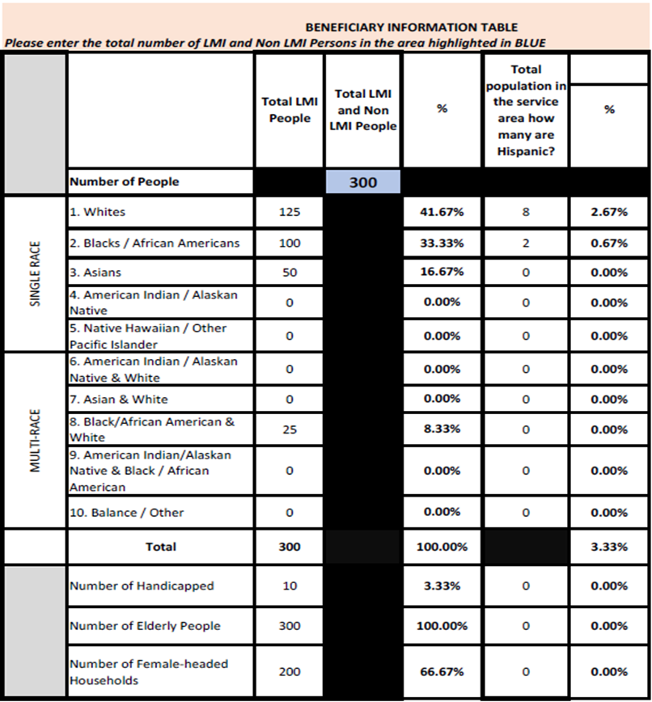
Project Information

  - Program Description: Provide a project description of 1,000 words or less. For identification purposes, identify street(s) and numbers of actual sites or units and attach information on additional locations. The description must include but is not limited to the following:

- A detailed holistic description of the actual physical activities or services that would be undertaken (purpose of the project). For PHM Blended with SSHP funds describe the capital improvements proposed to sustain the campus for 20-25 years. Include the number of ADA units onsite, # of units currently meeting state ADA requirements, proposed # of new ADA units, # of units that will be made ready for aging in place, describe energy efficiency upgrades, solar and storage, emergency power generator and Call for AID systems. Indicate in the description what the CDBG funds will be used for and what the SSHP funds will be used for.
- Is the project being completed in phases? If so, why?
- What is the nature of the project?
- Whom is it designed to benefit?
- What is the impact of the problem on Low/Mod income persons?
- To what extent does it benefit the neighborhood, municipality, and region?
- Identify the magnitude and severity of any identified problem and include any past efforts to deal with the problem.
- The status of site control (i.e., option to purchase, own, lease).
- At what stage are you on the planning and implementation of this project?
- Any unique situations or anticipated problems in the development of the project.
- Any special conditions/requirements imposed by funders or others.
- If the project involves relocation, identify the numbers of individuals, families, or businesses to be relocated.
- If new construction for home ownership is planned, please provide information on the type and style of housing, average size, expandability, and amenities.
- For economic development projects, demonstrate how the business assistance is necessary or appropriate to create or retain jobs and address where there is a justifiable public benefit to be derived.
- Demonstrate how the project addresses any local Community Development Plans (enclose a copy of the plan).
- For public service applications, describe the organization’s mission. List all services and programs that your municipality and/or affiliate organization provides, the number of individuals served by your agency, and the geographic area you serve. State the specific program/service that would be supported by CDBG. Demonstrate that the proposed service is either a new service or a quantifiable increase in service.
- For public service applications, define specific and measurable outputs or outcomes and the method for tracking them, including data relevant to the number of individual clients or households to be served through the CDBG funds- provide the unduplicated number of families/ persons that will benefit from the activity in one CDBG program year, and the “cost per unit” to provide the service (see Public Services Budget Template attachment).
- For public service applications, describe your program or service delivery plans, including your hours
of operation, intake system, program personnel, outreach and marketing or referral procedures and other
program features that may support program service delivery.

1.2 Acquisition (provide information related to acquisition)
In situations when there is an option to purchase the property, the option must be effective until December 31, 2024. If it expires before then, the town or subrecipient must have title to the property.

1.3 Tenant Relocation – check all boxes that apply regarding tenant relocation, including temporary displacement.

1.4 Relocation Plan (provide information related to relocation)
Benefits to business or residential tenants under the Federal Uniform Relocation Assistance and Property Acquisition Policies Act of 1970 (URA) can be triggered at the time the applicant submits its application to DOH. This occurs if the applicant has already acquired, or entered into an agreement to acquire, the property. If this is the case, it is imperative that the General Information Notice (GIN), modified to fit the circumstances of your project, be sent to every tenant prior to or simultaneous with the submission of this application. A sample GIN can be found in the Small Cities CDBG Program Manual.

If tenants were not involved with the acquisition, please explain briefly in an attachment uploaded along with the Relocation Plan. Provide specifics concerning how long the property has been vacant or unoccupied.

  - Fair Housing Plan – A copy of the municipality Fair Housing Plan must be uploaded.

1.6 Consistent with State Conservation and Development Policies Plan – check the appropriate box. Provide a brief explanation of project’s consistency with the C&D Plan text and map, which category of development/conservation, and nature of Project or indicate why the Commissioner may consider an exception to the C&D Plan.

Project Need

2.1 Project Need Submit a brief narrative of 500 words or less that explains how the project will address the specific needs of the community. You are encouraged to use the documentation that is best suited to demonstrate that there is a specific need for the proposed project.

For Small Cities and State Sponsored Housing Portfolio (SSHP) blended projects, seeking up to $4 million please indicate how the additional funds will make it possible to sustain the facilities on the project site for 20-25 years. Describe how partnerships with Green Bank, Eversource and Sustainable CT will be incorporated in this project.

Housing Rehabilitation Program Applications Only must submit a waiting list, use the form provided.
Exhibit 2.1.A

Exhibit 2.1.B
Public Housing Modernization Applications Only must submit a Capital Needs Assessment (CNA) as documentation and explain specifically how it demonstrates the need for the proposed project and how the project meets the recommendations of the CNA. Below are some suggested sources of information:
- Documentation of health and safety issues
- Capital Needs Assessment (CNA)
- Unemployment rate for community/region
- Demonstrated business need/interest
- Plant closures and other economic changes
- Waiting lists for existing assisted housing
- Waiting lists for proposed activity in rehab loans
- Waiting lists at projects - comparable housing
- Vacancy rates for housing at existing housing developments or in general housing market
- Occupancy rates for existing commercial/industrial space
Accessibility
- Availability of housing tenure type affordable to your target income group(s)
- Availability of unit sizes affordable to your target income group(s)
- Waiting lists for proposed home ownership program
- Results of surveys for home ownership programs
- Availability of affordable home ownership housing stock in target area
- Comparable market rate for similar housing
- Waiting list for existing services
- Results of specific surveys
- Technical evaluations of problems with existing facilities and infrastructures documented from agencies such as DEEP and DOT
- Lack of services, facilities, and/or public utilities
- Percentage of substandard housing in target area
- Public Services Applications Only - Describe why CDBG funds are critical to the implementation of the proposal.
- Public Services Applications Only – Provide a description of the community need the proposal is intended to address, including the extent of the need and its intended impact on the target population or community. Include the number of persons affected and the characteristics of the affected population.
- Public Services Applications Only – Describe the population of recipients receiving the services. Estimate the number of clients to be served by the services in one CDBG program year, including specifically those supported only through the CDBG portion of the program budget within one CDBG program year (the number should match the portion of CDBG supported “units” in your program budget).

Applicant Capacity

  - Key Personnel
  - Qualifications would include relevant Small Cities experience, licenses, degrees, and previous experience with federal programs. Provide resumes and additional narratives as needed. The Town is ultimately responsible for all aspects of the project and will be the first point of contact. Also, identify the four (4) most recent Small Cities CDBG projects similar to the one proposed that the grantee and/or subrecipient has either brought to completion or assisted in bringing to completion. Complete table
  - Public Services Applications Only – Describe your, and/or the affiliates organization’s experience and qualifications for performing the proposed work. Describe the agency’s past experience in administering programs for primarily low- and moderate-income populations.
  - Public Services Applications Only - Provide a specific and clear description of the proposed program or service for which CDBG funds will be used, including the organization’s prior years of experience with said program as currently proposed or designed.

  - Small Cities Projects – Identify the four (4) most recent Small Cities CDBG projects similar to the one proposed that the grantee and/or sub-recipient has either completed or assisted in completing.

  - Community Development Projects
Identify all community development projects undertaken by the municipality and funded from sources other than a Small Cities Block Grant.

  - Prior Spending Verification
Identify the spending status of every Small Cities CDBG grant that has not received a Closeout Certificate. Applicants cannot have more than 2 grants outstanding. In addition, 2021 grants must be 10% expended, 2020 grants must be 50% expended, and 2019 and earlier grants must be 100% expended with a Pre-Closeout Certificate and the final semi-annual report. If the applicant does not meet these threshold requirements, their application will not be reviewed. 2021 and 2020 grants will be reviewed on a case-by-case basis and exemptions may be granted at the discretion of DOH.

3.5 Compliance with Project Requirements.
Indicate for projects noted in Section 3.2 instances of audit or monitoring findings.

3.6 Litigation/Compliance/Citizen Complaints – applies to both the applicant and the subrecipient.
Has there been a citizen complaint in the last five years? Explain the nature of the complaints; e.g., contractor’s workmanship issue that caused grantee additional expenses, etc.

3.6.A If Yes, indicate the nature of the litigation, citizen complaint, and/or DOH monitoring finding (only consider findings that arose from the monitoring of previous Small Cities grants). If litigation, identify court and docket number and if there has been an adverse decision in the last 4 years. Attach as Exhibit 3.6. DOH reserves the right to consider the merit of the litigation and/or citizen complaint.

3.7 Returned Small Cities Funds
Has the applicant returned Small Cities funds to DOH in the last 3 years? Explain the amount and reason for the return. Also indicate if return of funds was due to a prior management team.

Project Feasibility and Merits

4.1 Budget Summary
ACTIVITY | CDBG | LOCAL | IN-KIND | TOTAL
Construction Costs
Program Soft Costs
Professional Fees
Land Acquisition
(if any)

Environmental Review
General Administration
(Maximum of $33,000 or 8% of the grant, whichever is less. )
TOTAL

Please note, the cells in the row above and similarly throughout the application contain formulas. To engage: right click the mouse, select the “update field” to generate the total. Likewise, if you correct number(s) in the table you must “update field”.

4.1.A. Exhibit 4.1.A-Financing Plan and Budget In addition to completing the summary in 4.1,
also complete and submit. Upload
4.1.B Attach all commitment letter(s). Upload

*************The remainder of this page was left blank intentionally****************
4.2 Local Leverage
In a brief description, identify all potential sources of financing for this project in order of lien position. Explain the level of commitment (firm, conditional, etc.) for 100% of the leveraged funds from each source of funding. Indicate whether the grantee and/or subrecipient has applied for any other sources of funding. If not, why not?

Source of Funds By Agency |  | Date of Application/  Commitment | Date of Commitment: Indicate FC/CC/NC/AP | Amount of Funds | Type of Funds (i.e. grant/loan) | Rate and Terms of Funding (if applicable) | Annual Debt Service | Name & Phone # of Contact Person
Total Cost

Firm Commitment (FC) Attach a letter or written documentation from the funding source(s) committing the funds to the specific project, without condition.

Conditional Commitment (CC) Attach a letter or written documentation from the funding source(s) committing the funds to the specific project, with conditions.

No Commitment (NC) There is no documentation from another funding source identified by the applicant.

Application Pending (AP) Attach a letter or other written documentation from the funding source(s) indicating that they have received information/application for the specific project.

Identify all potential sources of financing for this project in order of lien position. Explain the level of commitment (firm, conditional, etc.) for 100% of the leveraged funds from each source of funding. Indicate whether the grantee and/or subrecipient has applied for any other sources of funding. If not, why not?

4.2.A Operating Funds and Rental Subsidies (Public Housing Projects)
Briefly identify all sources of operating funds and rental subsidies for this project.
Complete Exhibit 4.2.A and attach commitment letter(s).

4.2.B Financial or Programmatic Link with Social Service Providers (if applicable)
Briefly identify any links that will be formalized with social service providers.
Complete Exhibit 4.2.B and attach commitment letter(s).

4.2.C Multi-Unit Housing Projects
For all multi-unit (three or more units) housing projects, please provide a copy of the most recent audited financial report or the financial statements on a compilation basis for the owner and housing project.

4.3 Program Income on Hand
Indicate the amount of program income on hand, the year it was earned, and the source.

4.3.A Certify the Program Income account balance, statement ending April 30, 2022.

4.3.B Describe in approximately 200 words the plan to utilize PI on Hand funds in excess of $35,000,00. Indicate total amount of Program Income committed to this Project.

4.3.C If no PI funds are reallocated for this project, describe in 200 words or less how the balance of PI will be applied within the next fiscal year.

4.3D Pre-Development Loan Disclosure Upload Exhibits 4.3D (i) and (ii)

4.3E Funding Partners Disclosure (Other Sources of Funds) Upload Exhibits 4.3E (i),(ii),(iii),(iv),(v),(vi)

4.4 Site & Building Report Exhibit 4.4
The purpose of the report is to identify any past or current conditions at or surrounding the site or structure(s) that would have an impact on the proposed project activity or that would influence the development process. The report is required for any proposed new construction or rehabilitation of existing buildings. It is not required for infrastructure projects or rehab programs.
Items to be submitted with the Site & Building Report.

Site & Building Report Complete Form. Submit as 4.4Site & Building Report

Location Map Submit as 4.4LM

Street Map Submit as 4.4SM

Zoning Map Submit as 4.4Z (New Construction/addition)

FEMA FIRM (Flood Insurance Rate Map) Submit as 4.4FEMA

CEPA Determination Submit completed form with DOH ATS scoping determination indicated.
Form is located on DOH website. Submit as 4.4CEPA

Phase I and II (if applicable) Environmental Site Assessments Submit as 4.4ESA

Hazardous Materials Reports Submit as 4.4HAZREPORT

Hazardous Materials Notifications Submit as 4.4HAZNOT

SHPO Notification Letter Submit as 4.4SHPONOT (submit if no SHPO determination letter)

SHPO Response/Determination Letter Submit as 4.4SHPODET

Interior & Exterior Building Photos Submit as 4.4INPICs and 4.4EXPICS

Capital Needs Assessment Submit (Housing Authorities Only) Submit as 4.4CNA

4.4. A Infrastructure Projects Complete Exhibit 4.4.A and submit.

4.4. B Coordination/Approvals/Clearances (All projects)
Complete Exhibit 4.4.B and submit.

4.5 Construction Documents Status (All Projects except Public Services)
Indicate construction documents completion level and the time required to complete them. Due to the various completion levels of construction drawings and specifications submitted, we are requiring the responsible entity to certify that all drawings and specifications will be completed by the required qualified professionals as indicated by governing federal, state, and local statutes.

4.5 Construction Document Status Complete Exhibit 4.5. and submit

4.5. A Drawing & Specifications Compliance Certification Complete Exhibit 4.5.A and submit.

4.5. A.1 Drawing & Specifications Submission Requirements Exhibit 4.5.A.1
This document provides the requirements for drawings and specifications.

4.5. A.2. Construction Drawings & Specifications Submit as Exhibit 4.5.A.2

4.5. B Cost Estimate (All Projects except Public Services)
Provide construction cost estimate using Exhibit 4.5.B. Complete and submit.

4.5. C Project Development Budget (All Projects)
There are 2 budget forms: one for programs and one for projects. Make sure you fill out the right form. Complete Exhibit 4.5.C and submit.

4.5. D A/E Professional Services Procurement Compliance (All Projects except Public Services) Procurement for professional services must be according to applicable state and federal guidelines.

4.5. D.1 Grant Consultant Contract (As Applicable)
Submit a copy of the municipality’s contract with the Consultant, procurement advertisement, list of responders.

4.5. D.2 A/E Professional Services Procurement and Contract
Submit Architect’s Contract and a copy of all procurement documentation, including RFP advertisement, solicitation letters, list of responders, score sheets used for the selection of Architect.

4.5. D.3 Construction Procurement Plan
Please attach a narrative description of the process that will be used for the selection of the (construction professionals) contractor, project manager, technical specialist, etc.

4.5. D.4 Draft Advertisement or Quote Solicitation Document
Construction Projects >$200K, Public Ad as per 2 CFR Part 200 requirements. Construction Projects <$200K Quote Solicitation as per CT DOH Procurement Requirements. Submit a copy of the draft Ad or Letter for review.

4.5 D.5 Draft Owner/Contractor Agreement
Must utilize AIA Contracts for Construction Services.

4.5. D.5 Draft Owner/Contractor Agreement (As Applicable) Submit copy
Submit a draft of the standard Owner/Contractor Agreement you propose to use for your project. All Contracts should be fixed fee, stipulated sum.

4.6 Energy Efficient and Green Building Design (All Projects except Public Services)
Green/sustainable/resilient high-performance building is the practice of creating structures and using processes that are environmentally responsible and resource-efficient throughout a building's life-cycle from siting to design, construction, operation, maintenance, renovation, and deconstruction. This practice expands and complements the classical building design concerns of economy, utility, durability, and comfort Upload supporting documents for the sustainable/green/resilient building design features and products you intend to incorporate from categories A-F.

4.6.A Energy Upgrades
Submit Utility Rebate Acknowledgement Letter.
Submit as evidence of the applicant's efforts to secure other energy efficiency-related funding. Examples of this evidence may include government or utility-sponsored incentive commitments; e.g., Letter of Agreement (LOA), Letter of Participation (LOP), or other written correspondence from the local utility to the applicant, or a summary letter/report with an estimated Utility-Administered Financial Incentives/Rebates from a Professional Engineer, BPI-, RESNET HERS-, EnergyStar®-certified Assessor/Rater or Utility-authorized Contractor. Rebate estimate must be on company letterhead and include consultants name, signature, date, title, firm name, street address, email address, and telephone number.
Submit an Energy Conservation Plan. Letter of Agreement (LOA) and Participation (LOP).

4.6.B On-site Renewable Energy (solar photovoltaics, solar thermal, wind)
Solar: Site Plan with roof plan showing panel layout, one-line diagram etc. (coordinated or with electrical plans) system/panel description, details, production meter, junction box, etc. Panels must be shown on building elevations. Include preliminary annual electrical production reports and percentage of total project energy calculation.

4.6.C Water Efficiency – Plumbing fixtures specifications to comply with
EPA WaterSense® Program. Submit plumbing fixtures specifications or schedule.
Water Closets (1.28gpf), Lavatories (0.5 gpm), Shower (2.0 gpm),
Dishwater (GPC < 3.5), Clothes Washer (IWF < 4.3)

4.6.D Sustainable Sites
Alternative Transportation support includes bicycle racks, carpool preferred parking, and access to public transportation. Stormwater management and low impact development (LID) techniques include dry-wells, detention basins, biofilters, bio-swales, permeable paving, percolation basins, rain gardens, and infiltration trenches that help minimize impervious surfaces, reduce run-off, and improve surface water quality. Submit civil or landscape drawings showing site development.

4.6.E Materials
Low Emitting Flooring (Floorscore / Greenguard Gold / Green Label Plus)
Low Emitting Indoor Materials. Submit cutsheets / specifications for the following:
Interior Paints and Primers: 50 g/L VOC max.
Anti-corrosive paints: 250 g/L VOC max.
Coatings: 100 g/L VOC max.
Sealants: 250 g/L VOC max.
Adhesives: 50 g/L VOC max.
Composite Woods: No Added Urea Formaldehyde (NAUF)

Make sure that the sustainable features and design elements are ultimately included in your construction drawings and specifications documents (Exhibit 4.5.A.1).

4.7 RESIDENTIAL REHABILITATION Programs ONLY:
The submission requirements for programs are narrative descriptions and forms which address the project management processes used in the construction administration/implementation of the Program.

4.7.A Procurement Process

4.7.A.1 Narrative: Describe your procurement procedures for Architect/Contractor/Technical Assistance/Environmental/Professional/Consultants. The town’s procurement policy should support your narrative.

4.7.A.2 Attach the applicants Procurement Policy

4.7.A.3 Draft Contractor Solicitation Document: Submit a draft copy of the standard solicitation document as required per state or local (town’s) procurement policy guidelines.

4.7.A.4 Draft Bid Package: Construction projects <$100K are to be procured according to state or local municipality’s procurement requirements. Submit a draft bid package boilerplate.

4.7.B Building/Site Evaluation Process
Describe your building/site evaluation procedure. Submit a copy of the Initial Inspection Form that you use for your projects’ initial inspections (signature lines for inspector and owner must be included on the form).

4.7.C Hazardous Material Notification Process
Describe your procedures. Submit a copy of your standard notification letter/document(s) that will be issued to residents due to required hazardous materials remediation or abatement.

4.7.D Construction Monitoring Process
Describe your procedures. Submit a copy of your Progress Inspection Form (signature lines for project manager and contractor must be included on the form).

4.7.E Approval/Permitting Process
Describe your procedures for Local/DEEP/DPH approvals/permitting.

4.7.F Typical Project Schedule
List the steps and the amount of time (average) for each step from start to finish for a typical project once an applicant has been selected/notified.

4.7.G 75% Rule/Walk-Away Compliance Certification
Complete and attach Exhibit 4.7.G.

4.7.H Rehabilitation Standards/Asbestos/Lead Compliance Certification
Complete and attach Exhibit 4.7.H.

4.7.I Program Development Budget
Complete and attach Exhibit 4.7.I.1

4.7.J Cost Estimating Form
Submit the cost estimating form that you use for your projects. (signature line for cost estimator must be included on the form).

4.7.K Construction Administration
Submit a narrative listing the Construction Administration Protocol. How many people are involved, and who are they? What is the approval process, roles, and responsibilities of the consultant, contractor, supervisor, project manager, homeowner, etc. Who is the lead person? Also, provide a copy of the agreement between the Town and its consultant, which should outline the services the consultant will provide.

4.7.L Energy Star/Sustainable/Green/Eco-Friendly Products, Recycling/Salvage
Provide a list with specifications for:

4.7.L.1 Energy Star – For Standards and Qualified Products, go to www.energystar.gov for product information.

4.7.L.2 Sustainable Green Products - Products with identifiable recycled content. Low or non-toxic materials that emit few or no carcinogens, reproductive toxicants, or irritants as demonstrated by the manufacturer through appropriate testing. Products and systems that resist moisture or inhibit the growth of biological contaminants in buildings.

4.7.L.3 Construction waste recycling – Describe how the separation and recycling of recoverable waste materials generated during construction and remodeling will be accomplished, if applicable. In renovation, appliances, masonry materials, doors, windows, shingles, etc. are recyclable. (photographic evidence will be required).

4.7.M Rehabilitation Guidelines - attach a copy of the Rehab Program Guidelines

4.8 PUBLIC SERVICES PROGRAMS ONLY:
4.8.A Program Sustainability - Describe the organization’s plan or ability to maintain this program in light of any potential staffing changes without jeopardizing service to clients or CDBG grant obligations to the State of Connecticut. Describe staffing quantity, flexibility, cross-training, or other contingency plans to ensure minimal to no interrupted service delivery. If applicable, briefly describe an example of addressing or overcoming unexpected similar staff changes/challenges in the past.

4.8.B Financial Sustainability – Describe your organization’s financial sustainability plans. Be sure
to address such strategies as annual fund raising campaigns, major gift programs, corporate
sponsorships, fees for service, etc. If plans are not currently in place, describe your plan for putting them in place including the strategies and timeframes for doing so.

4.8.C Program Development Budget
Complete and attach Exhibit 4.8.C

4.9 Projected Timeline – Please provide projected dates of completion for the following. Be advised that these dates will be considered part of your project schedule.
- Project Design and Specifications Completed
- Construction Bid Opening Date
- Construction Start Date
Enter amounts projected to be spent per quarter by line item. Amounts listed in Quarters 2-8 should be cumulative.
Complete and attach Exhibit 4.9.1

Community Impact

5.1.A Community Impact Map
Constructing the map may involve using a phone book map or other readily available maps. The purpose of the map is to create a “snapshot” of the project, to illustrate the way the project fits into the surrounding neighborhood, and how it will impact the area. The map should highlight major housing patterns, transportation, relevant services, etc. (attach as Exhibit 5.1.A).

5.1.B Community Impact Map Narrative
Highlight important features represented on the map and address the following (attach as Exhibit 5.1.B):
- Describe how the project will promote diversity and economic integration.
  - Community Development Linkage: Describe how the project is consistent with existing planning or if the project will overcome fair housing impediments identified in existing plans (local, state, regional, etc.).
- Describe what the Town has done and is currently doing to advance its goal in its local Plan of Conservation & Development. Include appropriate section of the latest approved local Plan of Conservation & Development as it relates to the proposed project.
- Describe how the project is part of a coordinated approach to community development needs.
- Describe the way this project will be part of a broader community plan.
- Describe how this project will promote community members’ ability to contribute to their own well-being and that of their families and community (housing only).
- Public Services Only – Identify locations where services will be provided.

  - Community Letters of Support
Letters may come from various groups:
- Advocacy groups
- Church groups
- Social service providers
- Neighborhood groups
- Regional policy makers and service providers
In addition, you can submit letters of support from regional planning agencies or other regional organizations to demonstrate the relationship between the proposed activities and regional needs. Letters from municipal departments and State/Federal representatives/senators will not be accepted.

  - Resident Participation
How does this project promote resident participation? If a housing authority activity, does it have a Resident Participation Plan? Explain briefly and include Plan, if applicable.

  - HOUSING PROJECTS ONLY Is any displacement anticipated in the project? Will the project be required to provide 1 for 1 replacement under federal regulations? If this program is a first-time homebuyer program, will homeowner training be required? If so, please list the number of hours and a description of the training program.

5.5 PUBLIC SERVICES ONLY Describe how the program is evaluated in its effectiveness at addressing the need outlined in question 2.1. Include anticipated results and previous results if the program is ongoing.

Fair Housing and Equal Opportunity

Questions 6.1 – 6.4 Complete If Past Grantee Only

6.1 Past Performance Fair Housing Action Steps. A past grantee is one who has received a Small Cities grant in the one of the past three consecutive years. These action steps must be implemented within a 3-year period beginning with the date of contract execution.

The Municipality must have either (A) completed the action step within the past three years, or (B) the action step is currently “in process.” Written documentation to verify the action steps MUST be provided to receive points. “In process” means that the step is at least 50% complete. In order to receive points for steps “in process,” the applicant MUST provide a list of action step milestones to prove that the step is at least 50% complete and the documentation to verify action step. (Examples of verification are: Town Council Resolutions, Town Council meeting minutes, meeting minutes with affordable housing developers, proof of financial or other assistance to affordable housing developers, copies of flyers of training programs, registration forms, payments, training materials, copies of existing and proposed or approved new zoning or code modifications along with Town approval and evidence of communication with applicable Town departments.)

6.2 Section 3 Past Performance. Section 3 of the Housing and Urban Development Act of 1968, as amended, applies to recipients of federal funds for activities such as housing rehabilitation, housing construction, and other public construction, where the grant amount exceeds $200,000. In addition, contracts in excess of $100,000 must also meet requirements of Section 3. See the Small Cities CDBG Manual for further information on Section 3 requirements. Complete the chart in the application by listing the number of proposed contracts, dollar amounts and numerical hiring/training goals over the past 3 years in accordance with your existing Section 3 Plan.

6.2.A Then, list the actual accomplishments by year and provide supporting documentation.

6.3 Section 3 Good Faith Efforts. Check the appropriate box or boxes indicating that you have demonstrated good faith efforts in accordance with the requirements of Section 3 and provide documentation to verify your actions.

6.4 SBE/MBE/WBE Past Performance. Complete the chart in the application by listing the number of contracts and subcontracts awarded to certified small businesses and minority- and women-owned firms, and the dollar amounts over the past 3 years. “Certified” means receiving certification from the Connecticut Department of Administrative Services (DAS), the federal Small Business Administration (SBA), or other state or federal governmental agency. Then check the appropriate box or boxes describing the good faith efforts that were undertaken in order to comply.

For the contracts and subcontracts awarded to small businesses and minority- and women-owned firms which you have claimed to have utilized provide documentation to verify that the firms were (1) actually hired and (2) certified by a governmental agency.

Questions 6.5 – 6.10 Complete If New Grantee Only

6.5 Local Fair Housing Initiatives. Identify up to three past projects, initiatives or actions taken by the municipality over the past 3 years to promote the principles of fair housing and equal opportunity. The applicant should list all local Fair Housing Action Steps that the Municipality has (A) completed, or are (B)” in progress” within the last three years. Written documentation to verify the action steps MUST be provided to receive points. “In progress” means that the step is at least 50% complete. In order to receive points for steps “in progress,” the applicant MUST provide a list of action step milestones to prove that the step is at least 50% complete as well as the documentation to verify action step. The focus of the municipality’s response should be on its record of performance in carrying out its responsibilities to promote racial and economic integration, seeking beneficiaries from all racial and ethnic groups including persons with physical and mental disabilities, families with children, and seeking a broad range of income-eligible beneficiaries.

6.6- 6.7 ADA/Section 504
Based on the requirements of the Title II of the Americans with Disabilities Act (ADA) of 1990, both an ADA/504 Notice and Grievance Procedure must be implemented by a recipient of federal funds. See the relevant exhibit for guidance on how to complete the ADA Notice (Exhibit 6.6) and Grievance Procedure (Exhibit 6.7). The ADA/Section 504 Notice and the Grievance Procedure must be signed and dated by the current administrator of the municipality.

6.8 ADA/Section 504 Self Evaluation Checklist for Existing Facilities
Has the town completed or updated a Section 504/ADA Self Evaluation for all of its rules, policies and programs within the past 3 years? If yes, provide a signed and dated copy.

6.9 ADA/Section 504 Self-Evaluation Questionnaire
Has the town completed or updated a Section 504/ADA Self Evaluation for all its facilities within the past 3 years? If yes, provide a signed and dated copy.

6.10 ADA/Section 504 Self-Evaluation and Transition Plan – new grantees only
In 1988, to promote compliance with Section 504 of the Rehabilitation Act of 1973, recipients of federal funds were required to review all of their services, programs and activities to identify any physical barriers or policies, practices or procedures that may limit or exclude participation by people with disabilities. Municipalities were then expected to produce a transition plan that included steps to address the barriers identified. However, since many of the plans were conducted so long ago, applicants are encouraged to conduct an updated review of all facilities, policies, practices, and procedures. See the Department of Justice ADA Guide for Small Times in the Handbook for instructions on how to develop a Section 504/ADA Transition Plan. Attach a copy of Section 504/ADA Transition Plan.

Fiscal and Grants Management

7.0 Describe the municipality an its affiliate’s fiscal management structure, financial controls, and process for managing grant funds, including the process and protocol for preparing and managing the quality and accuracy of reporting on grant outcomes and related grant expense requests prior to their submittal for reimbursement to grant funders.

7.1 Certified Audited Financial Report (Non-Profit Only)

Consistency with Connecticut Consolidated Plan

8.0 Show how the Application meets the State’s latest Consolidated Plan with the needs and goals addressed. Applicants are expected to clearly demonstrate how the program/project is consistent.

DOH Training

9.0 Indicate if you attended the required Small Cities Application Workshop for the current year?
9.0A List Name and titles of Staff members attended application training
9.1 List any non-required, relevant housing & community development trainings attended by municipal staff as it relates to this Small Cities grant application. Use table provided in the application.

End of Application Instructions

Section III: Appendices

Appendix A – Additional Guidance

Allowable Administrative Costs
Administration Costs are limited to $33,000 or 8% of the grant, whichever is less. *Also, Program Costs are limited up to 12% of grant funds for all activities except for Public Service activities. Applicant must provide supporting documentation for the program costs based on the type and complexity of the project. DOH will review these documents and approve the program costs accordingly.

Important Notice: Approved Blended Funds Projects AKA PHM iso SSHP. *All Program Costs will be charged directly to the SSHP budget capping at 12%, The CDBG budget will pay Construction and Admin only. More details are available with approved projects.

In order to comply with this requirement, Administrative Costs must be distinguished from Program Costs. Program Costs are those that are part and parcel of the delivery of individual project activities. For example, for a residential rehabilitation project, the salaries and related expenses of rehabilitation specialists, inspections or specification writing, or the cost of historic surveys and client services, would all be considered Program Costs rather than administrative expenses.

Administrative Costs, on the other hand, are the costs of items that cannot be directly attributed to an activity but are rather associated with overall program management. Under the Connecticut Small Cities Program the following categories will be considered as administrative costs:

1. General Management, Oversight and Coordination Costs are the reasonable costs of overall project management, coordination, monitoring, and evaluation and similar costs associated with management.
Such costs include, but are not limited to, the following necessary expenditure items:

- Administrative services performed under third party contracts or agreements, including such services as general legal services, accounting services, and audit services;

- Salaries, wages, and related costs of the recipient's staff, the staff of local public agencies, or other staff engaged in general management, coordination, monitoring, and evaluation.

- Travel costs incurred for official business in carrying out the overall administration of the program.

2. Indirect Costs - The cost of setting up accounting systems, purchasing procedures and allocation plans.

3. Citizen Participation - The cost of citizen participation (public hearings, newspaper notices, recording fees for public meetings, etc.) and public information programs specific to Small Cities activities.

4. Environmental Studies or Reviews - Reasonable costs associated with the preparation of the Environmental Review required for participation in the Small Cities Program.

5. Displacement Plan - Reasonable costs associated with the preparation of a Displacement Plan required for participation in the Small Cities Program if any displacement is anticipated or likely to occur.

6. Fair Housing Activities - Planning costs and development of a fair housing needs assessment, strategy and Analysis of Impediments to Fair Housing Choice.

7. Preparation of Small Cities Program Applications - Costs for preparation of applications is eligible under the administration line item. The preparation of Small Cities applications by local municipal or CDBG Small Cities staff is an eligible Small Cities administrative expense under the following conditions:

    - Costs may include Small Cities proposal preparation, consultants, and prefigured expenses as outlined above.

    - Costs may not exceed $3,000 for the preparation of a Single Purpose application. Any amount in excess of these amounts will be the sole responsibility of the applicant.

    - The cost of preparing an application is not reimbursable unless or until the new application is approved by DOH.

General Program Information:

A. New Housing Construction
New housing construction is generally prohibited under the Small Cities program. However, communities can use Small Cities funds for the purchase of land for the future construction of such buildings and for various site improvements that would serve the new housing, including bringing utilities and roads to the site.

A general exception to this prohibition of new housing construction is if such activities are carried out by an eligible subrecipient (see Eligible Applicants section). Applicants considering using subrecipients should contact DOH for additional information.

When Small Cities funds are used for this type of activity, all HUD requirements will be applicable unless other requirements are more stringent. Acquisition or rehabilitation of property for housing may be considered to benefit low and moderate income persons only to the extent that the units will, upon completion, be rented to low and moderate income persons or households at levels that are affordable for such persons or families.

B. Required FMR Rental Levels
As a method of assuring affordability, the Connecticut Small Cities program requires that all rental units rehabilitated with Small Cities funds are at or below the Fair Market Rent Levels. Note that the Fair Market Rent figures include utilities. If tenants are paying their own utilities, the Utility Allowance must be used to adjust the maximum rent level downward.

C. Rental Affordability
Rental housing rehabilitated with Small Cities funds must remain affordable as described in the above section for a minimum of five years after rehabilitation for expenditures below $5,000 per unit, ten years for expenditures up to $25,000, and fifteen years for those expenditures over $25,000 per unit.

D. Substantial Rehabilitation
Under recent revisions to federal regulations, Small Cities funds can be used to substantially rehabilitate residential units. Such substantial reconstruction can now be funded as long as (a) the need for such was not determined until rehabilitation had begun or (b) where the reconstruction is part of a neighborhood rehabilitation effort. If it is part of a rehabilitation effort, grantees must document that the housing is not suitable for rehabilitation as well as demonstrate that the cost of the rehabilitation will be less than the cost of new construction and less than the fair market value of the property after rehabilitation.

E. Residential Rehabilitation Structure Eligibility
If Small Cities funds are used to rehabilitate residential units, grantees must document the eligibility of each structure rehabilitated. To be eligible for rehabilitation under the Small Cities program, at least 51% of the total units within the structure must be occupied by low/mod income persons. This rule applies even if some of the units are not rehabilitated with Small Cities funds. The only exception is for duplexes, in which case only one unit (or 50%) must be occupied by a low and moderate income person.

Though a structure needs to be only 51% low/mod to be eligible for rehabilitation, grantees must always comply with the low/mod income benefit claimed in your application. If your application claims 100% benefit to low and moderate income persons, all units rehabilitated must meet the requirement.

F. Acquisition
Both the eligibility and the low and moderate income benefit of any acquisition activity is based on the future proposed use of the property. Low/mod benefit cannot be claimed merely because the parcel is located in a low and moderate income area. The proposed use will be reviewed to determine both eligibility and the national objective.

When developing projected costs and budgets, applicants should keep in mind that Small Cities funded acquisitions must comply with federal acquisition requirements. This includes the completion of an appraisal and a review appraisal. An additional federal requirement is that the purchase price not be lower than the lowest appraisal. This is opposite of state acquisition policies, which require acquisition costs to be negotiated downward if possible. Complying with the federal requirements could increase the final acquisition cost.

G. Public Facilities
There is a wide range of activities that can be carried out under the Public Facilities category. However, applicants should keep in mind two key restrictions to public facilities. First, you must document that public facilities clearly serve the residents of the area in which low/mod benefit is being claimed. For example, a street reconstruction must serve the residents of the area but cannot be an arterial road that merely runs through a low and moderate area but actually serves a larger area. The second restriction is that funding cannot be used towards operating costs or routine repair or maintenance. Those are considered general government expenses and are not eligible under the Small Cities program.

H. Hookups, Assessments, and Utility Fees
Following is a list of special HUD guidelines that relate to assessments, hookups, and user or activity fees in relation to public facilities projects funded with Small Cities funds.

Special Assessments - When Small Cities funds are used to pay all or part of a public improvement project, the Small Cities funds used towards the project cannot be recaptured through the use of a special assessment. In addition, the non-Small Cities portion of the public improvement can only be recaptured if certain criteria are met. Under these criteria grantees must use Small Cities funds to pay the assessments for all properties owned and occupied by low or moderate income persons.

For public improvements not initially assisted with Small Cities funds, the payment of special assessments with Small Cities funds constitutes Small Cities assistance for the original public improvement. Therefore, paying special assessments under this circumstance is only allowed if the original public improvement was carried out in compliance with all applicable Small Cities requirements, including labor, procurement and environmental requirements.

User Fees - Reasonable fees may be charged for the use of the facilities assisted with Small Cities funds. However, excessive fees that may limit the participation of low and moderate income persons are not permitted.

Hook-Ups - The hook-up of residential structures to water distribution or local sewer collection lines is an eligible Small Cities rehabilitation expense.

I. Public Services
Public and social services are eligible for Small Cities funding as long as certain requirements are met. Those circumstances are that the public service must serve low and moderate income persons, and the proposed services must offer a quantifiable increase in existing public services. Simply funding an existing public or social service is not eligible.

J. Code Enforcement
As described in the Eligible Activities section, code enforcement is an eligible Small Cities expense. Code enforcement involves the payment of salaries and overhead costs directly related to carrying out a local code enforcement program. Code enforcement activities must be:
- targeted at a deteriorated or deteriorating area;
- take place in an area where at least 51% of the residents are low or moderate income; and
- the code enforcement must be combined with other public improvements, rehabilitation, and public services, which together should be expected to arrest the decline of the area.
Code of enforcement cannot be used to fund inspections or any other activities that serve the purpose of processing applications for rehabilitation assistance.

K. Housing for the Homeless
CDBG funds may be used to provide the necessary financing for acquisition and/or rehabilitation of shelters for homeless persons. The project may also involve the provision of equipment and staff. Grantees may elect to either undertake these activities directly or to provide the funds to a non-profit organization for this purpose.

L. Fair Housing Activities
Fair housing activities can be funded under both the public services and administrative cost categories, provided they are done under the same spending ceilings for the program in general.

M. Federal Wage Rates
Federal funds used in whole or in part on construction projects over $2,000 or the rehabilitation of residential structures with 8 or more units are subject to the federal Labor Standards provisions. Davis-Bacon minimum wage requirements are one of these provisions and must be paid on all applicable construction projects. Remember to take into consideration these requirements when projecting costs of activities.

N. Small Business and Minority/Woman Business and Labor Surplus Area Enterprises
In accordance with 2 CFR Part 200, each Grantee is required to take affirmative steps to assure that Small and Minority/Women Businesses Enterprises and Labor Surplus Area Enterprises are utilized whenever possible as sources of supplies, equipment, construction, and services.

Minority Business Enterprise
"Minority Business Enterprise" means a business enterprise that is 51% or more owned, controlled and actively operated by one or more persons who are classified as a part of a socially and economically disadvantaged group. Such socially disadvantaged persons include, but are not limited to, Blacks, American Indians or Alaskan Natives, Hispanic, Asian or Pacific Islanders, and Portuguese.

Woman Business Enterprise
Woman Business Enterprise (WBE): is a business concern that is, (1) at least 51 percent owned by one or more women, or, in the case of a publicly owned business, at least 51 percent of the stock is owned by one or more women and (2) whose daily business operations are managed and directed by one or more of the women owners. In order to qualify and participate as a WBE subcontractor for loan recipients, an entity must be properly certified.

Business firms which are 51 percent owned by minorities or women, but are in fact managed and operated by non-minority individuals do not qualify for meeting MBE/WBE procurement goals. U.S. Citizenship is required.

Small Business Enterprises
Qualifications overlap partially, but not completely, with those in state law. A "socially and economically disadvantaged small business concern is any small business:

- Which is at least 51% owned by one or more socially and economically disadvantaged individuals; or in the case of publicly-owned business, at least 51% of the stock of which is owned by one or more socially and economically disadvantaged individuals;
- Whose management and daily business operations are controlled by one or more of such individuals; and
- Gross earning must not exceed 3 million dollars for the previous calendar year.

O. Relocation Expenses
If any displacement stems from a Small Cities funded activity, the displaced persons must be given relocation assistance. Though relocation payments are an eligible Small Cities expense, the costs associated with relocation payments may be so high as to make the project economically infeasible. In addition, the federal government now requires that any low/moderate residential dwelling unit taken off the market must be replaced on a one for one basis with a new low/mod housing unit.

In order to avoid the problems related to displacement and relocation, proposals should be designed to minimize relocation and to avoid it entirely if practical. Demolition of housing units should be avoided whenever possible. Where such actions cannot appear to be avoided, applicants must take relocation costs into consideration when projecting costs.

P. Environmental Considerations
All Small Cities grantees will have to complete an Environmental Review Record prior to incurring costs. The Environmental Review Record should begin as soon as possible. Applicants should take environmental conditions into consideration when developing proposals. This will help to avoid lengthy studies, reviews, and delays as you begin to implement your grant. It is strongly suggested that activities within floodplains and inland wetlands be avoided entirely and that any obvious potential historic preservation problems be taken into consideration.

Q. Combining CDBG Funds with Other Programs
When Small Cities CDBG funds are combined with other sources of funding on a project, all CDBG requirements apply to the entire project no matter how much or how little money is involved. The only exception is that other requirements will apply if they are more stringent.

In all cases, separate records for the CDBG and non-CDBG portions of all activities must be maintained. If projects are co-funded by other state agencies, DOH may review the joint budgets for appropriateness of expenses and/or for potential duplication of costs.

R. Program Income Guidelines
Certain Small Cities activities, such as housing rehabilitation or business loan programs, will produce program income as the loans are repaid. Program income can be a vital source of funds for a locality if either competition increases or federal funds are reduced. For this reason, DOH encourages that such programs be designed in a manner that produces the greatest amount of program income for the grantee. Please refer to the updated Program Income requirements for the Program Income Plan.

Appendix B – Eligible Applicants

Andover
Ansonia
Ashford
Avon
Bantam (Litchfield)
Barkhamsted
Beacon Falls
Berlin
Bethany
Bethel
Bethlehem
Bloomfield
Bolton
Bozrah
Branford
Bridgewater
Brookfield
Brooklyn
Burlington
Canaan
Canterbury
Canton
Chaplin
Cheshire
Chester
Clinton
Colchester
Colebrook
Columbia
Cornwall
Coventry
Cromwell
Danielson (Killingly)
Darien
Deep River
Derby
Durham
East Granby
East Haddam
East Hampton
East Haven
East Lyme
East Windsor
Eastford
Easton
Ellington
Enfield
Essex
Farmington
Fenwick (Old Saybrook)
Franklin
Glastonbury
Goshen
Granby
Griswold
Groton
Groton-City
Groton Long Point
Guilford
Haddam
Hampton
Hartland
Harwinton
Hebron
Jewett City (Griswold)
Kent
Killingly
Killingworth
Lebanon
Ledyard
Lisbon
Litchfield (Borough)
Lyme
Madison
Mansfield
Marlborough
Middlebury
Middlefield
Monroe
Montville
Morris
Naugatuck
New Canaan
New Fairfield
New Hartford
New Milford
Newington
Newtown
Newtown (Borough)
Norfolk
North Branford
North Canaan
North Haven
North Stonington
Old Lyme
Old Saybrook
Orange
Oxford
Plainfield
Plainville
Plymouth
Pomfret
Portland
Preston
Prospect
Putnam
Redding
Ridgefield
Rocky Hill
Roxbury
Salem
Salisbury
Scotland
Seymour
Sharon
Shelton
Sherman
Simsbury
Somers
South Windsor
Southbury
Southington
Sprague
Stafford
Sterling
Stonington
Stonington (Borough)
Suffield
Thomaston
Thompson
Tolland
Torrington
Trumbull
Union
Vernon
Voluntown
Wallingford
Warren
Washington
Waterford
Watertown
Westbrook
Weston
Westport
Wethersfield
Willington
Wilton
Winchester
Windham
Windsor
Windsor Locks
Wolcott
Woodbridge
Woodbury
Woodstock

Appendix C – Follow link for Application Exhibits Checklist

Appendix D- Follow link for 2024 Application Exhibits

