The Better Path to Assistive Living  The intent to an independent living program at MidState Arc is to encourage individuals to be as independent as possible. Rather than to do things for the residents, their highly trained staff will work to connect them to the resources needed within their community. This will enable them to be as independent and self-sufficient as possible. |  | Cluster Housing  The Cluster Service provides each person with the right number of supports based on their level of need including an overnight (11pm-7am) staff located within the complex/area to monitor all the apartments with assistive technology and respond to their needs either in person or through virtual supports. There will be monthly trainings to support safe, healthy, and successful living. These Trainings will be open to all residents within the complex to ensure community inclusion. |  | 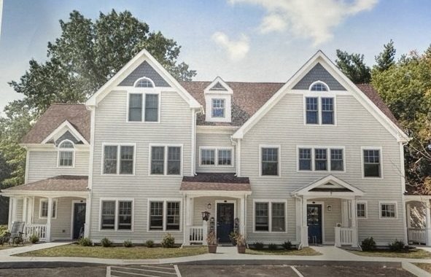  This development has 46 units spread throughout 6 apartment buildings, in which MidState will have 10 first floor units. The units will be available in December 2023.  Applications open November 01, 2023.
 |  | 200 Research Parkway Meriden, CT 06450  —  (203) 237 9975 ext. 384  —  kwood@midstatearc.org  —  http://independentlivingct.org |  | Orange Project  329 Smith Farm Rd, Orange, CT  

Assessment Process  Living with a disability or while aging, should not prevent a person’s dream or goal to live independently, safely and with peace of mind. MidState has an Assessment process, made up of 3-4 Assessments, to help those we serve achieve these goals. When a Person’s Support Team sends us a referral (through the DDS Case Manager), our Triage Team begins the process to identify if this type of environment is right for them. Once that is affirmed MidState begins addressing barriers that would interfere with independence through:  - Independent Living Assessment  - Safety and Risk Assessment  - Assistive Technology Assessment  - Transportation Assessment (if needed) |  | Assistive Technology  Cluster Housing occurs when people are living in individual apartments located throughout an apartment complex or a close geographic area. the apartments are equipped with individually chosen pieces of assistive technology that address a person’s barriers to independence. The staff monitors these devices and responds to the person’s needs either in person or through virtual supports (audio and/or video).  “It’s like a breath of fresh air for someone. That moment where they are like “this is mine, no one is controlling my life”. I have control of my own world. As we’ve worked with people who live independently, you notice them laughing more and looking for ways to engage in the community.”  -Kathryn Wood,  Director of Community Integration |  | Navigating Independence  Fuller, more independent lives for people living with intellectual and developmental disabilities has become a reality. New technologies, polices and funding options are accelerating the transition to these new realities.  The changing landscape can be confusing and difficult to navigate. The team of professionals at MidState Arc work to support the life-long journey to independence at home and in their integration into their communities. This includes allowing a person to exert their rights to freedom and make choices like everyone else. MidState Arc’s team is “bound” by a code of ethics to do good. While staff cannot assist someone in making a decision that is not good for them they will assist someone in a choice that is in their best interest, healthy and legal.  

